My four step packing task
White Standard sheet
Follow instructions in a practical task.
We help in a small packing room. It is made up.
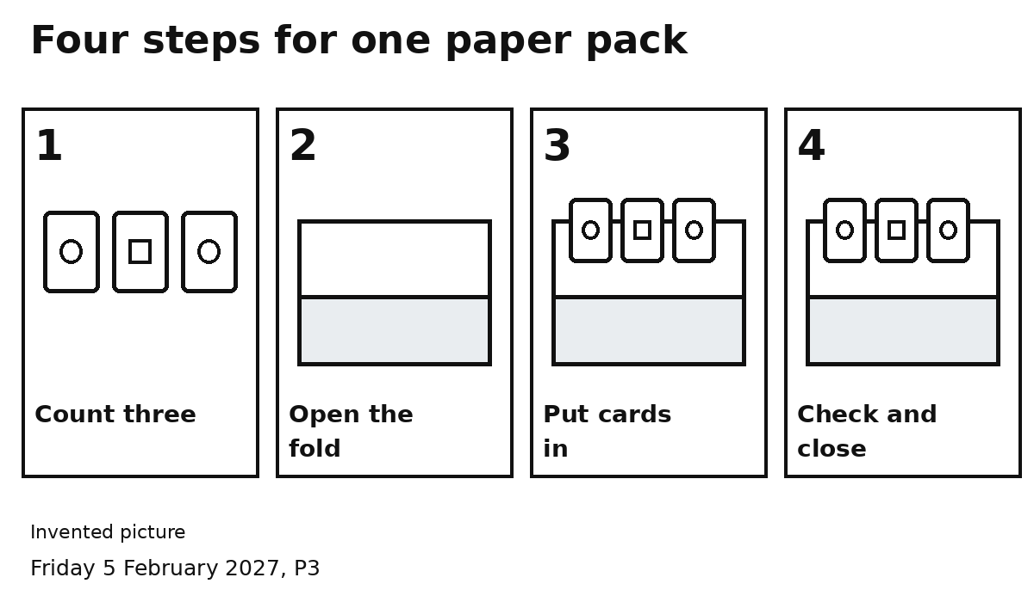
1 Count three cards.
2 Open the folded sheet.
3 Put three cards inside.
4 Check three cards. Close the fold.
Do one step at a time, in order.
You can point or ask for help.

