How our team worked
White Standard sheet
Reflect on how our team worked.
We help in a small packing room. It is made up.
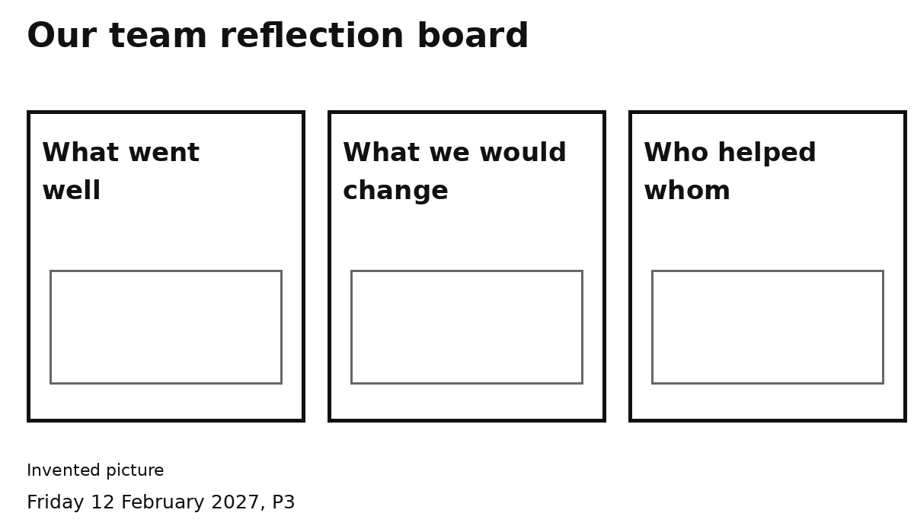
1 Think about one job we did.
2 Pick a heading on the board.
3 Add or show one idea.
4 Show or say your own reflection.
One idea is enough.
You can point, speak or ask an adult to write.

