Card 1 Three option groups
These are types of route after school. The pictures are made up signs for learning and work. Read the words too.
Picture | Option group
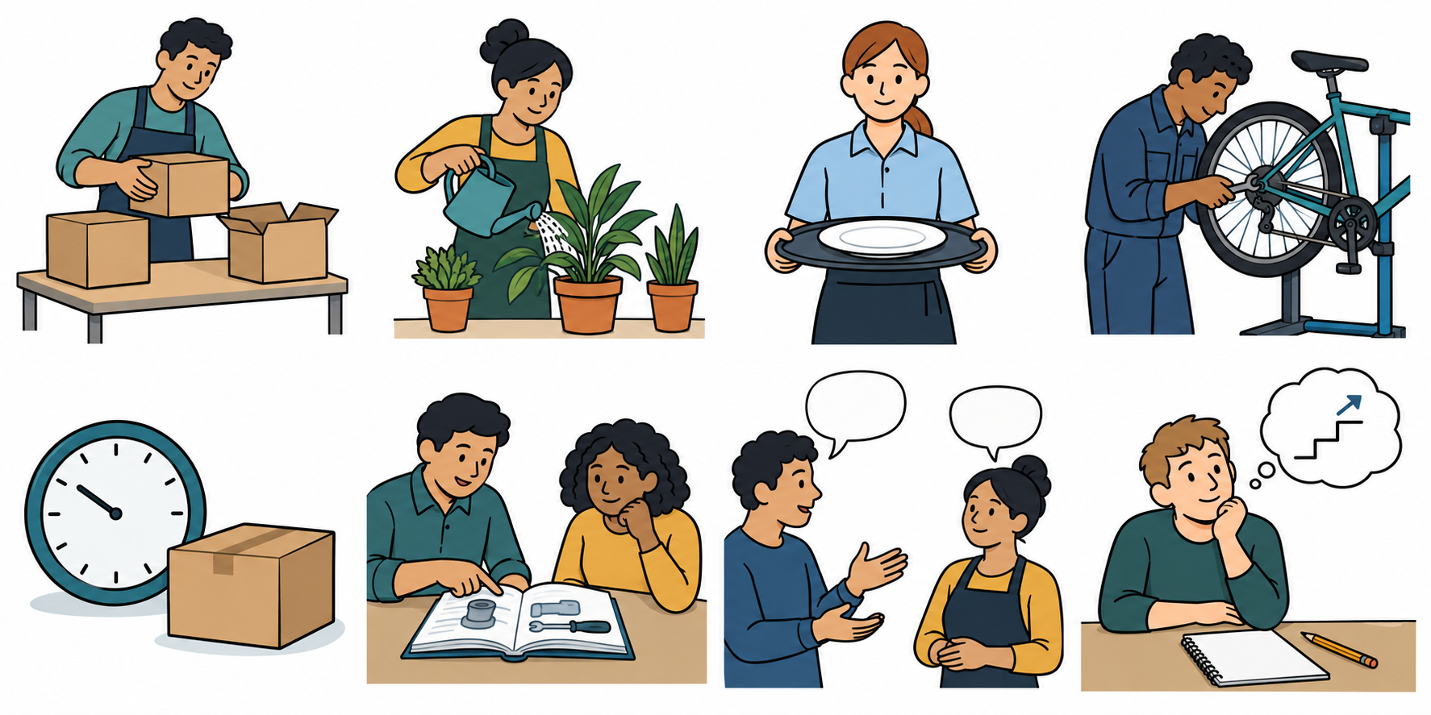 | 1 College/sixth form. Study courses and learn. A college may offer many subjects or job skills. A sixth form offers courses after school.
 | 2 Apprenticeship/training. An apprenticeship is a paid job with planned learning. A training course teaches skills. A course may not include a paid job.
 | 3 Employment with training/support. Do a paid job with training or help to do the work. Ask what learning and support are in place.
All three are options to find out about. No group is best for all people. You do not have to choose today.

Words and start
learn · earn · job · course · help
“One group is ... .” Use a card, your voice or your aid.

Card 2 Model and guided examples
All people and examples are made up. Use the words to sort. Pictures show learning or work, not real people.
Picture | Example
 | A A person takes a course at a college. They learn skills. This card has no paid job.
 | C A person is an apprentice. They have a paid job and planned learning.
 | D A person takes a training course to learn job skills. This card has no paid job.

Model A
A is group 1: college/sixth form. A is learn. The clue is a course with no paid job.

Try C and D with an adult
Which group? Learn, earn or both? A paid job and learning means both. A course may not have a paid job.
Start: “I can see ... . This card is ... .”

Card 3 Practice and missing facts
These people and examples are made up. Use B and E for your grid. F is a card to check together.
Picture | Example
 | B A person studies courses in a sixth form. This card has no paid job.
 | E A person has a paid job packing boxes. Staff train them and help them at work.
 | F A card says a person has a paid job. It says nothing about learning or support.

Use B and E
Name the group. Sort what each card shows: learn, earn or both. Use Card 1 and the A model.

Check F
F shows earn. We do not yet know the learning or help. Ask: “What training or help comes with the job?” F is not a full route plan.

Card 4 Sorting and help
Sort only what each made-up card tells us. Do not guess what is missing.
Word | What the card shows
Learn | Study or training; no paid job in this card.
Earn | Pay is shown; learning or help is not stated. Ask for more facts.
Both | A paid job and learning are both shown.

Three groups to name
1 College/sixth form. 2 Apprenticeship/training. 3 Employment with training/support.

A small step
Choose all three cards or one row at a time. An adult can read. Use your book, type, point or use a scribe.

Your choice check
You may pick a group to find out about, say not sure or pass. You may choose for a made-up person. This choice is private and not a mark.

Help in private
Point to HELP, write a request or ask for a private talk. Use a trusted adult or the school’s help route. If one adult is busy, ask another. You may pass, pause and return with help.

