Card 1 Plan a question
Choose a ready question, or build one from a topic. Ask about the option. Keep private details out.
Topic | Ready question
Course content | What will I learn?
Entry | What would I need to join?
Support | What help could I ask for?
Travel | What should I check about getting there?
Progression | What could I do next after this?

Build your own
“What will I ... ?” “What help ... ?” “What would I need ... ?” An adult can help you choose the words.
Picture | Your next move
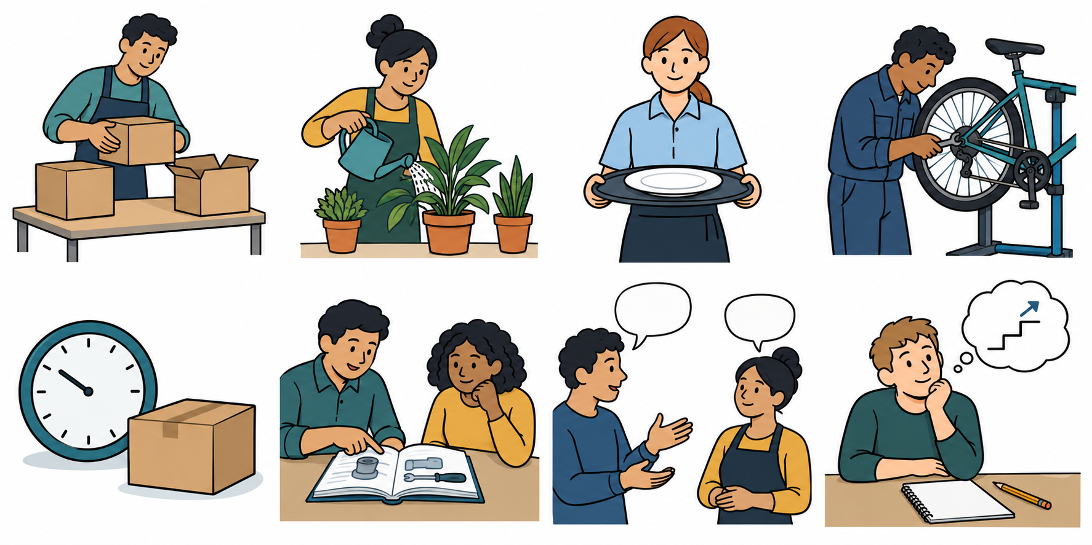 | Try your question with an adult. Use your usual aid.
 | Keep the question ready. Ask it when it is your quiet turn.

Listen and check
Ask, “Please say that again,” if you need to. If a fact is not known, keep it as a question to check.
You may point to a question for an adult to voice. No public talk is needed.

Card 2 Staff role play A
Fallback script. Staff choose A or B and say clearly that it is practice. No real provider is here.

Provider category
Further education college

Say this first
I am playing a made-up college provider. This is practice, not a real place or offer. Ask me a question about this option.
If asked about | Reply from this invented option
Course content | You would try short lessons and guided practical tasks.
Entry | We would talk about what you can do and check the needs of the course. No place is promised.
Support | You could ask for a word card, a short break or help with a step.
Travel | The place and journey are not set in this practice card. Ask a trusted adult to help check travel before a real choice.
Progression | You could look at another course or training. You would need to check its entry needs.

Keep it two way
Let the learner ask by voice, aid or selected card. Answer that question, then offer: “Which word or part would you like me to explain?” Allow a reply or pass.

If the fact is missing
I do not have that fact on this practice card. Let us record it as a question to check.
Record staff role-play and the actual date. Do not copy these answers into a real visitor record.

Card 3 Staff role play B
Fallback script. Staff choose A or B and say clearly that it is practice. No real provider is here.

Provider category
Independent training provider

Say this first
I am playing a made-up training provider. This is practice, not a real place or offer. Ask me a question about this option.
If asked about | Reply from this invented option
Course content | You would learn job skills in a small group and try guided tasks. This card does not offer a paid job.
Entry | We would discuss your starting skills and check what the training needs. No place is promised.
Support | You could ask for a short task list, a model or help to read a step.
Travel | No real journey is given here. Check the route, time and help with a trusted adult before a real choice.
Progression | You could explore more training or a job with training. You would need to check the next entry needs.

Keep it two way
Let the learner ask by voice, aid or selected card. Answer that question, then offer: “Would you like a shorter answer or an example?” Allow a reply or pass.

If the fact is missing
I do not have that fact on this practice card. Let us record it as a question to check.
Record staff role-play and the actual date. Do not copy these answers into a real visitor record.

Card 4 Answer and choice
This is a made-up model from script A. It is not your answer.

Question and answer
Question: “What help could I ask for?” Answer: “A word card, a short break or help with a step.”

A possible reflection
“Maybe. I heard that I could ask for a word card. I still need to check travel.” Yes or no could also be valid. The choice belongs to the learner.
Keep | Meaning
Yes | This could suit me.
Maybe | I am not sure yet.
No | This may not suit me.
Not known yet | The fact needs a check. It is not an answer to guess.

Record honestly
Write the date, provider type, question and answer. Mark real encounter or staff role-play. If it has not happened, mark pending. Keep names out.

Private help
Use a trusted adult or the school’s help route. You can point to HELP. You may pass, pause and return with help.

