Card 1 Worked route map
Made-up example A. These are possible practice routes, not real offers.
Picture | Job goal
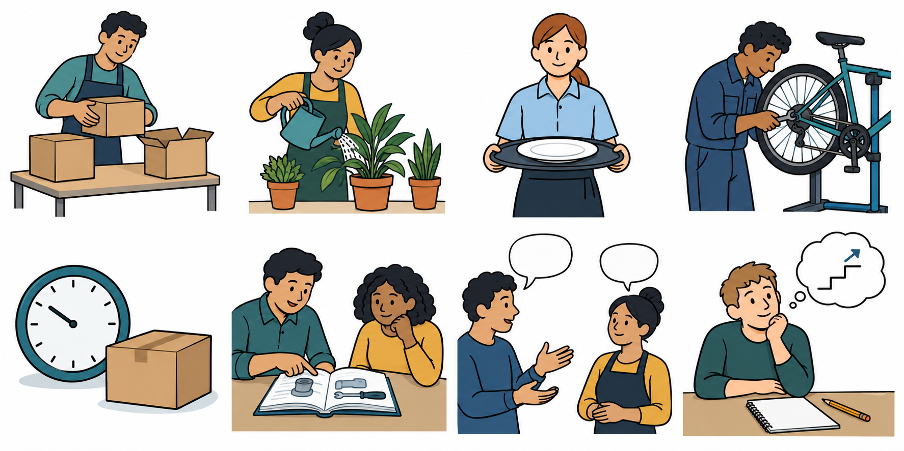 | Food service assistant

Plan A
A college course with food tasks, then food service work with training or support.

Plan B
A paid food service apprenticeship with training, then food service work.

One action and check time
By Friday 12 February, ask a trusted adult to help check the course entry needs.
A trusted adult can help read the entry details. Keep one answer or write not known yet.

A link to earlier work
A support answer from the made-up talk offered a word card. A skill check left a three-step task to practise. Use a word card with a trusted adult. Changing a plan can include asking for help.

Short frames
My goal is ... . Plan A is ... then ... . Plan B is ... then ... . My next step is ... with ... by ... .

Card 2 Stockroom routes
Made-up practice choices. Pick which route is Plan A and which is Plan B. Both aim at the same job. A card is not an offer.
Picture | Job goal
 | Stockroom worker

Route cards in mixed order
A paid stock handling apprenticeship with training, then stockroom work.
A college course with work skills, then stockroom work with training or support.

Action to choose or improve
By Friday 12 February, ask a trusted adult to help check one entry need.
Use the word list and ask an adult to read a step. Keep one fact or one question still to check.

Words and frames
route, first choice, backup, course, paid work, training, help, check. My goal is ... . Plan A is ... . Plan B is ... . One next step is ... .

Private help
Ask a trusted adult to read a step. Use your usual aid, type or point. You may pass or pause.

Card 3 Garden routes
Made-up practice choices. Pick which route is Plan A and which is Plan B. Both aim at the same job. A card is not an offer.
Picture | Job goal
 | Garden worker

Route cards in mixed order
A paid plant care apprenticeship with training, then garden work.
A college course with plant care tasks, then garden work with training or support.

Action to choose or improve
By Friday 12 February, ask a trusted adult to help check what training a route has.
Ask for a model of a task and a short list. Keep the answer or mark not known yet.

Words and frames
route, first choice, backup, course, paid work, training, help, check. My goal is ... . Plan A is ... . Plan B is ... . One next step is ... .

Private help
Ask a trusted adult to read a step. Use your usual aid, type or point. You may pass or pause.

Card 4 Clues from earlier work
Made-up recap examples. Your own earlier work comes first. These clues do not prove you completed an earlier task.
Week | Example clue
1 | Packed boxes. The role changed. Learned a new task with help. Change need not mean failure.
2 | College or sixth form; apprenticeship or training; work with training or support.
3 | An apprenticeship has paid work and training. One entry need may still need a check.
4 | A made-up learner asked for help with a word. A three-step plan still needed practice.
5 | In a staff practice talk, a college type offered word-card help. Travel stayed not known yet.
6 | Use a clue to make two routes and one next action.

Keep evidence honest
If a page or talk is missing, mark it not yet seen or pending. Keep practice talks separate from real talks. Record new work with its own date.

Help in private
Use a trusted adult or the school’s help route. Point to HELP. You may pass, pause and return with help.

