BUILD SCIENCE / Summer 1 / Sum1·W1

Shared evidence • Atlas clues
The plant-parts atlas
Name __________________________ Date ______________
Identify A-D on this simplified plant. Use location and shape clues.
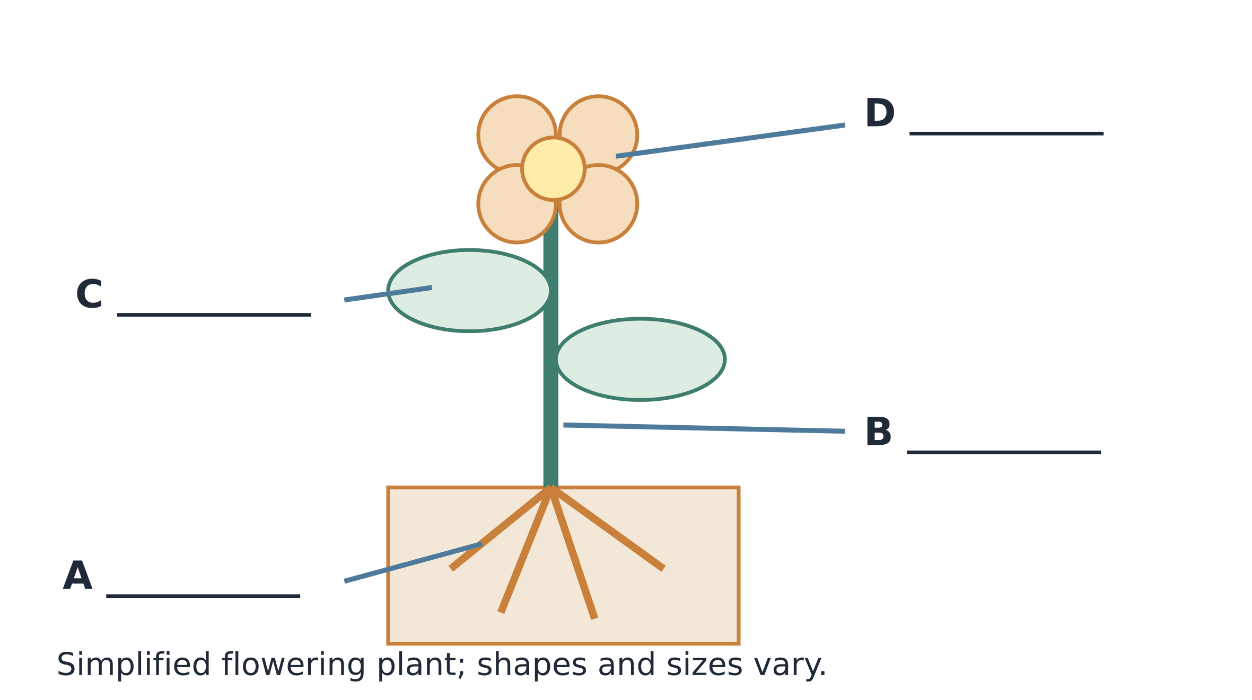
E • Observation record: a potted shoot has a visible stem and leaves. Its roots are hidden by the pot; no flower is visible today.
W1. Name A, B, C and D. Give one location clue.
_____________________________________________________________________
W2. Improve “the plant in E has no roots or flowers”.
_____________________________________________________________________
BUILD SCIENCE / Summer 1 / Sum1·W1

Route 1 • Build the label key
Word bank: roots / stem / leaves / flower.
S1. A branches below soil. Its name is...
_____________________________________________________________________
_____________________________________________________________________
S2. B is the upright connecting part. Its name is...
_____________________________________________________________________
_____________________________________________________________________
S3. Name C and D using the shared records.
_____________________________________________________________________
_____________________________________________________________________
S4. E lets us say...
A. Roots are hidden by the pot.
B. This plant has no roots.
S5. Name one part you would label on a plant drawing.
_____________________________________________________________________
_____________________________________________________________________
BUILD SCIENCE / Summer 1 / Sum1·W1

Route 2 • Make the atlas page
Draw a simple plant. Accuracy of labels matters more than artistic detail.
M1. Draw and label roots, stem, leaves and flower.

M2. Give one location clue for identifying a leaf.
_____________________________________________________________________
_____________________________________________________________________
M3. Can a green part be something other than a leaf? Give an example.
_____________________________________________________________________
_____________________________________________________________________
M4. Write one accurate sentence about what E does not show.
_____________________________________________________________________
_____________________________________________________________________
BUILD SCIENCE / Summer 1 / Sum1·W1

Route 3 • Review an unfamiliar view
A photograph shows a tall green stem with narrow leaves. Its base is outside the frame; it has no open flower.
T1. Name the two parts that are visible.
_____________________________________________________________________
_____________________________________________________________________
T2. Explain why the photograph cannot establish that roots are absent.
_____________________________________________________________________
_____________________________________________________________________
_____________________________________________________________________
T3. Rewrite “this cannot be a flowering plant” as a careful observation.
_____________________________________________________________________
_____________________________________________________________________
T4. Design two useful views for a more complete plant atlas. Explain what each would reveal.
_____________________________________________________________________
_____________________________________________________________________
_____________________________________________________________________
_____________________________________________________________________
BUILD SCIENCE / Summer 1 / Sum1·W1

Exit and reflection
Point, draw, write or tell an adult.
E1. Name the branching part usually below soil.
_____________________________________________________________________
_____________________________________________________________________
E2. Name the part that bears leaves.
_____________________________________________________________________
_____________________________________________________________________
E3. Does no visible flower prove a plant never flowers?
_____________________________________________________________________
_____________________________________________________________________
R1. Which idea did you improve or defend? What evidence helped?
_____________________________________________________________________
_____________________________________________________________________
_____________________________________________________________________
R2. What useful question would you investigate next?
_____________________________________________________________________
_____________________________________________________________________

