BUILD SCIENCE / Summer 1 / Sum1·W5

Shared evidence • Constructed growth records
The growth-record studio
Name __________________________ Date ______________
Same young bean species, matched starting height and conditions. A: 5 mL daily; B: 15 mL daily in this teaching example. Heights are cm; these are not universal care amounts.
Date / day | A1 | A2 | A3 | B1 | B2 | B3
3 May 2027 / day 0 | 3 | 3 | 3 | 3 | 3 | 3
6 May 2027 / day 3 | 4 | 5 | 3 | 5 | 6 | 4
10 May 2027 / day 7 | 5 | 6 | 4 | 8 | 9 | 7
13 May 2027 / day 10 | 6 | 7 | 5 | 11 | 12 | 10

Day 10 leaf notes: A has 2-3 leaves per plant; A3 slightly droops. B has 5-6 leaves per plant and green leaves. Means: A = 3, 4, 5, 6 cm; B = 3, 5, 8, 11 cm on days 0, 3, 7, 10.
W1. Find B1’s baseline and final height. What is the increase?
_____________________________________________________________________
_____________________________________________________________________
W2. Why keep B1, B2 and B3 as separate readings?
_____________________________________________________________________
_____________________________________________________________________
BUILD SCIENCE / Summer 1 / Sum1·W5

Route 1 • Read a plant record
Use B1. Word bank: baseline / cm / 8 / missing.
S1. What is B1’s height on day 0?
_____________________________________________________________________
_____________________________________________________________________
S2. What is B1’s height on day 10?
_____________________________________________________________________
_____________________________________________________________________
S3. How much did B1 increase in height?
_____________________________________________________________________
_____________________________________________________________________
S4. Give one leaf observation that should accompany height.
_____________________________________________________________________
_____________________________________________________________________
S5. A reading not taken should be recorded as...
A. Missing, with a reason.
B. 0 cm automatically.
BUILD SCIENCE / Summer 1 / Sum1·W5

Route 2 • Create the growth display
Use B1’s four readings. The horizontal positions already allow for unequal time intervals.
M1. State B1’s start, final height and height increase.
_____________________________________________________________________
_____________________________________________________________________
M2. Plot B1 on the axes; join successive recorded points. Keep the cm unit.
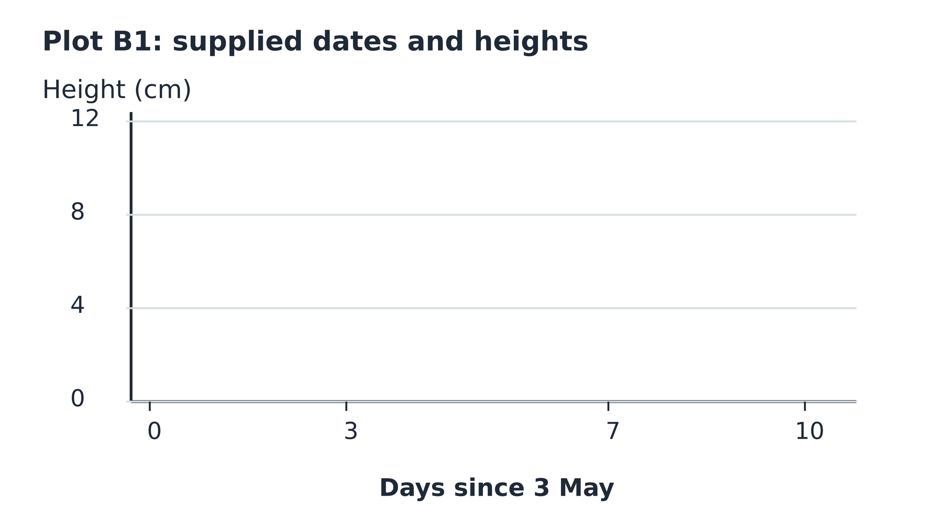
M3. Use the table and leaf notes to write one careful conclusion about these groups.
_____________________________________________________________________
_____________________________________________________________________
M4. Give one reason this cannot establish the best watering amount for every plant.
_____________________________________________________________________
_____________________________________________________________________
BUILD SCIENCE / Summer 1 / Sum1·W5

Route 3 • Audit the record and claim
A report says: “All B plants grew exactly 11 cm, and 15 mL is best for every plant.”
T1. Use baselines and the three day-10 B readings to correct “grew exactly 11 cm”.
_____________________________________________________________________
_____________________________________________________________________
_____________________________________________________________________
T2. Compare the day-10 ranges for A and B.
_____________________________________________________________________
_____________________________________________________________________
_____________________________________________________________________
T3. Give two reasons the universal watering claim is too strong.
_____________________________________________________________________
_____________________________________________________________________
_____________________________________________________________________
T4. Plan a valid response if a future observation is missed. What stays in the record?
_____________________________________________________________________
_____________________________________________________________________
_____________________________________________________________________
BUILD SCIENCE / Summer 1 / Sum1·W5

Exit and reflection
Point, draw, write or tell an adult.
E1. What is a baseline?
_____________________________________________________________________
_____________________________________________________________________
E2. A plant changes from 3 to 11 cm. What is its increase?
_____________________________________________________________________
_____________________________________________________________________
E3. Is a missing reading the same as zero?
_____________________________________________________________________
_____________________________________________________________________
R1. Which idea did you improve or defend? What evidence helped?
_____________________________________________________________________
_____________________________________________________________________
_____________________________________________________________________
R2. What useful question would you investigate next?
_____________________________________________________________________
_____________________________________________________________________

