Book strip
Creative Arts · BUILD · Autumn 2 · Week 6 · ART-BUILD-A2-W06-P1
I can show one thing that went well and a real clue.
□ I can find my real work or note.
□ I can show one part that went well.
□ I can link my idea to a real clue.
Made by Matt

Reference sheets

Find a real clue
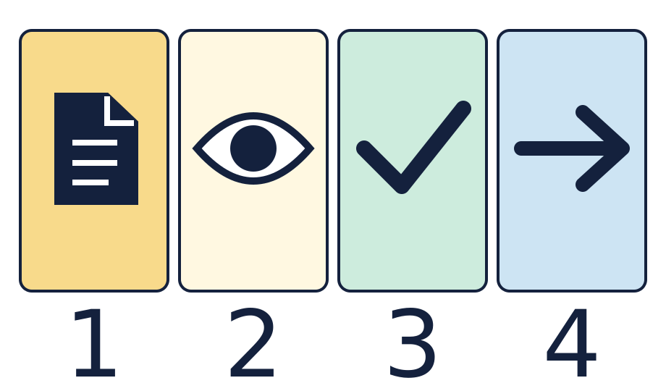
The page is a record. The eye means look. The tick means a part that worked. The arrow means one next step.

Choose a small change and check it
Keep the real clue, the strength and one checkable next step together. These symbols give prompts, not completed answers.

Worked model

Ask the question
Watch the model: use one real clue to check what went well.

Find the evidence
Look at the work or a note. Find one thing you saw or heard.

Explain the link
Link the clue to one good part. A clear stop is one part we can check.

Check what we know
Check the same moment. A good review says what helped, not just how it felt.

Shared investigation
Find a real cue sketch, art piece or note from the group piece.
Point to one part that went well. Use a quiet role if that was your part.
Say or show what was seen or heard at that moment.
Link the clue to the strength. Check that both refer to the same part.
Compare a clear note with a note that just says it was good.
In your book, keep one real clue and one short strength note.

We do decision checkpoint
Which note shows what went well?
A · We stopped at the square cue.
B · It was good.

Catch up for absence or access
Watch the model: use one real clue to check what went well.
Try the first step with the group or point through it quietly.

Arrival · Supported
Start with the picture. Point or make a mark in your book.
1. How many pages can you see?
2. Point to the first box.
3. Point to the last box.
4. Which word fits: ready, help or pause?
Green · Ready, Amber · Help, Red · Pause. Choose in private or pass.

You do · Supported

Show one good part
In your book
Point, speak, sign, draw, write or choose. You may pass.
Choose your real work or note with an adult.
Point to one part that went well.
Show a clue from that part.
In your book, draw or record the link.
Keep it for Lesson 2.
The ___ went well. My clue is ___.
In your book, keep a real clue and one review note.
You may point to the real work, draw a clue, or tell an adult what to record. A quiet review has the same value. You may pass.
Staff mark I · S · C beside the task.

Review and exit · Supported
Show the clue for your strength.
Use one next step to make the note clear.
Check the note against the real work.
Optional: show or tell an adult what you changed after feedback. You may use your usual response mode or pass.

Exit ticket
What is one part that went well? Show a real clue.
Why does the clue fit that part?

Pupil voice
What helped you most today, or what would you change next time?
Point, speak, sign, draw, write or choose. You may pass.

Feedback and response
In your book or usual mode
VF · WS · I · NS + … · E · R · // · ?
NS + ____________________
Edit in the same colour, on the same page or usual mode.
Mark R only after the pupil has responded to the next step and an adult has received and reflected the response.
My response
________________________
Adult ticks the improved work.

Arrival · Independent
Start with the picture. Point or make a mark in your book.
1. How many pages can you see?
2. Point to the first box.
3. What comes just after the page?
4. Which word fits: ready, help or pause?
Green · Ready, Amber · Help, Red · Pause. Choose in private or pass.

You do · Independent

Link a strength and a clue
In your book
Point, speak, sign, draw, write or choose. You may pass.
Choose a real note, cue sketch or art piece.
Find one part that went well.
Show what you saw or heard. Link it to that part.
In your book, keep your strength and its clue.
Use one next step to check the link. Keep it for Lesson 2.
I know ___ went well because ___.
In your book, keep a real clue and one review note.
You may point to the real work, draw a clue, or tell an adult what to record. A quiet review has the same value. You may pass.
Staff mark I · S · C beside the task.

Review and exit · Independent
Show the clue for your strength.
Use one next step to make the note clear.
Check the note against the real work.
Optional: show or tell an adult what you changed after feedback. You may use your usual response mode or pass.

Exit ticket
What is one part that went well? Show a real clue.
Why does the clue fit that part?

Pupil voice
What helped you most today, or what would you change next time?
Point, speak, sign, draw, write or choose. You may pass.

Feedback and response
In your book or usual mode
VF · WS · I · NS + … · E · R · // · ?
NS + ____________________
Edit in the same colour, on the same page or usual mode.
Mark R only after the pupil has responded to the next step and an adult has received and reflected the response.
My response
________________________
Adult ticks the improved work.

Arrival · Aspire
Start with the picture. Point or make a mark in your book.
1. How many pages can you see?
2. Point to the first box.
3. Point to the shape just before the arrow.
4. Which word fits: ready, help or pause?
Green · Ready, Amber · Help, Red · Pause. Choose in private or pass.

You do · Aspire

Aspire challenge: compare two clues
In your book
Point, speak, sign, draw, write or choose. You may pass.
Choose two real clues about one part.
Compare what each clue can show.
Explain why one clue helps you check the strength.
Keep both clues and your reason in your book.
Say what the clues cannot show.
The ___ clue helps because ___.
In your book, keep a real clue and one review note.
You may point to the real work, draw a clue, or tell an adult what to record. A quiet review has the same value. You may pass.
Staff mark I · S · C beside the task.

Review and exit · Aspire
Show the clue for your strength.
Use one next step to make the note clear.
Check the note against the real work.
Optional: show or tell an adult what you changed after feedback. You may use your usual response mode or pass.

Exit ticket
What is one part that went well? Show a real clue.
Why does the clue fit that part?

Pupil voice
What helped you most today, or what would you change next time?
Point, speak, sign, draw, write or choose. You may pass.

Feedback and response
In your book or usual mode
VF · WS · I · NS + … · E · R · // · ?
NS + ____________________
Edit in the same colour, on the same page or usual mode.
Mark R only after the pupil has responded to the next step and an adult has received and reflected the response.
My response
________________________
Adult ticks the improved work.

Arrival · Choice
Start with the picture. Point or make a mark in your book.
1. How many pages can you see?
2. Point to the first box.
3. Do any two boxes have the same shape?
4. Which word fits: ready, help or pause?
Green · Ready, Amber · Help, Red · Pause. Choose in private or pass.

You do · Choice

Choose how to show a strength
In your book
Point, speak, sign, draw, write or choose. You may pass.
Choose a real piece of work or direct an adult to it.
Point, draw or choose one part that went well.
Show the clue or ask an adult to read the real note.
In your book, keep the link in your usual way.
Keep it for Lesson 2.
I chose ___ as a clue for ___.
In your book, keep a real clue and one review note.
You may point to the real work, draw a clue, or tell an adult what to record. A quiet review has the same value. You may pass.
Staff mark I · S · C beside the task.

Review and exit · Choice
Show the clue for your strength.
Use one next step to make the note clear.
Check the note against the real work.
Optional: show or tell an adult what you changed after feedback. You may use your usual response mode or pass.

Exit ticket
What is one part that went well? Show a real clue.
Why does the clue fit that part?

Pupil voice
What helped you most today, or what would you change next time?
Point, speak, sign, draw, write or choose. You may pass.

Feedback and response
In your book or usual mode
VF · WS · I · NS + … · E · R · // · ?
NS + ____________________
Edit in the same colour, on the same page or usual mode.
Mark R only after the pupil has responded to the next step and an adult has received and reflected the response.
My response
________________________
Adult ticks the improved work.

