Book strip
Creative Arts · BUILD · Autumn 2 · Week 6 · ART-BUILD-A2-W06-P2
I can choose one small next step and show how to check it.
□ I can use my strength note and real clue.
□ I can choose one small change.
□ I can say what to look for on a new try.
Made by Matt

Reference sheets

Find a real clue
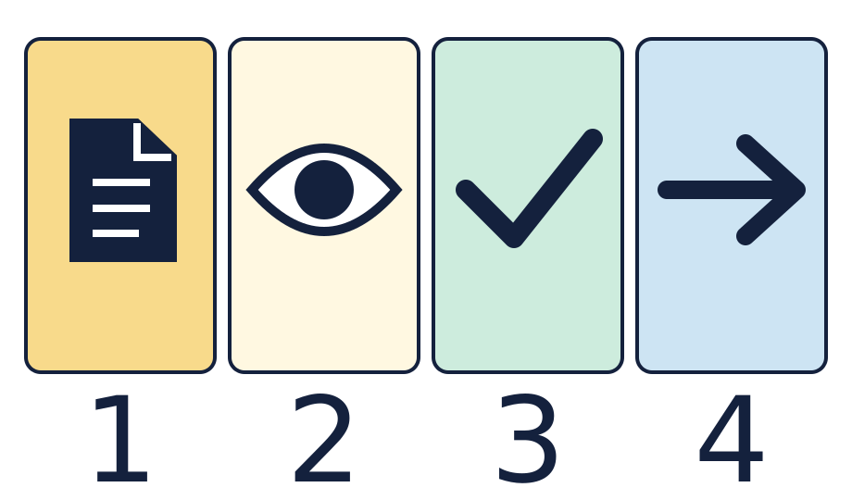
The page is a record. The eye means look. The tick means a part that worked. The arrow means one next step.

Choose a small change and check it
Keep the real clue, the strength and one checkable next step together. These symbols give prompts, not completed answers.

Worked model

Ask the question
Watch the model: use the real clue to choose one small change.

Find the evidence
Pick one cue to make clear. Move just that cue where all can see it.

Explain the link
Keep the short part the same. Check who can see the cue on a new try.

Check what we know
Record what you saw. If you have not tried it, keep it as a plan.

Shared investigation
Bring back a real strength note and clue from Lesson 1.
Choose one small change that follows from the real work.
Say what we will look for. Try one quiet cue check if useful.
Keep the strength, next step and check together. Record a result only if seen.

We do decision checkpoint
Which next step can we try and check?
A · Raise the cue and check who can see it.
B · Make the whole piece good.

Catch up for absence or access
Watch the model: use the real clue to choose one small change.
Try the first step with the group or point through it quietly.

Arrival · Supported
Start with the picture. Point or make a mark in your book.
1. How many pages can you see?
2. Point to the first box.
3. Point to the last box.
4. Which word fits: ready, help or pause?
Green · Ready, Amber · Help, Red · Pause. Choose in private or pass.

You do · Supported

Complete a short review
In your book
Point, speak, sign, draw, write or choose. You may pass.
Use your Lesson 1 strength and clue.
Choose one small cue change with an adult.
Show what you will look for on a new try.
Try a quiet check or keep it as a plan.
In your book, keep the strength, next step and check.
My next step is ___. I will look for ___.
In your book, keep a real clue and one review note.
You may point to the real work, draw a clue, or tell an adult what to record. A quiet review has the same value. You may pass.
Staff mark I · S · C beside the task.

Review and exit · Supported
Share your strength and next step with one adult or your team. You may pass.
Use one next step to make your review clear.
Check the link to the real work. Keep a plan separate from a result.
Optional: show or tell an adult what you changed after feedback. You may use your usual response mode or pass.

Exit ticket
What is your next step and how can you check it?
Is your note a plan or a real result? Show how you know.

Pupil voice
What helped you most today, or what would you change next time?
Point, speak, sign, draw, write or choose. You may pass.

Feedback and response
In your book or usual mode
VF · WS · I · NS + … · E · R · // · ?
NS + ____________________
Edit in the same colour, on the same page or usual mode.
Mark R only after the pupil has responded to the next step and an adult has received and reflected the response.
My response
________________________
Adult ticks the improved work.

Arrival · Independent
Start with the picture. Point or make a mark in your book.
1. How many pages can you see?
2. Point to the first box.
3. What comes just after the page?
4. Which word fits: ready, help or pause?
Green · Ready, Amber · Help, Red · Pause. Choose in private or pass.

You do · Independent

Finish and check your review
In your book
Point, speak, sign, draw, write or choose. You may pass.
Use your real Lesson 1 clue to choose one small change.
Say what you will look for and how to check it.
Try one short quiet check if useful. Record only what you saw.
Share the review with one adult or your team. You may pass.
Use one next step to make the note clear. Keep any untried step as a plan.
I will change ___ and check ___.
In your book, keep a real clue and one review note.
You may point to the real work, draw a clue, or tell an adult what to record. A quiet review has the same value. You may pass.
Staff mark I · S · C beside the task.

Review and exit · Independent
Share your strength and next step with one adult or your team. You may pass.
Use one next step to make your review clear.
Check the link to the real work. Keep a plan separate from a result.
Optional: show or tell an adult what you changed after feedback. You may use your usual response mode or pass.

Exit ticket
What is your next step and how can you check it?
Is your note a plan or a real result? Show how you know.

Pupil voice
What helped you most today, or what would you change next time?
Point, speak, sign, draw, write or choose. You may pass.

Feedback and response
In your book or usual mode
VF · WS · I · NS + … · E · R · // · ?
NS + ____________________
Edit in the same colour, on the same page or usual mode.
Mark R only after the pupil has responded to the next step and an adult has received and reflected the response.
My response
________________________
Adult ticks the improved work.

Arrival · Aspire
Start with the picture. Point or make a mark in your book.
1. How many pages can you see?
2. Point to the first box.
3. Point to the shape just before the arrow.
4. Which word fits: ready, help or pause?
Green · Ready, Amber · Help, Red · Pause. Choose in private or pass.

You do · Aspire

Aspire challenge: compare two next steps
In your book
Point, speak, sign, draw, write or choose. You may pass.
Choose two small next steps from the same real clue.
Compare what you could check for each step.
Explain why one step is more useful for that part.
Try a quiet check or show how you would test it.
Keep a plan separate from any result. Share your reason or pass.
I chose ___ because the check would show ___.
In your book, keep a real clue and one review note.
You may point to the real work, draw a clue, or tell an adult what to record. A quiet review has the same value. You may pass.
Staff mark I · S · C beside the task.

Review and exit · Aspire
Share your strength and next step with one adult or your team. You may pass.
Use one next step to make your review clear.
Check the link to the real work. Keep a plan separate from a result.
Optional: show or tell an adult what you changed after feedback. You may use your usual response mode or pass.

Exit ticket
What is your next step and how can you check it?
Is your note a plan or a real result? Show how you know.

Pupil voice
What helped you most today, or what would you change next time?
Point, speak, sign, draw, write or choose. You may pass.

Feedback and response
In your book or usual mode
VF · WS · I · NS + … · E · R · // · ?
NS + ____________________
Edit in the same colour, on the same page or usual mode.
Mark R only after the pupil has responded to the next step and an adult has received and reflected the response.
My response
________________________
Adult ticks the improved work.

Arrival · Choice
Start with the picture. Point or make a mark in your book.
1. How many pages can you see?
2. Point to the first box.
3. Do any two boxes have the same shape?
4. Which word fits: ready, help or pause?
Green · Ready, Amber · Help, Red · Pause. Choose in private or pass.

You do · Choice

Choose how to finish the review
In your book
Point, speak, sign, draw, write or choose. You may pass.
Point to your real Lesson 1 strength and clue.
Choose a small change, draw it, or direct an adult.
Show what you could see or hear on a check.
Try a quiet check or keep it as a plan.
Keep the review in your book. Share privately or pass.
I chose ___ and will check ___.
In your book, keep a real clue and one review note.
You may point to the real work, draw a clue, or tell an adult what to record. A quiet review has the same value. You may pass.
Staff mark I · S · C beside the task.

Review and exit · Choice
Share your strength and next step with one adult or your team. You may pass.
Use one next step to make your review clear.
Check the link to the real work. Keep a plan separate from a result.
Optional: show or tell an adult what you changed after feedback. You may use your usual response mode or pass.

Exit ticket
What is your next step and how can you check it?
Is your note a plan or a real result? Show how you know.

Pupil voice
What helped you most today, or what would you change next time?
Point, speak, sign, draw, write or choose. You may pass.

Feedback and response
In your book or usual mode
VF · WS · I · NS + … · E · R · // · ?
NS + ____________________
Edit in the same colour, on the same page or usual mode.
Mark R only after the pupil has responded to the next step and an adult has received and reflected the response.
My response
________________________
Adult ticks the improved work.

