Book strip
Creative Arts · GROW · Autumn 2 · Week 6 · ART-GROW-A2-W06-P2
I can use real evidence to choose a practical next step and a clear check.
□ I can retain a strength supported by an actual record.
□ I can choose a specific change linked to the actual work.
□ I can distinguish a planned check from an observed result.
Made by Matt

Reference sheets

Find a real clue
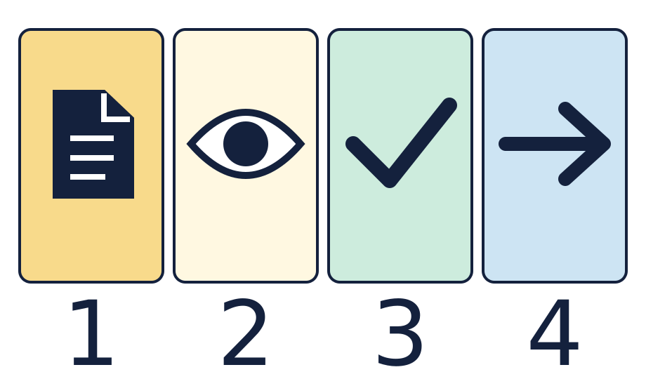
The page is a record. The eye means look. The tick means a part that worked. The arrow means one next step.

Choose a small change and check it
Keep the real clue, the strength and one checkable next step together. These symbols give prompts, not completed answers.

Worked model

Ask the question
Watch the model: use the Lesson 1 observation to select a practical change.

Find the evidence
Specify one cue adjustment and the response you intend to observe.

Explain the link
Keep other features constant during a short quiet check where practical.

Check what we know
Evaluate the observed result, or label the action as a plan if it remains untried.

Shared investigation
Bring back a real strength note and clue from Lesson 1.
Choose one small change that follows from the real work.
Say what we will look for. Try one quiet cue check if useful.
Keep the strength, next step and check together. Record a result only if seen.

We do decision checkpoint
Which next step can we try and check?
A · Raise the cue and check who can see it.
B · Make the whole piece good.

Catch up for absence or access
Watch the model: use the Lesson 1 observation to select a practical change.
Try the first step with the group or point through it quietly.

Arrival · Supported
Start with the picture. Point or make a mark in your book.
1. How many pages can you see?
2. Point to the first box.
3. Point to the last box.
4. Which word fits: ready, help or pause?
Green · Ready, Amber · Help, Red · Pause. Choose in private or pass.

You do · Supported

Complete a short review
In your book
Point, speak, sign, draw, write or choose. You may pass.
Use your Lesson 1 strength and clue.
Choose one small cue change with an adult.
Show what you will look for on a new try.
Try a quiet check or keep it as a plan.
In your book, keep the strength, next step and check.
My next step is ___. I will look for ___.
In your book, keep a real clue and one review note.
You may point to the real work, draw a clue, or tell an adult what to record. A quiet review has the same value. You may pass.
Staff mark I · S · C beside the task.

Review and exit · Supported
Share your strength and next step with one adult or your team. You may pass.
Use one next step to make your review clear.
Check the link to the real work. Keep a plan separate from a result.
Optional: show or tell an adult what you changed after feedback. You may use your usual response mode or pass.

Exit ticket
How does your proposed change follow from the actual observation?
What can your record support, and what remains a plan?

Pupil voice
What helped you most today, or what would you change next time?
Point, speak, sign, draw, write or choose. You may pass.

Feedback and response
In your book or usual mode
VF · WS · I · NS + … · E · R · // · ?
NS + ____________________
Edit in the same colour, on the same page or usual mode.
Mark R only after the pupil has responded to the next step and an adult has received and reflected the response.
My response
________________________
Adult ticks the improved work.

Arrival · Independent
Start with the picture. Point or make a mark in your book.
1. How many pages can you see?
2. Point to the first box.
3. What comes just after the page?
4. Which word fits: ready, help or pause?
Green · Ready, Amber · Help, Red · Pause. Choose in private or pass.

You do · Independent

Complete and evaluate the review
In your book
Point, speak, sign, draw, write or choose. You may pass.
Use your actual Lesson 1 record to retain a supported strength.
Select one practical refinement and explain how it follows from the observation.
Define an observable check. Try a short quiet test where useful.
Distinguish the observed result from an untried plan. Avoid claims beyond the record.
Share privately or within the team, then use feedback to refine the review. You may pass.
The proposed change is ___; the observable check is ___.
In your book, keep a real clue and one review note.
You may point to the real work, draw a clue, or tell an adult what to record. A quiet review has the same value. You may pass.
Staff mark I · S · C beside the task.

Review and exit · Independent
Share your strength and next step with one adult or your team. You may pass.
Use one next step to make your review clear.
Check the link to the real work. Keep a plan separate from a result.
Optional: show or tell an adult what you changed after feedback. You may use your usual response mode or pass.

Exit ticket
How does your proposed change follow from the actual observation?
What can your record support, and what remains a plan?

Pupil voice
What helped you most today, or what would you change next time?
Point, speak, sign, draw, write or choose. You may pass.

Feedback and response
In your book or usual mode
VF · WS · I · NS + … · E · R · // · ?
NS + ____________________
Edit in the same colour, on the same page or usual mode.
Mark R only after the pupil has responded to the next step and an adult has received and reflected the response.
My response
________________________
Adult ticks the improved work.

Arrival · Aspire
Start with the picture. Point or make a mark in your book.
1. How many pages can you see?
2. Point to the first box.
3. Point to the shape just before the arrow.
4. Which word fits: ready, help or pause?
Green · Ready, Amber · Help, Red · Pause. Choose in private or pass.

You do · Aspire

Compare and justify two refinements
In your book
Point, speak, sign, draw, write or choose. You may pass.
Generate two practical next steps from the same actual observation.
Compare how each refinement could be checked and which uncertainty it addresses.
Justify the more useful option for the specific moment under review.
Test one change quietly where practical, keeping other features constant.
Evaluate the evidence honestly. Separate an observed effect from a prediction.
I favour ___ because ___ would provide a clearer check.
In your book, keep a real clue and one review note.
You may point to the real work, draw a clue, or tell an adult what to record. A quiet review has the same value. You may pass.
Staff mark I · S · C beside the task.

Review and exit · Aspire
Share your strength and next step with one adult or your team. You may pass.
Use one next step to make your review clear.
Check the link to the real work. Keep a plan separate from a result.
Optional: show or tell an adult what you changed after feedback. You may use your usual response mode or pass.

Exit ticket
How does your proposed change follow from the actual observation?
What can your record support, and what remains a plan?

Pupil voice
What helped you most today, or what would you change next time?
Point, speak, sign, draw, write or choose. You may pass.

Feedback and response
In your book or usual mode
VF · WS · I · NS + … · E · R · // · ?
NS + ____________________
Edit in the same colour, on the same page or usual mode.
Mark R only after the pupil has responded to the next step and an adult has received and reflected the response.
My response
________________________
Adult ticks the improved work.

Arrival · Choice
Start with the picture. Point or make a mark in your book.
1. How many pages can you see?
2. Point to the first box.
3. Do any two boxes have the same shape?
4. Which word fits: ready, help or pause?
Green · Ready, Amber · Help, Red · Pause. Choose in private or pass.

You do · Choice

Choose how to finish the review
In your book
Point, speak, sign, draw, write or choose. You may pass.
Point to your real Lesson 1 strength and clue.
Choose a small change, draw it, or direct an adult.
Show what you could see or hear on a check.
Try a quiet check or keep it as a plan.
Keep the review in your book. Share privately or pass.
I chose ___ and will check ___.
In your book, keep a real clue and one review note.
You may point to the real work, draw a clue, or tell an adult what to record. A quiet review has the same value. You may pass.
Staff mark I · S · C beside the task.

Review and exit · Choice
Share your strength and next step with one adult or your team. You may pass.
Use one next step to make your review clear.
Check the link to the real work. Keep a plan separate from a result.
Optional: show or tell an adult what you changed after feedback. You may use your usual response mode or pass.

Exit ticket
How does your proposed change follow from the actual observation?
What can your record support, and what remains a plan?

Pupil voice
What helped you most today, or what would you change next time?
Point, speak, sign, draw, write or choose. You may pass.

Feedback and response
In your book or usual mode
VF · WS · I · NS + … · E · R · // · ?
NS + ____________________
Edit in the same colour, on the same page or usual mode.
Mark R only after the pupil has responded to the next step and an adult has received and reflected the response.
My response
________________________
Adult ticks the improved work.

