Humanities · GROW · Autumn 2 · Week 2 · HUM-GROW-A2-W02

Knowledge organiser
Read a four-figure grid reference and follow a route.
The park is in square 1122. It shows a square. It does not show one exact point.
Tier | Word | Meaning
Tier 2 | settlement | A place where people live
Tier 2 | urbanisation | Growth in the share of people living in urban places
Tier 2 | land use | What land is used for
Tier 2 | GIS | Mapping information in separate data layers
Read ____ across. Read ____ up. The square is ____.

Humanities · GROW · Autumn 2 · Week 2 · HUM-GROW-A2-W02

Practice grid and key
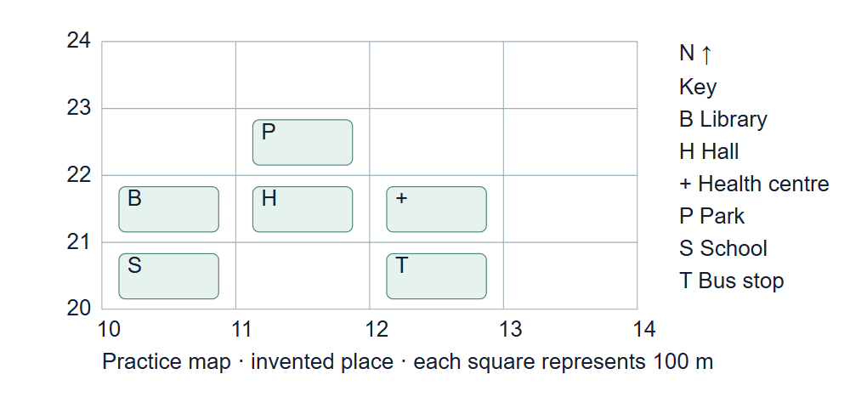
A four-by-four grid with eastings 10 to 14 and northings 20 to 24, with labelled feature symbols. The key identifies the library, hall, health centre, park, school and bus stop.
Use the key and north arrow. Check where each square starts.

Humanities · GROW · Autumn 2 · Week 2 · HUM-GROW-A2-W02

Evidence cards A and B

A · Local reference points
The main railway station and the local bridge are reference points on our digital map. Toggle layers to examine their positions. the civic building lies beyond this map’s southern boundary.
These points alone cannot show population density or prove why development happened.

B · Reasons places grow
Work, transport and services can attract people and businesses. A growing town may need more homes and infrastructure. Population growth can also occur within existing settlements.
A reason is a hypothesis until tested against evidence for a particular place.

Humanities · GROW · Autumn 2 · Week 2 · HUM-GROW-A2-W02

Evidence cards C and D

C · Practice land-use sample
Fictional practice tally: shops 8, homes 12, public services 4, green spaces 6. This is training data only. Replace it with your labelled observations for the fieldwork enquiry.
This example does not describe every person or place.

D · Contrasting reference place
Compare a small centre such as the smaller centre with the larger centre at comparable map scales. Record the area, source and observation round.
One sampled street does not represent a whole settlement.

Humanities · GROW · Autumn 2 · Week 2 · HUM-GROW-A2-W02

Shared investigation
Read eastings before northings on the practice grid. Set a partner a location challenge. Take a turn to suggest a match, then check the evidence.
1. What is the hall’s grid reference?
2. Where is the park from the hall?
3. How do you check the route?
Evidence or step | Check
What is the hall’s grid reference? | Add your answer or card clue.
Where is the park from the hall? | Add your answer or card clue.
How do you check the route? | Add your answer or card clue.
Our explanation
____________________________________________________________

Optional · respond to feedback together
Optional: show one grid clue to an adult. Hear one piece of feedback. Reply with a change, a reason to keep it or a request for help.
My response or improvement
____________________________________________________________

Humanities · GROW · Autumn 2 · Week 2 · HUM-GROW-A2-W02

We do decision checkpoint
A pupil says the park is in 2211. What should they change?
1. Read across first, then up
2. Read up first, then across
3. Use the closest label
My claim and clue
____________________________________________________________

Humanities · GROW · Autumn 2 · Week 2 · HUM-GROW-A2-W02

Worked model

Ask the question
The park is in square 1122. Use card A. Read 11 across. Read 22 up. Put them together: 1122.

Find the evidence
Read 11 across. Read 22 up. Put them together: 1122. The first pair shows the column. The last pair shows the row.

Explain the link
Start at the left of the square. Then read its bottom line. Read ____ across. Read ____ up. The square is ____.

Check what we know
It shows a square. It does not show one exact point. A grid reference shows the square. A key tells you what the symbol means.

Humanities · GROW · Autumn 2 · Week 2 · HUM-GROW-A2-W02

Arrival Supported
 | Ready to learn?  ● Green · Ready  ● Amber · Help  ● Red · Pause  You may point, choose or pass.
  1. Point to the picture that matches the top one.    __________________  __________________ | 2. Which meaning fits settlement?  __________________  __________________
  3. What is the park’s four-figure reference on the practice grid?  __________________  __________________ | 4. What does a four-figure reference identify?  __________________  __________________
Point, speak, sign, draw, write or choose. You may pass. An adult may note your own words or choice.

Humanities · GROW · Autumn 2 · Week 2 · HUM-GROW-A2-W02

You do Supported
Staff mark I · S · C beside the task.
1. Start in your book. Find three places on the grid.
2. Read across, then up. Write a grid reference.
3. Show one move from the hall to the park.
4. Try one new place on your own.
Word bank: settlement · urbanisation · land use · GIS.
My example and card detail
____________________________________________________________
My reason and check
____________________________________________________________
Point, speak, sign, draw, write or choose. You may pass. An adult may note your own words or choice.

Humanities · GROW · Autumn 2 · Week 2 · HUM-GROW-A2-W02

Review and exit Supported
Edit in the same colour, on the same page.
What is the park’s grid reference?
____________________________________________________________
What does a four-figure reference show?
____________________________________________________________
Point, speak, sign, draw, write or choose. You may pass. An adult may note your own words or choice.

Humanities · GROW · Autumn 2 · Week 2 · HUM-GROW-A2-W02

Arrival Independent
 | Ready to learn?  ● Green · Ready  ● Amber · Help  ● Red · Pause  You may point, choose or pass.
  1. Point to the picture that matches the top one.  __________________  __________________ | 2. Which meaning fits settlement?  __________________  __________________
  3. What is the park’s four-figure reference on the practice grid?  __________________  __________________ | 4. What does a four-figure reference identify?  __________________  __________________
Point, speak, sign, draw, write or choose. You may pass. An adult may note your own words or choice.

Humanities · GROW · Autumn 2 · Week 2 · HUM-GROW-A2-W02

You do Independent
Staff mark I · S · C beside the task.
1. Start in your book. Use the supplied grid to find three places.
2. Give a four-figure reference and a direction between two places.
3. Complete one new location question independently.
Word bank: settlement · urbanisation · land use · GIS.
My example and card detail
____________________________________________________________
My reason and check
____________________________________________________________
Point, speak, sign, draw, write or choose. You may pass. An adult may note your own words or choice.

Humanities · GROW · Autumn 2 · Week 2 · HUM-GROW-A2-W02

Review and exit Independent
Edit in the same colour, on the same page.
What is the park’s grid reference?
____________________________________________________________
What does a four-figure reference show?
____________________________________________________________
Point, speak, sign, draw, write or choose. You may pass. An adult may note your own words or choice.

Humanities · GROW · Autumn 2 · Week 2 · HUM-GROW-A2-W02

Arrival Aspire
 | Ready to learn?  ● Green · Ready  ● Amber · Help  ● Red · Pause  You may point, choose or pass.
  1. Point to the picture that matches the top one.  __________________  __________________ | 2. Use settlement in an accurate example.  __________________  __________________
  3. What is the park’s four-figure reference on the practice grid? Which detail supports your answer?  __________________  __________________ | 4. What does a four-figure reference identify?  __________________  __________________
Point, speak, sign, draw, write or choose. You may pass. An adult may note your own words or choice.

Humanities · GROW · Autumn 2 · Week 2 · HUM-GROW-A2-W02

You do Aspire
Staff mark I · S · C beside the task.
1. Start in your book. Use the supplied grid to find three places.
2. Give a four-figure reference and a direction between two places.
3. Complete one new location question independently.
4. Use tenths within a square to describe a more precise location and explain the extra detail.
Word bank: settlement · urbanisation · land use · GIS.
My example and card detail
____________________________________________________________
My reason and check
____________________________________________________________
Point, speak, sign, draw, write or choose. You may pass. An adult may note your own words or choice.

Humanities · GROW · Autumn 2 · Week 2 · HUM-GROW-A2-W02

Review and exit Aspire
Edit in the same colour, on the same page.
What is the park’s grid reference? Use one clue.
____________________________________________________________
What does a four-figure reference show?
____________________________________________________________
Point, speak, sign, draw, write or choose. You may pass. An adult may note your own words or choice.

Humanities · GROW · Autumn 2 · Week 2 · HUM-GROW-A2-W02

You do Choice
Staff mark I · S · C beside the task.
1. Choose to point, speak, sign, draw or write. Keep your response in your book.
2. Read across, then up. Write a grid reference.
3. Show one move from the hall to the park.
4. Try one new place on your own.
Word bank: settlement · urbanisation · land use · GIS.
My example and card detail
____________________________________________________________
My reason and check
____________________________________________________________
Point, speak, sign, draw, write or choose. You may pass. An adult may note your own words or choice.

Humanities · GROW · Autumn 2 · Week 2 · HUM-GROW-A2-W02

Review and exit Choice
Point, draw, sign or tell an adult. What is the park’s grid reference?
____________________________________________________________
What does a four-figure reference show?
____________________________________________________________
Point, speak, sign, draw, write or choose. You may pass. An adult may note your own words or choice.

Humanities · GROW · Autumn 2 · Week 2 · HUM-GROW-A2-W02

Route card
Choose one: □ Supported · □ Independent · □ Aspire · □ Choice.
Start in your book and keep your evidence and check together.

Staff feedback boxes and pupil responses

□ VF
My response
____________________________________________________________

□ WS
My response
____________________________________________________________

□ I
My response
____________________________________________________________

□ NS + …
My response
____________________________________________________________

□ E
My response
____________________________________________________________

□ R
My response
____________________________________________________________

□ //
My response
____________________________________________________________

□ ?
My response
____________________________________________________________

Humanities · GROW · Autumn 2 · Week 2 · HUM-GROW-A2-W02

Catch-up absence or access only
For absence or access only.
Use card A with an adult. Read 11 across. Read 22 up. Put them together: 1122. Join the task with one clue.

Humanities · GROW · Autumn 2 · Week 2 · HUM-GROW-A2-W02

Word page
A four-by-four grid with eastings 10 to 14 and northings 20 to 24, with labelled feature symbols. The key identifies the library, hall, health centre, park, school and bus stop.
Tier | Word | Meaning
Tier 2 | settlement | A place where people live
Tier 2 | urbanisation | Growth in the share of people living in urban places
Tier 2 | land use | What land is used for
Tier 2 | GIS | Mapping information in separate data layers

Humanities · GROW · Autumn 2 · Week 2 · HUM-GROW-A2-W02

Book strips
Humanities · GROW · Autumn 2 · Week 2 · HUM-GROW-A2-W02
Grid references and navigation

Today I can
I can find a clue in the source. · I can explain one idea in my own words. · I can check my work with the source.
Humanities · GROW · Autumn 2 · Week 2 · HUM-GROW-A2-W02
Grid references and navigation

Today I can
I can find a clue in the source. · I can explain one idea in my own words. · I can check my work with the source.
Humanities · GROW · Autumn 2 · Week 2 · HUM-GROW-A2-W02
Grid references and navigation

Today I can
I can find a clue in the source. · I can explain one idea in my own words. · I can check my work with the source.
Humanities · GROW · Autumn 2 · Week 2 · HUM-GROW-A2-W02
Grid references and navigation

Today I can
I can find a clue in the source. · I can explain one idea in my own words. · I can check my work with the source.

