Knowledge organiser
I can sort one raw item.
I can sort one made item.
I can add a row to a table.

I am learning to sort things from nature and things people make.
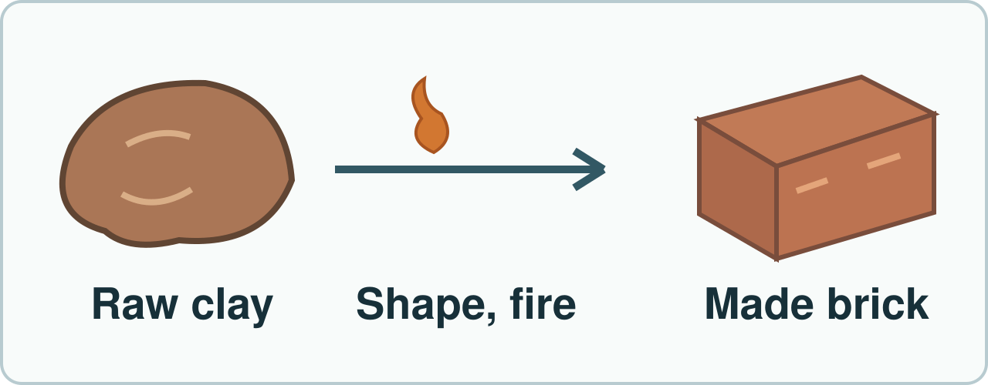
People shape and fire natural clay to make a brick. Simplified; not to scale.
I can sort one raw item. I can sort one made item. I can add a row to a table.

Word page
I can sort one raw item.
I can sort one made item.
I can add a row to a table.

Word | It means | Example
natural | from nature, not made into a new item | A raw rock is natural.
human-made | made or changed by people | People make a brick from clay.
material | what a thing is made of | The brick has clay in it.
table | rows and columns for facts | This row says brick: made.

A raw item comes from nature. People make a new item from one or more raw materials. Use a row for each item.

Arrival and starter
I can sort one raw item.
I can sort one made item.
I can add a row to a table.

Hold a safe raw rock. Look at a brick card.
Think back. Say, sign or point.
1. Name one use of a rock.
2. What does a water test check?
3. What do people and animals get from food?
You may point, sign, say or write your first ideas.

I do · model and check
I can sort one raw item.
I can sort one made item.
I can add a row to a table.

Watch a row go in a table.
Watch: This raw rock is from nature. I write raw rock in the Natural row.
Show me: Is a finished brick raw clay, or an item made by people?
People shape and fire natural clay to make a brick. Simplified; not to scale.

We do · sort and explain
I can sort one raw item.
I can sort one made item.
I can add a row to a table.

Sort safe samples and cards.
Our turn: People shape and fire clay to make a brick. I write brick in the ____ row.
Look at each item. Has it been shaped into a new thing by people? Point to the clue, then choose a group.
Talk, then sort.
Card | Choose a group
Raw rock | From nature / Made by people
Leaf on a branch | From nature / Made by people
Finished clay brick | From nature / Made by people
Glass bottle | From nature / Made by people

Supported: Hold a raw rock. Point to its group.
Independent: Sort four safe items. Tell your rule.
Aspire: Where do raw clay and finished brick go? Why?

We do 2 · choose and explain
I can sort one raw item.
I can sort one made item.
I can add a row to a table.

Which table row is right?
A. Brick | Human-made
B. Brick | Raw rock
C. Rock | Human-made
All of us: People shape sand into a glass bottle. What is the finished bottle?
A. A raw, natural sand sample.
B. A raw and finished rock.
C. A human-made glass item.
D. A thing outside all groups.
Show your choice and say why. You may use a point, card, board or sign. Take one quiet minute to reset.

Independent · Supported
I can sort one raw item.
I can sort one made item.
I can add a row to a table.

Make a row for raw and made items.
Say it first. You can plan in any language.
Point, sign, speak, draw, type, write, use a scribe or a staff-captured photo.
Put one raw and one made item in groups. Fill one row.
Say: This ____ goes in the ____ group.
Item | Group
________________ | ________________
________________ | ________________
________________ | ________________
________________ | ________________

Choose one route within the full 8 minutes. Keep your own response.

Independent · Independent
I can sort one raw item.
I can sort one made item.
I can add a row to a table.

Make a row for raw and made items.
Say it first. You can plan in any language.
Point, sign, speak, draw, type, write, use a scribe or a staff-captured photo.
Sort four items. Add two rows to a table.
Say: I put ____ in the table as ____.
Item | Group
________________ | ________________
________________ | ________________
________________ | ________________
________________ | ________________

Choose one route within the full 8 minutes. Keep your own response.

Independent · Aspire
I can sort one raw item.
I can sort one made item.
I can add a row to a table.

Make a row for raw and made items.
Say it first. You can plan in any language.
Point, sign, speak, draw, type, write, use a scribe or a staff-captured photo.
Why is clay natural but a brick made?
Say: The raw ____ is ____, but the finished ____ is ____.
Go deeper: An object has two materials. How can your table show both?
Mixed item judge: Choose a made item with two raw materials. Plan a fair row.
Item | Group
________________ | ________________
________________ | ________________
________________ | ________________
________________ | ________________

Choose one route within the full 8 minutes. Keep your own response.

Practical model · safe steps and record
I can sort one raw item.
I can sort one made item.
I can add a row to a table.

Kit: Clean blunt raw rock, picture cards of made items, tray
Hold the checked rock, sort it with the made-item cards, then fill a table row.
Risk: A raw rock could have a rough edge or loose dust.
Safe: Use only a clean blunt checked rock on a tray. Do not taste or scrape it; wash hands after.
Use the kit your teacher has checked. A picture or adult-led model is a valid route.

Review and exit
I can sort one raw item.
I can sort one made item.
I can add a row to a table.

Check one row. Hear one next step.
Hear feedback (VF) and one next step (NS(+)). Edit one part (//).
Take one quiet minute to reset.
Show your row to an adult.
Read it back: I am learning to sort things from nature and things people make.
My feedback was… I showed…
Next I need to… try one small fix.
How I know: I can sort one raw item. I can sort one made item. I can add a row to a table.
Tell your teacher. They will pick our next start.
Take one quiet minute before the next lesson.

Staff answers and checks
Starter: a suitable slate can cover a roof (Autumn 2 Week 4); the water test checks whether water passes through a sample (Autumn 2 Week 3); people and animals get nutrition from food (Autumn 1 Week 5). Autumn 1 is the prior half-term. Check actual taught coverage before asking.
Model: raw rock is natural; a finished brick is made by people from clay. The drawing shows raw clay, shaping/firing and a finished brick. It is simplified and not to scale. The shared missing group is Human-made. Do not fill the learner’s blank in advance.
Sort in source order: Raw rock / Leaf on a branch are Natural raw item. Finished clay brick / Glass bottle are Human-made item. Keep the distinction between the raw material and the finished item. A made object can contain natural materials.
Step check: first, Brick | Human-made. Hinge: C, third, A human-made glass item. A confuses raw sand with the finished bottle; B calls a finished item raw; D misses the supplied grouping. The source description of making glass is simplified; the finished bottle is the classification target.

Staff answers · task, limits and next move
Parallel hinge: people cut wood and assemble a chair. The finished chair is human-made. For the pair, hear each independent choice and reason; do not turn a class percentage rule into a score. Re-model the raw-rock row for an unsure learner, then use the chair check.
Supported sorts one raw and one made item and fills one row. Independent sorts four and adds two rows. Aspire explains clay versus brick and may use the mixed-item challenge. An object made from two materials needs a clear item row with both materials named, rather than a false single-source claim.
Misconceptions: natural raw ingredients do not make the finished object a raw item; place clay and brick in separate rows. A table carries row and column information: name the item column and group column and add an accurate row. Accept point, sign, speech or exact scribing with a clear link to the row.
Keep the learner’s row, feedback and self-edit. Exit shows the row to a real adult and chooses the next start. Source task words and order remain. Next weekly line: Plan and carry out a simple fair test on rocks. Career link: a maker selects and changes materials for a finished item.

Staff guidance · pair, access and feedback
The pair works with a shared model and individual evidence. One explains and one asks for the clue, then they swap. Hear both independent reasons before moving on. Re-model an unsure learner’s step and use a fresh parallel question while the other continues.
No cold calling or forced public reading. A learner may pass. Point, sign, speak, draw, type, write, direct an adult or use exact scribing. Read the task exactly when needed. Keep the science challenge and allow planning in any language. EAL is language, not SEN.
Use a stable tray or large cards and the agreed accessible input. Give processing time. Agree a quiet supervised pause and a brief first–then cue. Re-enter at the last completed step. Do not gather evidence while a learner is distressed.
Record actual VF, WS, I, NS(+), E, R, // and ? only when they occur. Keep deepest adult prompt separate from the pupil response. A real adult receives and names back the science. R requires the pupil’s response to an NS(+) next step and real Audience; never award it for a click or completion. Keep the pupil’s own wording and own-colour response.

Staff guidance · evidence and handover
Keep each first response, result or labelled explanation, the feedback and the pupil’s edit or justified decision to keep it. E requires an observable curriculum action on [SYS]. Use SCI-BUILD-A2-W05 for written, spoken, practical or photographic evidence. Record prompt level, response mode, support faded and what was independent.
At Independent agree actual adult roles and swap across the week. If one adult attends, use the actual staffing plan. Follow individual support and behaviour plans. Record access, regulation and curriculum actions against the learner’s own targets without recording a diagnosis as evidence.
If behind, preserve Make a row for raw and made items. and the safety teaching. After a secure check shorten repeated oral rehearsal. Record any change, reason and coverage impact. Pass checked understanding, deepest prompt and unresolved errors to Week 6. Do not replace incomplete individual work with a group product.
Evaluation: date taught; delivered as planned; criteria met; actual adaptations and reasons; changes to the scheme and coverage; evidence banked. Source evidence mapping remains [AWARD] [QUAL]; no unit or qualification award is claimed by this lesson.

TA brief · access, kit and safety
Prepare a clean blunt adult-checked raw rock, leaf and brick cards, a safe bottle picture, a tray, pencil and blank table. The source kit route is optional model rehearsal. The learner may enter the same rows in an offline document for the ICT link.
Check the school risk assessment and actual kit. A rough rock edge or loose dust can harm. Use clean blunt samples on a stable tray. No tasting, scraping, dust or forced touch. Wash hands after.
The pair works with a shared model and individual evidence. One explains and one asks for the clue, then they swap. Hear both independent reasons before moving on. Re-model an unsure learner’s step and use a fresh parallel question while the other continues.
No cold calling or forced public reading. A learner may pass. Point, sign, speak, draw, type, write, direct an adult or use exact scribing. Read the task exactly when needed. Keep the science challenge and allow planning in any language. EAL is language, not SEN.
Use the least prompt needed, then fade it. Keep prompts separate from the pupil’s response.

TA brief · prompt ladder and stage handover
1. Point to the relevant place / instruction.
2. Ask one short question: "What is it asking you to find?"
3. Rephrase the instruction in simpler language.
4. Provide a scaffold or limited choice.
5. Model the first step only, then return the task to the pupil.
Arrival: predictable start and private choice. Starter: hear first attempts before answers. I do: point to the model and let the learner track each step. We do: leave the missing step to the learner. Independent: protect an individual first try.
Review and Exit: the adult receives the learner’s own science, names it back and agrees a precise next move. Record the deepest prompt and what was independent. No physical prompting; pass and pause remain available.
Timing: Arrival 5 min, Starter 3 min, I do 5 min, We do 7 min, We do 2 5 min, Independent 8 min, Review 4 min, Exit 3 min. Total 40 minutes. Alternative route views share the same task time.

