Knowledge organiser
I can name what we change.
I can name what stays the same.
I can record what I see.

I am learning to keep a rock test the same each time.
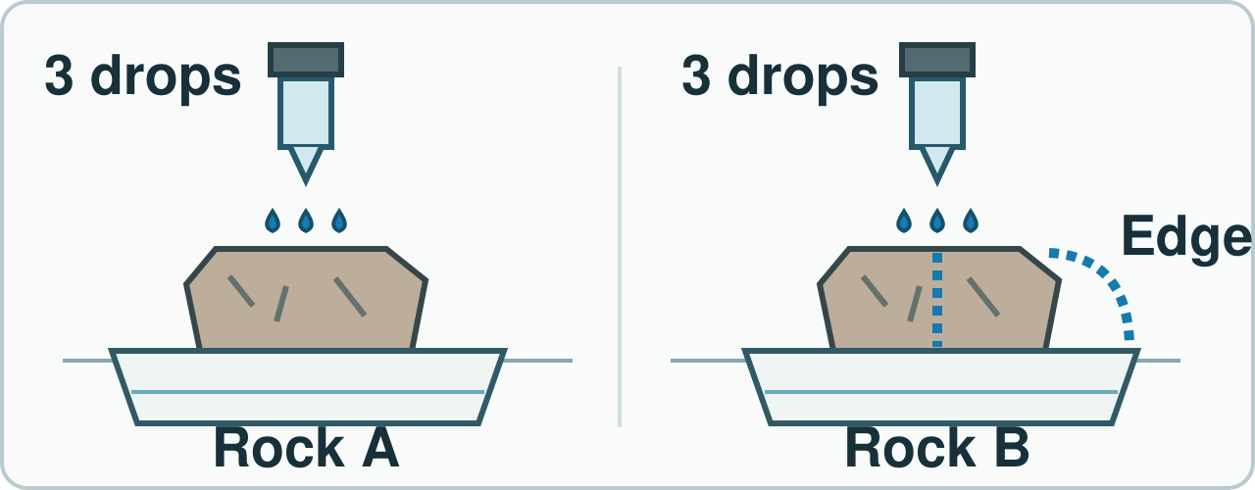
Fair check: same drops and wait; inspect top, through and edge routes. No result is assumed. Simplified; not to scale.
I can name what we change. I can name what stays the same. I can record what I see.

Word page
I can name what we change.
I can name what stays the same.
I can record what I see.

Word | It means | Example
fair test | a check with one planned change | I use three drops each time.
same | not changed in each try | I use the same water.
change | make one thing different | I change the rock.
result | what the check showed | A drop stayed on top.

Change the rock. Keep the drop count and wait the same. Write what you see in a row.

Arrival and starter
I can name what we change.
I can name what stays the same.
I can record what I see.

See two rocks and a dropper.
Think back. Say, sign or point.
1. Name one raw and one made item.
2. Why can slate suit a roof?
3. How can food help a body?
You may point, sign, say or write your first ideas.

I do · model and check
I can name what we change.
I can name what stays the same.
I can record what I see.

Watch a fair water check.
Watch: A gets three drops. I wait one count. B gets the same.
Show me: Do three drops on A and ten on B keep the water amount the same?
Fair check: same drops and wait; inspect top, through and edge routes. No result is assumed. Simplified; not to scale.

We do · sort and explain
I can name what we change.
I can name what stays the same.
I can record what I see.

Plan and run the same steps.
Our turn: A gets three drops. B gets ____ drops. I wait the same time.
Talk, then sort.
Card | Choose a group
Use three drops each time | Keep the same / Change
Wait for the same count | Keep the same / Change
Test a second rock | Keep the same / Change
Use the same tray each time | Keep the same / Change

Supported: Place three dot counters by each rock.
Independent: Plan what stays the same and what changes.
Aspire: Why could different sample sizes spoil this check?

We do 2 · choose and explain
I can name what we change.
I can name what stays the same.
I can record what I see.

What should we put in each sample?
A. Three drops each
B. Three on A, ten on B
C. No drops on B
All of us: New samples C and D get four and nine drops. Is the water amount controlled?
A. No. Give each four drops.
B. Yes. Both got some water.
C. No. Use the same rock.
D. Yes. D could be bigger.
Show your choice and say why. You may use a point, card, board or sign. Take one quiet minute to reset.

Independent · Supported
I can name what we change.
I can name what stays the same.
I can record what I see.

Test two rocks. Record what you see.
Say it first. You can plan in any language.
Point, sign, speak, draw, type, write, use a scribe or a staff-captured photo.
Point to what stays the same.
Say: I keep ____ the same.
Rock | Drops | What happened?
A | ____ | ____________
B | ____ | ____________

Choose one route within the full 8 minutes. Keep your own response.

Independent · Independent
I can name what we change.
I can name what stays the same.
I can record what I see.

Test two rocks. Record what you see.
Say it first. You can plan in any language.
Point, sign, speak, draw, type, write, use a scribe or a staff-captured photo.
Plan one fair water check.
Say: I change ____ and keep ____ the same.
Rock | Drops | What happened?
A | ____ | ____________
B | ____ | ____________

Choose one route within the full 8 minutes. Keep your own response.

Independent · Aspire
I can name what we change.
I can name what stays the same.
I can record what I see.

Test two rocks. Record what you see.
Say it first. You can plan in any language.
Point, sign, speak, draw, type, write, use a scribe or a staff-captured photo.
One rock is much larger. How could you compare?
Say: The check may fail if ____; I will ____.
Go deeper: Drops run off an edge. Did water pass through? Fix it.
Fairness repair: Find two unfair steps. Fix them.
Rock | Drops | What happened?
A | ____ | ____________
B | ____ | ____________

Choose one route within the full 8 minutes. Keep your own response.

Practical model · safe steps and record
I can name what we change.
I can name what stays the same.
I can record what I see.

Guess first: Will the drops act the same?
Kit: Two like-size safe rocks · Dropper · Tray
Guess first.
Add three drops to A. Wait one count.
Do the same on B.
Record and compare.
Risk: Rock edges may scratch skin; water may spill.
Safe: Use blunt rocks in a tray. Wipe spills. Do not taste; wash hands after.
Rock | Drops | What happened?

Use the kit your teacher has checked. A picture or adult-led model is a valid route.

Review and exit
I can name what we change.
I can name what stays the same.
I can record what I see.

Check two rows. Hear a next step.
Hear feedback (VF) and one next step (NS(+)). Edit one part (//).
Take one quiet minute to reset.
Say what stayed the same.
Read it back: I am learning to keep a rock test the same each time.
My feedback was… I showed…
Next I need to… try one small fix.
How I know: I can name what we change. I can name what stays the same. I can record what I see.
Tell your teacher. They will pick our next start.
Take one quiet minute before the next lesson.

Staff answers and checks
Starter: raw rock and a finished brick are suitable examples. Slate can form thin roof pieces. Food supplies nutrition. Source retrieval locators are Autumn 2 Week 5, Autumn 2 Week 4 and Autumn 1 Week 6. Check actual taught coverage.
Model: A gets three drops, wait one count, then give B three drops and the same wait. The show-me comparison of three versus ten drops is not fair. The source drawing distinguishes water on top, through and at an edge. A drop in the tray may be runoff; do not infer that it passed through the rock.
We do: fill three for B. Sort in source order: Keep the same; Keep the same; Change; Keep the same. Keep drop count, wait and tray alike while changing the rock sample. Different sample sizes introduce a second change.
Step check: A, three drops each. Hinge: A, No. Give each four drops. B ignores unequal amounts; C removes the changed rock; D invents a reason to change water amount. Hear both learners separately. Re-model for an unsure learner, then ask the parallel check.

Staff answers · task, limits and next move
Parallel check: E waits ten counts while F waits two. This is not fair; keep the wait the same. Accept a point, sign, spoken answer or exact scribe with the same science reason.
Practical: predict first. Use two similar-size clean blunt rocks in a stable tray. Give each three drops, wait the same count, inspect the routes and record each actual observation. Keep the blank two-row table blank until the learner observes. No result is assumed.
Supported points to what stays the same and may use three dot counters. Independent plans one fair water check. Aspire repairs unequal sample size, considers edge runoff and fixes two unfair steps. Use like-size samples or state the size limit honestly. Do not claim runoff proves absorption.
Review two rows, give actual VF and one NS(+), and keep the learner’s edit or read-back. Exit names what stayed the same and a next step. Week7 reviews skeletons, nutrition and rocks. A laboratory worker controls the method so results can be compared.

Staff guidance · pair, access and feedback
The pair works with a shared model and individual evidence. One explains and one asks for the clue, then they swap. Hear both independent reasons before moving on. Re-model an unsure learner’s step and use a fresh parallel question while the other continues.
No cold calling or forced public reading. A learner may pass. Point, sign, speak, draw, type, write, direct an adult or use exact scribing. Read the task exactly when needed. Keep the science challenge and allow planning in any language. EAL is language, not SEN.
Use a stable tray or large cards and the agreed accessible input. Give processing time. Agree a quiet supervised pause and a brief first–then cue. Re-enter at the last completed step. Do not gather evidence while a learner is distressed.
Record actual VF, WS, I, NS(+), E, R, // and ? only when they occur. Keep deepest adult prompt separate from the pupil response. A real adult receives and names back the science. R requires the pupil’s response to an NS(+) next step and real Audience; never award it for a click or completion. Keep the pupil’s own wording and own-colour response.

Staff guidance · evidence and handover
Keep each first response, result or labelled explanation, the feedback and the pupil’s edit or justified decision to keep it. E requires an observable curriculum action on [SYS]. Use SCI-BUILD-A2-W06 for written, spoken, practical or photographic evidence. Record prompt level, response mode, support faded and what was independent.
At Independent agree actual adult roles and swap across the week. If one adult attends, use the actual staffing plan. Follow individual support and behaviour plans. Record access, regulation and curriculum actions against the learner’s own targets without recording a diagnosis as evidence.
If behind, preserve Test two rocks. Record what you see. and the safety teaching. After a secure check shorten repeated oral rehearsal. Record any change, reason and coverage impact. Pass checked understanding, deepest prompt and unresolved errors to Week 7. Do not replace incomplete individual work with a group product.
Evaluation: date taught; delivered as planned; criteria met; actual adaptations and reasons; changes to the scheme and coverage; evidence banked. Source evidence mapping remains [AWARD] [QUAL]; no unit or qualification award is claimed by this lesson.

TA brief · access, kit and safety
Two similar-size clean blunt rocks, dropper, stable tray, towel, three dot counters per sample and a two-row record. An adult may handle kit while the learner directs and records. One page and pack cover both BUILD periods.
Follow the school risk assessment and approved practical guidance. Use clean blunt samples in a stable tray. Wipe spills. No tasting, scraping or forced touch. Wash hands after. Distinguish edge runoff from water passing through.
The pair works with a shared model and individual evidence. One explains and one asks for the clue, then they swap. Hear both independent reasons before moving on. Re-model an unsure learner’s step and use a fresh parallel question while the other continues.
No cold calling or forced public reading. A learner may pass. Point, sign, speak, draw, type, write, direct an adult or use exact scribing. Read the task exactly when needed. Keep the science challenge and allow planning in any language. EAL is language, not SEN.
Use the least prompt needed, then fade it. Keep prompts separate from the pupil’s response.

TA brief · prompt ladder and stage handover
1. Point to the relevant place / instruction.
2. Ask one short question: "What is it asking you to find?"
3. Rephrase the instruction in simpler language.
4. Provide a scaffold or limited choice.
5. Model the first step only, then return the task to the pupil.
Arrival: predictable start and private choice. Starter: hear first attempts before answers. I do: point to the model and let the learner track each step. We do: leave the missing step to the learner. Independent: protect an individual first try.
Review and Exit: the adult receives the learner’s own science, names it back and agrees a precise next move. Record the deepest prompt and what was independent. No physical prompting; pass and pause remain available.
Timing: Arrival 5 min, Starter 3 min, I do 5 min, We do 7 min, We do 2 5 min, Independent 8 min, Review 4 min, Exit 3 min. Total 40 minutes. Alternative route views share the same task time.

