Rails Meet the River
  - BUILD · Humanities · 40 minutes
I can explain the railway’s principal coal purpose, its link to Stockton’s river port and the opening-day passenger evidence.
Name: __________________________ Date: ______________
You may write, type, say, sign, point or direct a partner. An adult can read the words and record your exact response. Keep the choice and explanation your own.

We do · make a choice and give a reason
Commit before reveal: Which is the safest claim?
- It linked inland coal to the Tees, and the opening steam train also carried passengers in wagons
- It was built only for passengers
- It began because Eston ironstone was found
My choice and the evidence I used:

Resources and independent record

BUILD Humanities · W10 · Rails Meet the River
Enquiry: Why did the Stockton & Darlington Railway link coal areas to the River Tees when it opened in 1825?
Learning objective: I can explain the railway’s principal coal purpose, its link to Stockton’s river port and the opening-day passenger evidence.
Inherited: Week 9 lower-Tees route and port connection.
CONSTRUCTED TEACHING SOURCE — created for classroom practice. It is not an archival original.

Independent Humanities mission
Rail–river network showing the 1825 coal purpose, the opening-day passenger evidence, and the 1830 extension as a later change.
Evidence target: Rail–river network showing the 1825 coal purpose, the opening-day passenger evidence, and the 1830 extension as a later change.

Supported
Build the four-node coal route.
Evidence: Route plus one because-link.
Scaffold: Coal moved from ___ by ___ to ___.

Standard
Add cargo and a careful 1825 claim.
Evidence: Annotated network plus claim.
Scaffold: The railway mattered because it linked ___ to ___.

Stretch
Compare the 1825 purpose with the 1830 extension and add a limit.
Evidence: Chronological comparison plus limitation.
Scaffold: In 1825 ___. By 1830 ___. This evidence cannot prove ___.

Source/material record
Teacher-prepared constructed lab cards plus the locally approved source cards named for this lesson.

Historian/geographer response & Influence
Pupil Humanities decision:

Evidence or representation used:
Reasoning, limitation or uncertainty:
Audience genuinely received: describe through the agreed school workflow; no signature is required here.
Influence: The named class teacher uses the chosen Week 11 opener and re-models the route first where the evidence shows it is needed.
Decision maker: Class teacher — replace with the adult’s name before delivery.
Report back by: Start of Week 11 — add the calendar date before delivery.

Learner source cards
ADAPTED PRIMARY-SOURCE CARD

HUM-B-W10-C01 · John Backhouse reports the opening train
Provenance source: HUM-B-W10-S01
Fourteen-year-old John Church Backhouse described the 27 September 1825 opening train to his sister. His sketch labelled Locomotion, wagons for visitors and a coach called Experiment. He reported a very large crowd, but his reported numbers are not treated as an exact count.
Can establish Establish what one young witness noticed and reported about the opening train.
Cannot establish Establish exact passenger totals, every wagon’s contents or every observer’s view.
Accessible route Numbered details: 1 — young witness; 2 — opening day; 3 — locomotive; 4 — visitor wagons; 5 — Experiment coach; 6 — reported estimate, not verified total.
ADAPTED SECONDARY-SOURCE CARD

HUM-B-W10-C02 · Why the route met the Tees
Provenance source: HUM-B-W10-S02
The railway linked County Durham collieries to Stockton’s wharves so coal could continue by ship. Coal was its most important early traffic. Stockton’s wharves later proved too limited for the volume, helping prompt an extension to a new port at Middlesbrough.
Can establish Supports the coal purpose and the reason for seeking a downstream port.
Cannot establish Does not make the 1830 extension part of the original 1825 route.
Accessible route Route strip: collieries → railway → Stockton wharves → ship; later branch → Middlesbrough port.

Source provenance
HUM-B-W10-S01 · Letter from John Backhouse to his sister describing the opening train Maker: John Church Backhouse; Science Museum Group Collection · Date: Event 27 September 1825; letter written in October 1825 Origin: Science Museum Group Collection; National Railway Museum archive Rights/use: Descriptions CC BY 4.0; catalogue fields CC0; displayed manuscript images marked CC BY-NC-SA 4.0. No image is embedded in this pack. Access: Short modern-English source card and labelled sketch description; full transcription remains in teacher notes only.
HUM-B-W10-S02 · Leonard Raisbeck: Pioneer of the Stockton & Darlington Railway Maker: National Railway Museum, Science Museum Group · Date: 14 April 2023 Origin: National Railway Museum; Science Museum Group Rights/use: General website copyright. Facts restated in original wording with citation; no article prose, quotation or image reproduced. Access: Labelled chain: colliery → wagon → Stockton wharf → ship → market.
HUM-B-W10-S03 · Victorian Commercial Buildings in the Middlesbrough High Street Heritage Action Zone Maker: Lucy Jessop PhD; Historic England · Date: 21 March 2023 Origin: Historic England Research Rights/use: Text paraphrased with citation. Page photographs, historic maps and OS maps have separate rights and are not reproduced. Access: Two-date card: 1829—town planned; 1830—rail branch opened.
Print surface requires physical classroom checking before live use.

Paper route · discuss the lesson choices
Use these choices with the matching teaching stage. Point to or number a choice, explain it, then revisit it after feedback. The original HTML keeps the live controls.
- railway
- ship
- colliery
- Stockton wharves
- Extend to 1830
- Freight or passengers?
- ↺ Reset
- event 1825 — railway opening
- event 1830 — Middlesbrough extension
- event 1850 — Eston ironstone find
- GOODS coal
- PEOPLE passengers in wagons
- PEOPLE Experiment coach
Choice / card | My reason or evidence | My revision after feedback

Visual evidence from the lesson
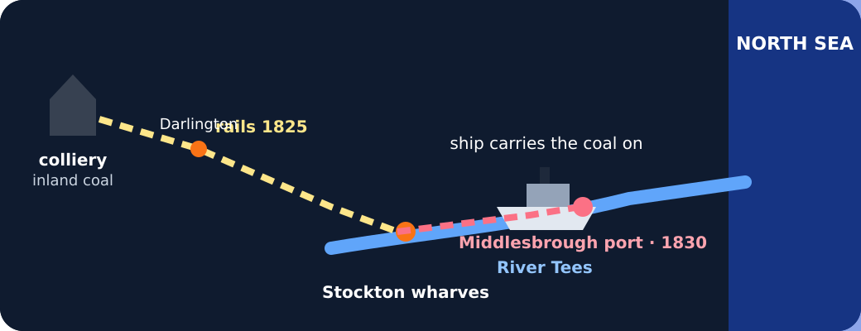
Schematic map of the 1825 railway and 1830 extension

Exit · one next step
After the adult has listened, what will you keep, improve or check next?

