Meet the Lower Tees
  - BUILD · Humanities · 40 minutes
I can locate the lower Tees, identify an estuary and explain one physical–human connection.
Name: __________________________ Date: ______________
You may write, type, say, sign, point or direct a partner. An adult can read the words and record your exact response. Keep the choice and explanation your own.

We do · make a choice and give a reason
Commit before reveal: Which best describes an estuary?
- A wide tidal river area where fresh and sea water meet
- The top of a hill
- Any bridge
My choice and the evidence I used:

Resources and independent record

BUILD Humanities · W9 · Meet the Lower Tees
Enquiry: How does the lower River Tees link land, water, people and the sea?
Learning objective: I can locate the lower Tees, identify an estuary and explain one physical–human connection.
Inherited: Week 8 closed the migration unit: retrieve map movement, key and what maps hide. Acknowledge the report-back if available; if it is not available, the named adult states its status or reasoned boundary, then this new enquiry begins.
CONSTRUCTED TEACHING SOURCE — created for classroom practice. It is not an archival original.

Independent Humanities mission
Ordered and labelled Lower Tees representation, one physical–human connection and one limitation at the selected access route.
Evidence target: Ordered and labelled Lower Tees representation, one physical–human connection and one limitation at the selected access route.

Supported
Order five route cards and explain the destination.
Evidence: Route strip plus one clue.
Scaffold: The Tees passes ___ then reaches ___.

Standard
Label six features, including at least two physical and two human, and draw two because-arrows.
Evidence: Labelled map plus two links.
Scaffold: ___ is near ___, so ___.

Stretch
Add an opportunity, a constraint and a map limit.
Evidence: Annotated map plus qualified explanation.
Scaffold: The river helped ___, but ___. This map cannot show ___.

Source/material record
Teacher-prepared constructed lab cards plus the locally approved source cards named for this lesson.

Historian/geographer response & Influence
Pupil Humanities decision:

Evidence or representation used:
Reasoning, limitation or uncertainty:
Audience genuinely received: describe through the agreed school workflow; no signature is required here.
Influence: The named class teacher opens Week 10 with that pupil’s chosen card and states any boundary on the choice.
Decision maker: Class teacher — replace with the adult’s name before delivery.
Report back by: Start of Week 10 — add the calendar date before delivery.

Learner source cards
ADAPTED SOURCE CARD

HUM-B-W09-C01 · Lower Tees official context
Provenance source: HUM-B-W09-S01
The Environment Agency describes the Lower Tees and estuary catchment as stretching from Croft-on-Tees to the North Sea. Stockton, Middlesbrough and industrial areas sit within this lower catchment.
Can establish Shows the official modern lower-catchment extent and broad settlement pattern.
Cannot establish Does not prove why each town or industry developed in its position.
Accessible route Ordered reading route: Croft-on-Tees → Stockton → Middlesbrough → Teesmouth → North Sea.

HUM-B-W09-C02 · Constructed Lower Tees schematic
Provenance source: HUM-B-W09-S02
A not-to-scale classroom route consulted against OS Open Rivers and the Environment Agency catchment description. It uses selected labels and omits minor watercourses, exact distances and administrative boundaries.
Can establish Supports route ordering and selected feature classification.
Cannot establish Cannot establish precise geometry, distance, historical river form or cause.
Accessible route The same five locations are supplied as a numbered text strip; colour is not needed to follow the route.

Source provenance
HUM-B-W09-S01 · Tees Lower and Estuary Operational Catchment Maker: Environment Agency; Defra Data Services Platform · Date: Undated live catchment-plan page Origin: Environment Agency Catchment Data Explorer; Defra Data Services Platform Rights/use: OGL v3.0 unless stated otherwise; attribute Environment Agency/Defra. Do not reuse the page photograph without separate rights confirmation. Access: High-contrast route strip plus a short plain-language card.
HUM-B-W09-S02 · OS Open Rivers Maker: Ordnance Survey · Date: Live product; release date varies Origin: Ordnance Survey open data products Rights/use: The product was consulted as an open geographical reference. No OS screenshot, map tile, coordinate extract or dataset geometry is embedded. If the dataset is later used directly, add the applicable OGL attribution and exact release/version. Access: Simplified labelled diagram plus ordered text list; colour is not the sole locator.
Print surface requires physical classroom checking before live use.

Paper route · discuss the lesson choices
Use these choices with the matching teaching stage. Point to or number a choice, explain it, then revisit it after feedback. The original HTML keeps the live controls.
- PHYSICAL
- HUMAN
- river → port
- tide → mudflats
- river → bridge
- river → town
- What does this map hide?
- route Upstream
- route Stockton
- route Middlesbrough
- route Teesmouth
- route North Sea
- PHYSICAL channel
- PHYSICAL estuary
- PHYSICAL mudflat
- PHYSICAL tide
- HUMAN town
- HUMAN bridge
- HUMAN port
- HUMAN railway
Choice / card | My reason or evidence | My revision after feedback

Visual evidence from the lesson
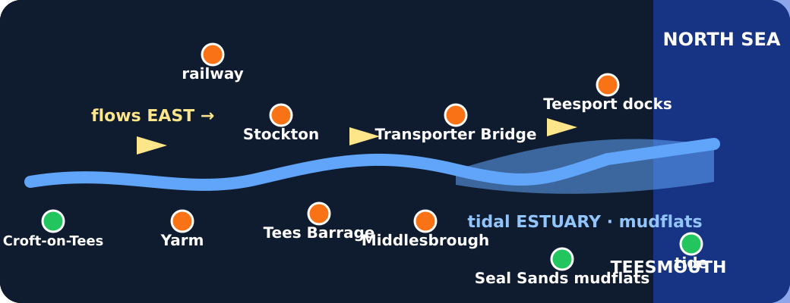
Tappable schematic map of the lower Tees

Exit · one next step
After the adult has listened, what will you keep, improve or check next?

