Teesside: Connected World
  - GROW · Humanities · 40 minutes
I can describe and explain different global connections, using map and source evidence with a limitation.
Name: __________________________ Date: ______________
You may write, type, say, sign, point or direct a partner. An adult can read the words and record your exact response. Keep the choice and explanation your own.

We do · make a choice and give a reason
A port website shows a sea route from Teesport to the Netherlands. What is the strongest claim that evidence supports?
- Teesport has a trade/transport connection with a Dutch market or hub.
- Everyone in Teesside regularly travels to the Netherlands.
- The route explains every cultural connection in Middlesbrough.
My choice and the evidence I used:

Resources and independent record

GROW Humanities · Week 10
40 minutes Autumn 2 · Week 3 · GROW Weekly – Autumn B55:C55 Name: ____________________ Date: __________
Enquiry
How can maps and sources show connections without reducing a community to one route or statistic?
Independent mission
Build a Teesside connection profile using at least two connection types. Add locations, a route/medium, evidence, one possible local effect and a limitation. Use fictional/composite people unless an individual independently opts into a personal route.
Supported route
Complete two safe connection chains from the approved cards and add one ‘does not prove’ statement.
Prompt frame: ____ connects Teesside to ____ through ____. Source ____ shows ____. It does not prove ____.
Standard route
Explain two different connection types with a mapped route, source reference, local effect and limitation.
Method: Place → connection type → route/medium → evidence → possible effect → limitation.
Stretch route
Compare operator, census and community perspectives; judge which claim is best supported and what evidence is missing.
Method: Perspective/scale comparison → strongest claim → counterexample or missing voice → qualified judgement.

Connection locator and evidence cards
Separate source types before making a claim.
TEESSIDE NETHERLANDS MARKET FICTIONAL YOUTH HUB goods / transport · PDP messages / culture · CMP Schematic route model—not distance, equality or cause evidence.
PDP · operator source · adapted factual note: PD Ports describes Teesport as linking road, rail and sea services with markets including the Netherlands and other European areas. An operator promotes its service; this is not a complete social or environmental impact account.
MBC · local-authority statistics · adapted factual note: Middlesbrough Council’s Census 2021 summary reports that 12.29% of residents were born outside the UK. Country of birth cannot reveal a person’s identity, faith, route or reason for moving.
MBM · fictional composite: A youth hub in another country exchanges messages, music recommendations and project ideas with a Teesside group. This safe rehearsal card is invented; it is not evidence that a real person or organisation did this.

Connection profile
Describe how communities are connected across the world.
Connection | Places + route/medium | Named evidence | Possible local effect | Does not prove
Goods/trade
People/population
Messages/culture

Connection judgement

Evidence, prompt and response record
A completed sheet does not itself verify a UAS outcome.

Paper route · discuss the lesson choices
Use these choices with the matching teaching stage. Point to or number a choice, explain it, then revisit it after feedback. The original HTML keeps the live controls.
- Steel and chemicals leave Teesport by ship for Rotterdam
- A family moves to Middlesbrough for work in a food factory
- A video call from Redcar to a cousin in Mumbai
- A Polish bakery opens on Linthorpe Road
- Wind-turbine parts arrive on the Tees from Norway
- A school in Stockton emails its partner school in Kraków
- goods
- people
- messages
- culture
- Is this claim too big?
- Goods / trade
- People / population
- Messages / culture
Choice / card | My reason or evidence | My revision after feedback

Visual evidence from the lesson
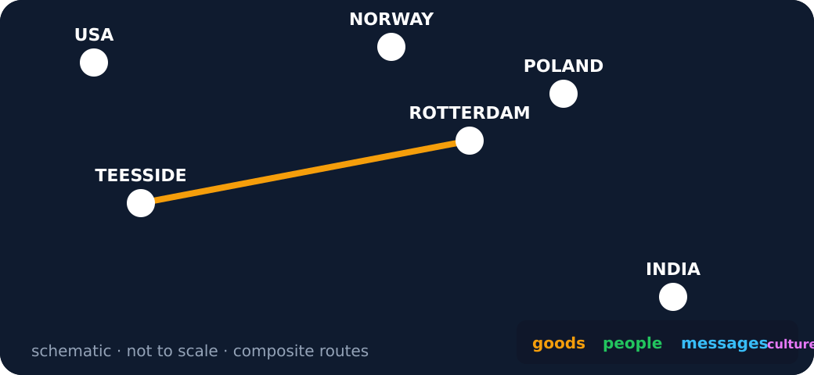
Schematic network with one goods route from Teesside to Rotterdam
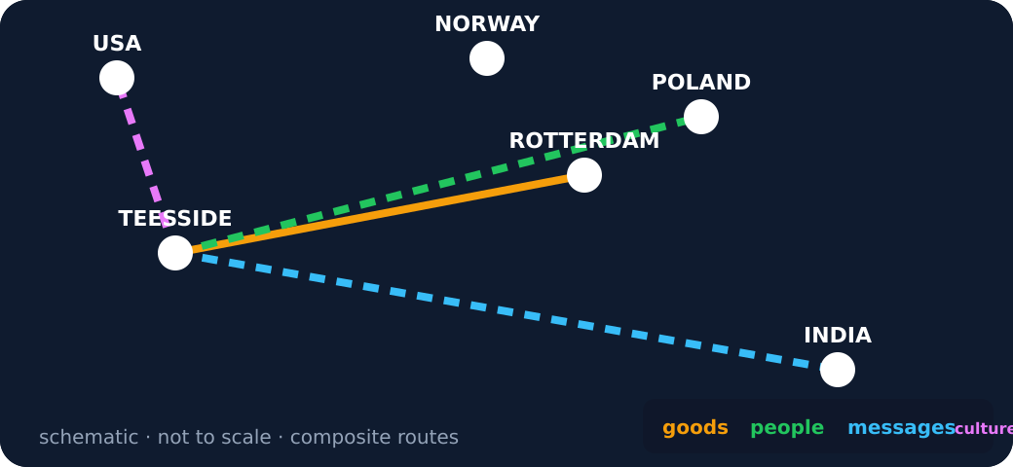
Four route types from Teesside
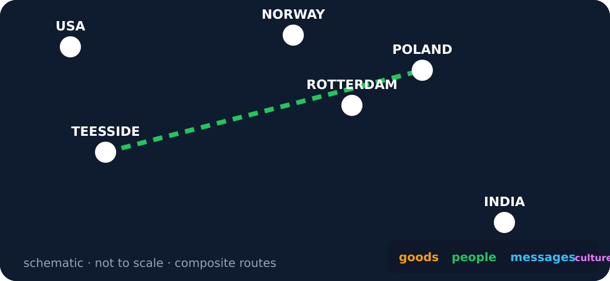
A single people route
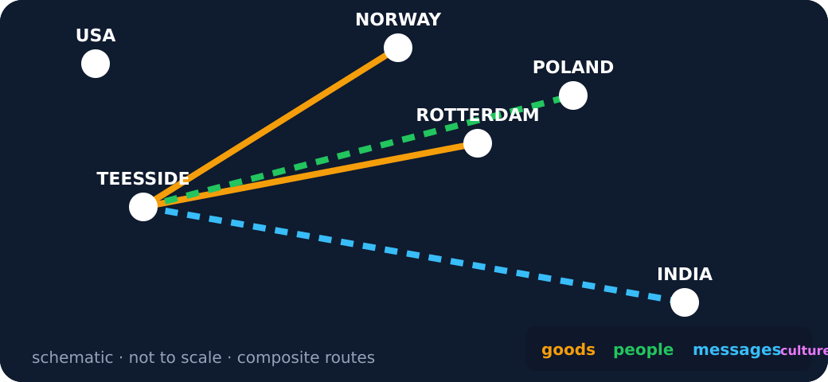
Several routes with a limit note
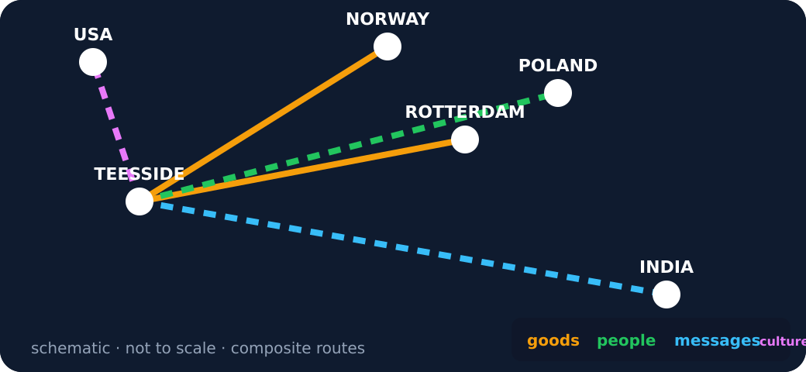
Schematic network with all four route types

Exit · one next step
After the adult has listened, what will you keep, improve or check next?

