Light Across the Map
  - GROW · Humanities · 40 minutes
I can map festival examples, extract meaning/practice from faith-community sources and explain variation.
Name: __________________________ Date: ______________
You may write, type, say, sign, point or direct a partner. An adult can read the words and record your exact response. Keep the choice and explanation your own.

We do · make a choice and give a reason
A BAPS page describes diyas, rangoli, worship and gathering. Which conclusion is defensible?
- This BAPS source gives examples from one Hindu tradition; practices and meanings can vary.
- Every Hindu person celebrates Diwali in exactly this way.
- Diwali is only celebrated inside India.
My choice and the evidence I used:

Resources and independent record

GROW Humanities · Week 11
40 minutes Autumn 2 · Week 4 · GROW Weekly – Autumn B56:C56 Name: ____________________ Date: __________
Enquiry
How do place, movement and community shape where a festival is celebrated—without making faith equal nationality?
Independent mission
Create a three-case festival geography board. For each case: plot one example location or global-reach statement, record meaning/practice from the named source, and add a variation/limitation label. No personal faith disclosure is required.
Supported route
Complete two case cards using provided phrases; plot two examples; add ‘This source cannot represent ___.’
Prompt frame: Source ____ shows that some ____ communities ____. One example place is ____. This does not mean ____.
Standard route
Complete three sourced case cards with location/reach, meaning, practice and one respectful qualification each.
Method: Example location/reach → creator → meaning → practice → variation/limitation.
Stretch route
Compare how source perspective and map scale alter the story; repair one misleading ‘faith = country’ claim.
Method: Map selection + source perspective → misleading inference → evidence-led repair.

Pupil evidence sheet
Investigate festivals of light around the world.
A · London
B · Beijing
C · US cities
D · Karlsruhe
E · Pacific
Constructed locator—not to scale or distribution evidence.
BAPS-LDN · community event account · adapted factual note: BAPS Shri Swaminarayan Mandir in London says its 12 November 2023 Diwali event brought together thousands from the local community and further afield. It describes hope, light and goodwill, Sharda Pujan, prayers, food, service and community participation. One London Swaminarayan Hindu institution and one year; practice varies.
WJC · representative-organisation news account · adapted factual note: A 19 December 2006 report documents a Hanukkah candle-lighting in Beijing and mentions menorahs in cities across the United States. An older selected news account is not current distribution data or every community’s practice.
WCC · ecumenical feature · adapted factual note: A 9 January 2025 feature brings together Christmas messages and examples from places including Karlsruhe in Germany and churches across the Pacific, alongside other regions. Selected member-church examples are not a survey of all Christian communities.
Case/source | Named place/reach | Meaning/practice evidence | Variation/limit
BAPS-LDN · Diwali
WJC · Hanukkah
WCC · Christmas/light symbolism

Evidence, prompt and response record

Paper route · discuss the lesson choices
Use these choices with the matching teaching stage. Point to or number a choice, explain it, then revisit it after feedback. The original HTML keeps the live controls.
- This source documents one London event where lamps were lit.
- All Hindus celebrate Diwali in the same way.
- Some communities in more than one country mark a festival of light.
- Everyone in that country is religious.
- Jewish people always light candles in December.
- One example in this pack is a Reform community in Milton Keynes.
- safe wording
- too big
- Diwali
- Chanukah
- Christmas
Choice / card | My reason or evidence | My revision after feedback

Visual evidence from the lesson
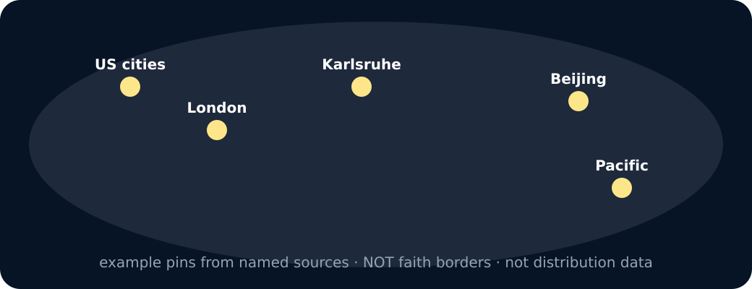
Schematic world with example pins
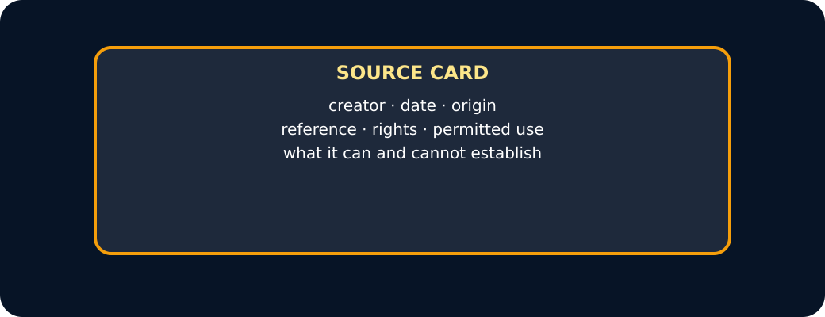
Source card
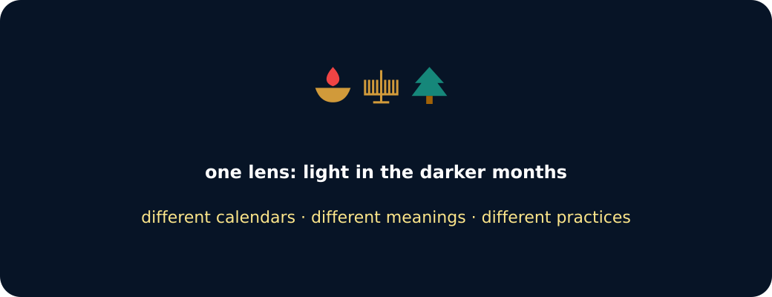
Three light symbols
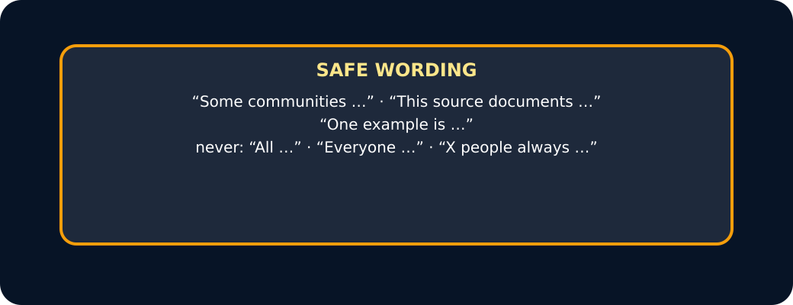
Safe wording card

Exit · one next step
After the adult has listened, what will you keep, improve or check next?

