Compare With Care
  - GROW · Humanities · 40 minutes
I can compare two named source accounts using a shared lens, evidence, difference and qualification.
Name: __________________________ Date: ______________
You may write, type, say, sign, point or direct a partner. An adult can read the words and record your exact response. Keep the choice and explanation your own.

We do · make a choice and give a reason
Which sentence makes the most careful comparison?
- Both named sources include light, but they explain different meanings and neither represents every community.
- Diwali and Chanukah are basically the same festival because both use lights.
- All Hindus and all Jewish people celebrate in opposite ways.
My choice and the evidence I used:

Resources and independent record

GROW Humanities · Week 12
40 minutes Autumn 2 · Week 5 · GROW Weekly – Autumn B57:C57 Name: ____________________ Date: __________
Enquiry
How can we compare celebrations accurately while protecting difference within each community?
Independent mission
Compare two approved source accounts through one shared lens. Produce a similarity, difference, evidence on both sides, belonging connection and one scope limitation. A third-person or source-based route is the default.
Supported route
Complete a two-column evidence grid and use the frame ‘Both sources ____. However, source A ____ while source B ____. This may connect people by ____. The sources cannot show ____.’
Prompt frame: Both ____ and ____. However, ____ while ____. Source ____ says ____. This matters for belonging because ____. It cannot show ____.
Standard route
Write or record one linked comparison using both sources, a belonging explanation and a within-community qualification.
Method: Shared lens → A evidence → B evidence → similarity/difference → belonging → qualification.
Stretch route
Evaluate how creator/perspective or a changed lens would alter the comparison; select the most defensible claim.
Method: Perspective/lens change → what becomes visible/hidden → best-supported comparison.

Pupil evidence sheet
Compare how two communities celebrate.
BAPS-LDN · community event account · adapted factual note: BAPS Shri Swaminarayan Mandir in London says its 12 November 2023 Diwali event brought together thousands from the local community and further afield. It describes hope, light and goodwill, Sharda Pujan, prayers, food, service and community participation. One London Swaminarayan Hindu institution and one year; practice varies.
JML · museum object record · adapted factual note: Jewish Museum London object 1474.11, photographed by Sarah Friedmann, documents members of Milton Keynes and District Reform lighting Hanukah candles. The catalogue stresses that Jewish belief and practice vary. One photograph cannot show every participant, meaning or setting.
Shared lens | Source A evidence | Source B evidence | Similarity | Difference

Belonging + qualification
This may connect people to a community because ____.

This comparison cannot represent/prove ____.

Evidence, prompt and response record

Paper route · discuss the lesson choices
Use these choices with the matching teaching stage. Point to or number a choice, explain it, then revisit it after feedback. The original HTML keeps the live controls.
- A: how light is used · B: how light is used
- A: how light is used · B: how many people attended
- A: what the gathering is for · B: what the gathering is for
- A: the food served · B: the date it falls
- A: where the event took place · B: where the event took place
- same lens
- mismatched
- Add the four qualifiers
- Diwali + Chanukah
- Chanukah + Christmas
- Diwali + Christmas
Choice / card | My reason or evidence | My revision after feedback

Visual evidence from the lesson
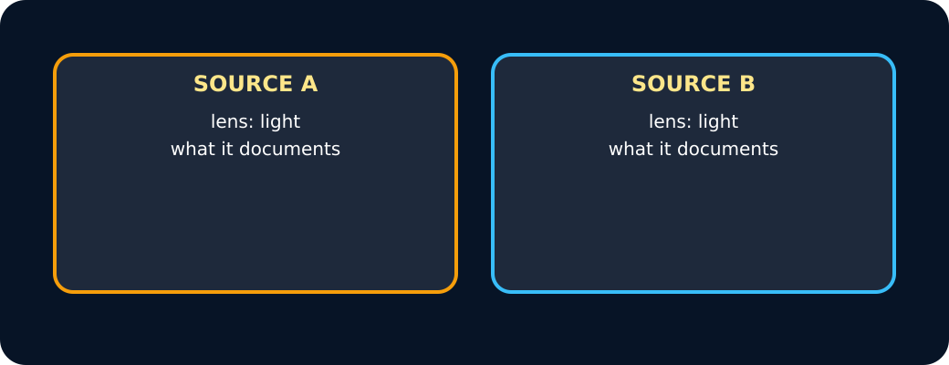
Two sources, one lens
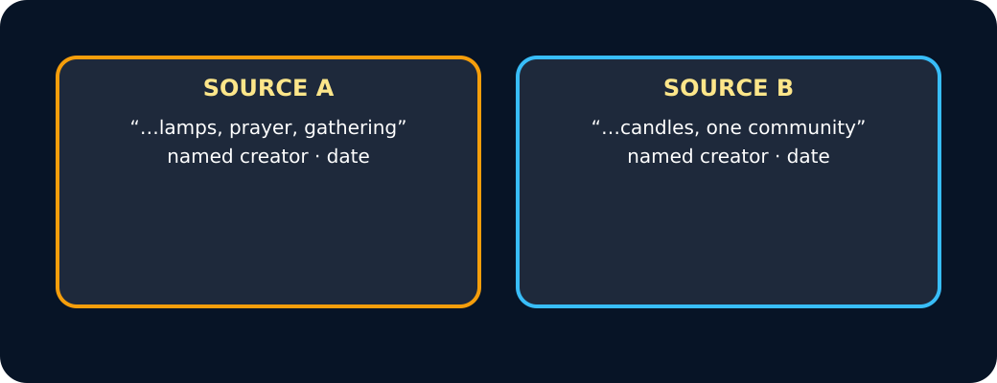
Evidence from both
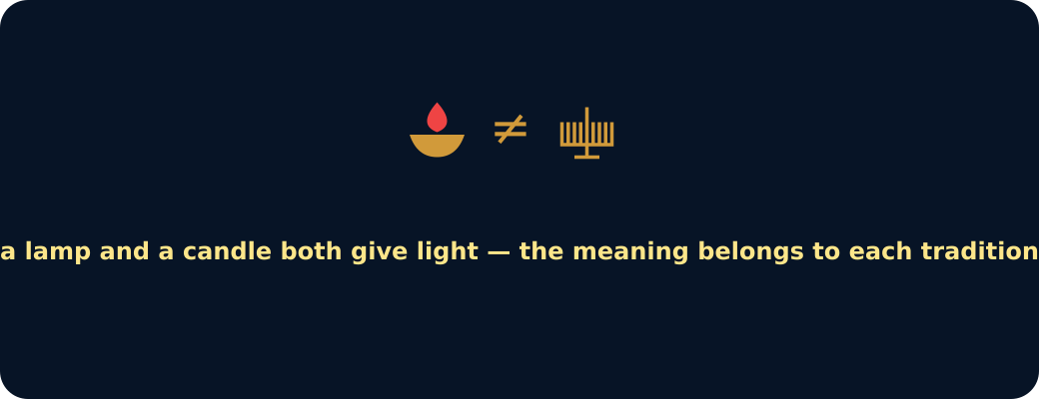
Similar symbol not same meaning
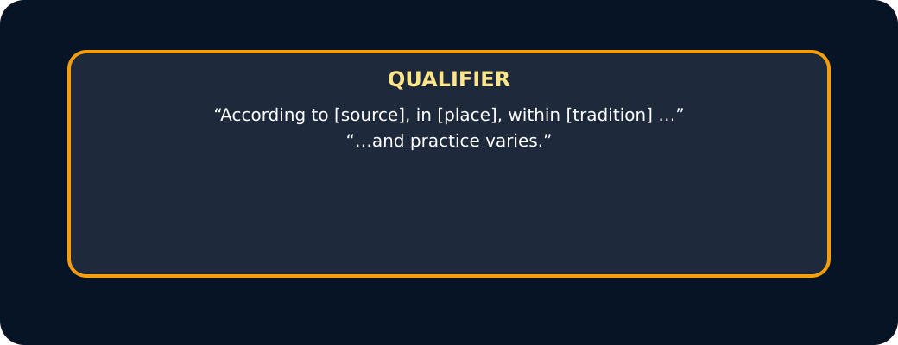
Qualifier

Exit · one next step
After the adult has listened, what will you keep, improve or check next?

