Pinpoint the Place
  - GROW · Humanities · 40 minutes
I can use an atlas index and grid references to locate and describe a place, then state one representation limit.
Name: __________________________ Date: ______________
You may write, type, say, sign, point or direct a partner. An adult can read the words and record your exact response. Keep the choice and explanation your own.

We do · make a choice and give a reason
A bridge lies in the square east of line 31 and north of line 44. Which four-figure reference identifies the square?
- 3144
- 4431
- 3245
My choice and the evidence I used:

Resources and independent record

GROW Humanities · Week 9
40 minutes Autumn 2 · Week 2 · GROW Weekly – Autumn B54:C54 Name: ____________________ Date: __________
Enquiry
How can a grid reference make a location precise without pretending a map shows everything?
Independent mission
Use the printed River Tees rehearsal grid and one teacher-approved atlas/map. Record locations with grid evidence, write a relative-location sentence, then identify one limitation of the representation.
Supported route
Find two symbols; record two four-figure references; complete ‘___ is ___ of ___. The map cannot show ___.’
Prompt frame: Along first: ____. Up second: ____. Grid reference: ____. It is ____ of ____. The map cannot show ____.
Standard route
Use index/key plus three four-figure references; describe a route or relative location; explain one map limitation.
Method: Index/key → easting → northing → direction/distance → representation limit.
Stretch route
Use the symbol’s position within its square to explain what a six-figure reference would add; do not invent one from this schematic. Then judge whether extra precision changes the conclusion.
Method: Four figures locate a square. Six figures would narrow the point by ____. More precise location does / does not strengthen the wider claim because ____.

Pupil evidence sheet
Use an atlas and grid references to describe location.
Bridge
▣ Market
Library
31
32
33
34
35
36
41
42
43
44
45
46
Constructed practice grid: original educational schematic, not an OS/navigation map; use only for this task.
1 · Grid evidence
Record the four-figure reference for Bridge, Market and Library.

2 · Describe location
Use north/south/east/west, beside/across and distance/scale.
3 · Representation limit
A grid/map helps by ____. It cannot show/explain ____.

Evidence, prompt and response record

Paper route · discuss the lesson choices
Use these choices with the matching teaching stage. Point to or number a choice, explain it, then revisit it after feedback. The original HTML keeps the live controls.
- 31
- 32
- 33
- 34
- 35
- 36
- 41
- 42
- 43
- 44
- 45
- 46
- What can this reference NOT show?
- Locate bridge
- Locate market
- Locate library
Choice / card | My reason or evidence | My revision after feedback

Visual evidence from the lesson
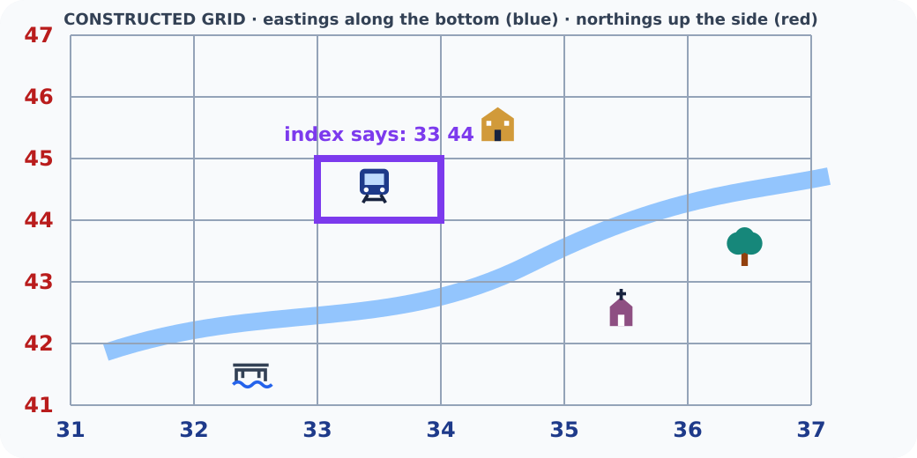
Grid map with the target square highlighted
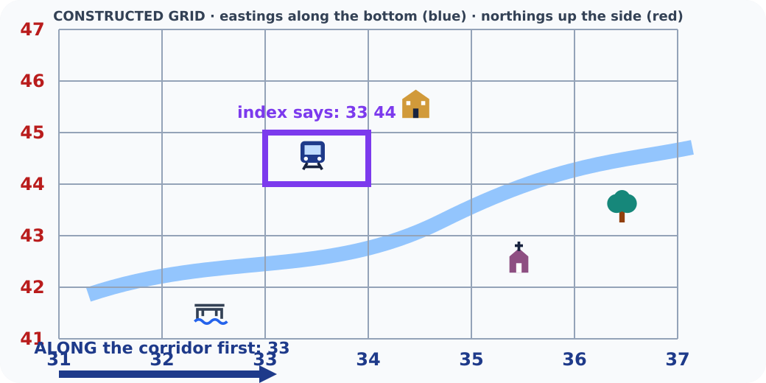
Arrow along the bottom to easting 33
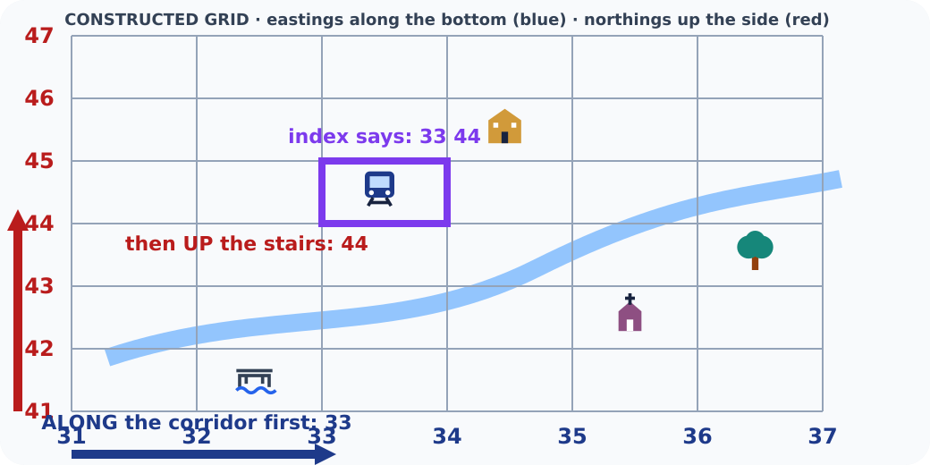
Arrow up the side to northing 44
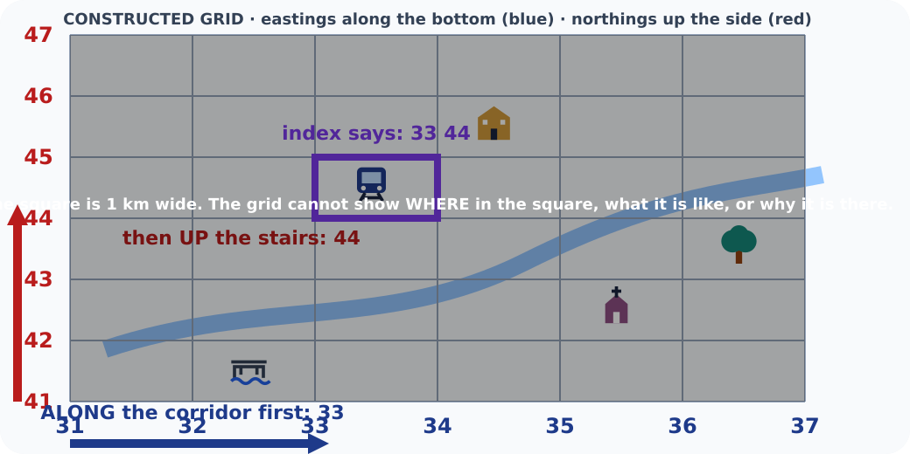
Grid map dimmed with a note on its limits
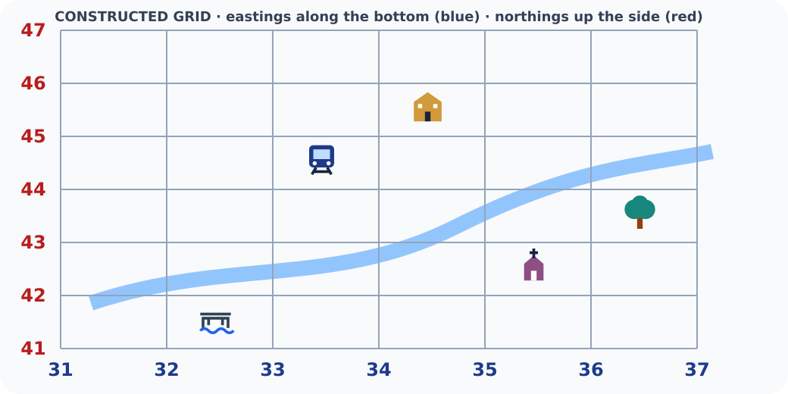
Tappable six by six grid map with symbols

Exit · one next step
After the adult has listened, what will you keep, improve or check next?

