Settlement & Urbanisation · Why Here?
  - LAUNCH · Humanities · 40 minutes
I can explain settlement growth through a connected causal chain, weigh a counter-factor and reach a qualified judgement.
Name: __________________________ Date: ______________
You may write, type, say, sign, point or direct a partner. An adult can read the words and record your exact response. Keep the choice and explanation your own.

We do · make a choice and give a reason
Commit before reveal: Which evidence most directly demonstrates urbanisation?
- One town’s population rises.
- New homes are built beside a road.
- The fictional region’s urban population share rises from 54% to 67%.
My choice and the evidence I used:

Resources and independent record
LAUNCH Humanities · Week 10 of 14 40 minutes · Aut2·W3 · Explain settlement & urbanisation

Enquiry: Why do settlements grow, and who experiences the effects differently?
Learning objective: I can explain settlement growth through a connected causal chain, weigh a counter-factor and reach a qualified judgement.
Vocabulary: settlement · urbanisation · land use · accessibility · driver · stakeholder · brownfield · sustainability
CONSTRUCTED CLASSROOM RESOURCE: This fictional composite is inspired by the broad Teesside setting. It is not official data, is not to scale and must not be used for navigation, safety or real-world planning.

Week 10 evidence pack · Teesbridge Change Series
Year | Population | Built land | Urban share of fictional region | Manufacturing jobs
1950 | 18,000 | 6 km² | 54% | 46%
1980 | 31,000 | 11 km² | 67% | 38%
2000 | 39,000 | 16 km² | 73% | 20%
2025 | 47,000 | 21 km² | 79% | 12%

Table continued · same row labels
Year | Service jobs
1950 | 22%
1980 | 35%
2000 | 52%
2025 | 68%

Causal-chain cards
A new crossing reduces journey time.
Firms value access to labour and markets.
Jobs and services attract some households.
Housing and built land expand near accessible sites.
Some residents gain access; others face cost or displacement pressure.
Open-land and travel impacts create a planning trade-off.
Planning choices: brownfield homes · edge expansion · bus investment · riverside green space. There is no perfect score: identify who gains, who bears a cost and what evidence is missing.
Evidence boundary: Teacher-approved/licensed sources retain title, author/producer, date, origin, scale and rights/use. No personal/family location or migration disclosure is required.

Independent evidence · Week 10

Supported
Arrange the causal cards, add one time-series figure and explain one chain with because → therefore → however.
Available support: Supported access: causal-chain tiles and stakeholder icons; learner supplies the link.

Standard
Use two quantified changes in a connected causal chain, then weigh a counter-factor or stakeholder trade-off.
Available support: Standard scaffold: driver → process → evidence → impact → however.

Stretch
Make a planning decision using two time-series figures, defend it from two stakeholder viewpoints and weigh a counter-policy.
Available support: Stretch scaffold: ranked factor → counter-factor/counterfactual → qualified verdict.

Response

Evidence → judgement → limitation
My decision / product:
Evidence I used:
Counter-evidence, anomaly or limitation:
Response route: written/typed verbal/recorded annotated/map scribed exact words
Exit: Complete: Urbanisation is more than population growth because… Then state the strongest evidence limit.

Paper route · discuss the lesson choices
Use these choices with the matching teaching stage. Point to or number a choice, explain it, then revisit it after feedback. The original HTML keeps the live controls.
- Ironworks open; workers arrive from Wales, Ireland, Scotland and the countryside
- 1830: the railway is extended to a new coal port on the Tees
- 1901: population passes 90,000
- 1850: ironstone is found in the Eston Hills, close to the port
- Stockton had the river first — so the river alone cannot explain it
- The coal port was slow at first — so the railway alone cannot explain it
- The town needed people to choose to move — so growth also depended on migrants
- Judgement: the railway caused the town
- Judgement: ironstone was decisive, but only because the railway and port already existed
- Brownfield homes
- ↗ Edge expansion
- Bus investment
- Riverside green
- ↺ Reset
Choice / card | My reason or evidence | My revision after feedback

Visual evidence from the lesson
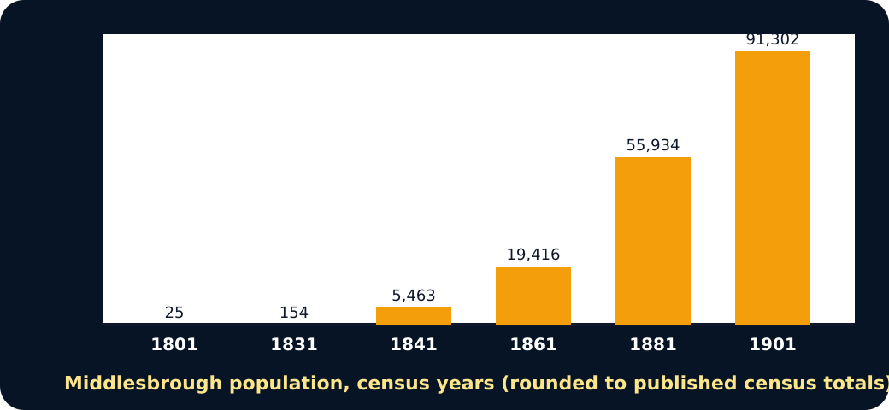
Bar chart of Middlesbrough population growth 1801 to 1901

Causal chain: railway then ironstone
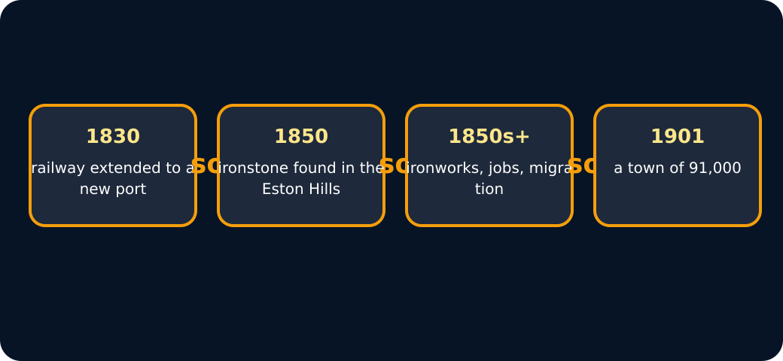
Full causal chain to 1901
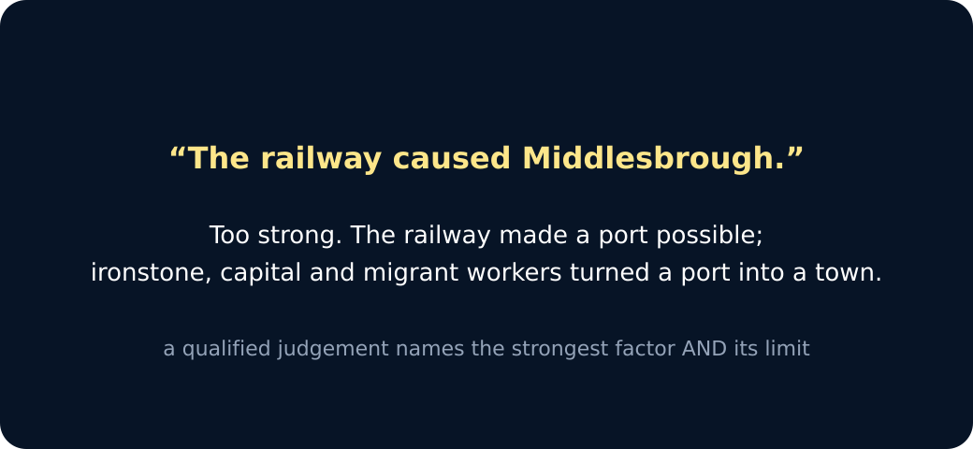
A qualified judgement

Exit · one next step
After the adult has listened, what will you keep, improve or check next?

