Local Fieldwork · Test the Claim
  - LAUNCH · Humanities · 40 minutes
I can design and use a repeatable sampling method, identify bias and apply ethical and safety controls.
Name: __________________________ Date: ______________
You may write, type, say, sign, point or direct a partner. An adult can read the words and record your exact response. Keep the choice and explanation your own.

We do · make a choice and give a reason
Commit before reveal: Recording data every 120 m along the same transect is which sampling method?
- Systematic sampling
- Random sampling
- Opportunity sampling
My choice and the evidence I used:

Resources and independent record
LAUNCH Humanities · Week 11 of 14 40 minutes · Aut2·W4 · Local-area fieldwork: collect data

Enquiry: How can we collect safe, fair and repeatable local fieldwork evidence?
Learning objective: I can design and use a repeatable sampling method, identify bias and apply ethical and safety controls.
Vocabulary: enquiry · variable · sampling · systematic · random · stratified · bias · reliability · validity · ethics
CONSTRUCTED CLASSROOM RESOURCE: This fictional composite is inspired by the broad Teesside setting. It is not official data, is not to scale and must not be used for navigation, safety or real-world planning.

Week 11 evidence pack · Virtual Transect
Default enquiry: How do environmental quality and pedestrian activity vary with distance from the fictional Transit Gate?
Method decision | Prepared choices | Fair-test control
Variable | Three 3-minute pedestrian counts; EQS using fixed descriptors | Same definition at every site
Sample | Six sites at 120 m intervals | Systematic rule, not convenience
Duration/repeats | Three equal 3-minute observation periods | Same duration and repeat count
Record | Site, distance, time, raw count, EQS, deviation | Missing stays labelled; never invent data

EQS fixed descriptors · total −8 to +8
Indicator | −2 | −1 | 0 | +1
Litter | heavy / widespread | some in several places | mixed / unclear | little / isolated
Traffic pressure | continuous / very high | frequent / high | intermittent / mixed | occasional / low
Vegetation cover | none | sparse | limited / mixed | moderate
External upkeep | poor / widespread disrepair | several visible issues | mixed | maintained / good

Table continued · same row labels
Indicator | +2
Litter | none visible
Traffic pressure | none / very low
Vegetation cover | abundant
External upkeep | very high

Additional plotted indices: Green /5 runs from 1 = very little visible vegetation to 5 = abundant visible vegetation. Noise /5 runs from 1 = very quiet/low audible traffic to 5 = very loud/continuous audible traffic.
Site | Distance | Count 1 | Count 2 | Count 3
Transit Gate | 0 m | 58 | 63 | 61
Market Link | 120 m | 49 | 46 | 50
Civic Crossing | 240 m | 38 | 42 | 40
Riverside Walk | 360 m | 26 | 29 | 27
Park Edge | 480 m | 18 | 17 | 19
Housing Green | 600 m | 13 | 12 | 11

Table continued · same row labels
Site | Mean | EQS (−8 to +8) | Green /5 | Noise /5
Transit Gate | 60.7 | -5 | 1 | 5
Market Link | 48.3 | -3 | 1 | 4
Civic Crossing | 40.0 | 0 | 2 | 3
Riverside Walk | 27.3 | 4 | 4 | 2
Park Edge | 18.0 | 6 | 5 | 1
Housing Green | 12.0 | 5 | 4 | 2

Safety and ethics gate
Centre-approved on-site route or equal desk-based route Supervision and local risk assessment No names, faces, plates, interviews or personal routes No road, rail, river-edge, industrial or private-property access
Evidence boundary: Teacher-approved/licensed sources retain title, author/producer, date, origin, scale and rights/use. No personal/family location or migration disclosure is required.

Independent evidence · Week 11

Supported
Complete the method builder, then collect or legitimately use at least four labelled observations and retain one safety, ethics or bias control.
Available support: Supported access: method headings, fixed descriptors and desk-based virtual transect.

Standard
Write a replicable method, collect or legitimately use at least four labelled observations and evaluate two bias/safety controls.
Available support: Standard scaffold: question → variables → sample → repeat → record → evaluate.

Stretch
Apply the justified sampling method to at least four labelled observations, retain one safety/ethics control, then evaluate reliability and validity separately.
Available support: Stretch scaffold: compare sampling methods and expose bias, reliability and validity limits.

Response

Evidence → judgement → limitation
My decision / product:
Evidence I used:
Counter-evidence, anomaly or limitation:
Response route: written/typed verbal/recorded annotated/map scribed exact words
Exit: State the sampling method, one control that made it fair and one remaining limitation.

Paper route · discuss the lesson choices
Use these choices with the matching teaching stage. Point to or number a choice, explain it, then revisit it after feedback. The original HTML keeps the live controls.
- systematic
- random
- convenience
- Two people score each site independently
- Sample at the same time of day
- Only sample where it is easy to stand
- ↺ Clear sample
Choice / card | My reason or evidence | My revision after feedback

Visual evidence from the lesson
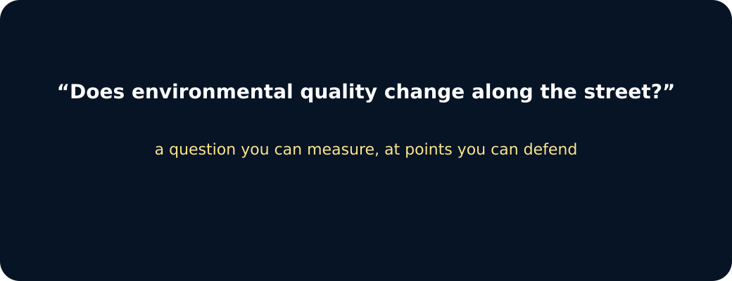
Question

Systematic transect

Convenience sampling
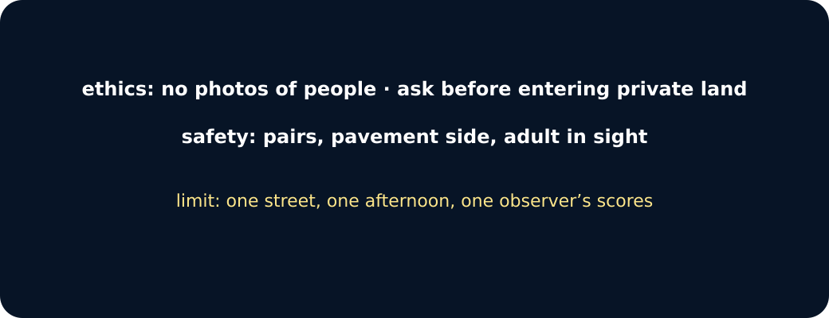
Ethics, safety, limit

Sampling points along a street

Exit · one next step
After the adult has listened, what will you keep, improve or check next?

