Fieldwork Data Lab · Pattern & Anomaly
  - LAUNCH · Humanities · 40 minutes
I can check and present fieldwork data in a suitable graph, then interpret pattern, anomaly and reliability.
Name: __________________________ Date: ______________
You may write, type, say, sign, point or direct a partner. An adult can read the words and record your exact response. Keep the choice and explanation your own.

We do · make a choice and give a reason
Commit before reveal: Which graph best tests the relationship between distance and environmental-quality score?
- Pie chart
- Scatter graph
- Pictogram
My choice and the evidence I used:

Resources and independent record
LAUNCH Humanities · Week 12 of 14 40 minutes · Aut2·W5 · Record fieldwork in a spreadsheet; graph it

Enquiry: Which representation makes the fieldwork pattern clearest without distorting it?
Learning objective: I can check and present fieldwork data in a suitable graph, then interpret pattern, anomaly and reliability.
Vocabulary: cell · formula · mean · axis · unit · scale · scatter graph · correlation · anomaly
CONSTRUCTED CLASSROOM RESOURCE: This fictional composite is inspired by the broad Teesside setting. It is not official data, is not to scale and must not be used for navigation, safety or real-world planning.

Week 12 evidence pack · Raw data to graph
Site | Distance | Count 1 | Count 2 | Count 3
Transit Gate | 0 m | 58 | 63 | 61
Market Link | 120 m | 49 | 46 | 50
Civic Crossing | 240 m | 38 | 42 | 40
Riverside Walk | 360 m | 26 | 29 | 27
Park Edge | 480 m | 18 | 17 | 19
Housing Green | 600 m | 13 | 12 | 11

Table continued · same row labels
Site | Mean | EQS (−8 to +8) | Green /5 | Noise /5
Transit Gate | 60.7 | -5 | 1 | 5
Market Link | 48.3 | -3 | 1 | 4
Civic Crossing | 40.0 | 0 | 2 | 3
Riverside Walk | 27.3 | 4 | 4 | 2
Park Edge | 18.0 | 6 | 5 | 1
Housing Green | 12.0 | 5 | 4 | 2

Formula cue: mean = sum of the three equal counts ÷ 3. Spreadsheet equivalent: =AVERAGE(C2:E2) .
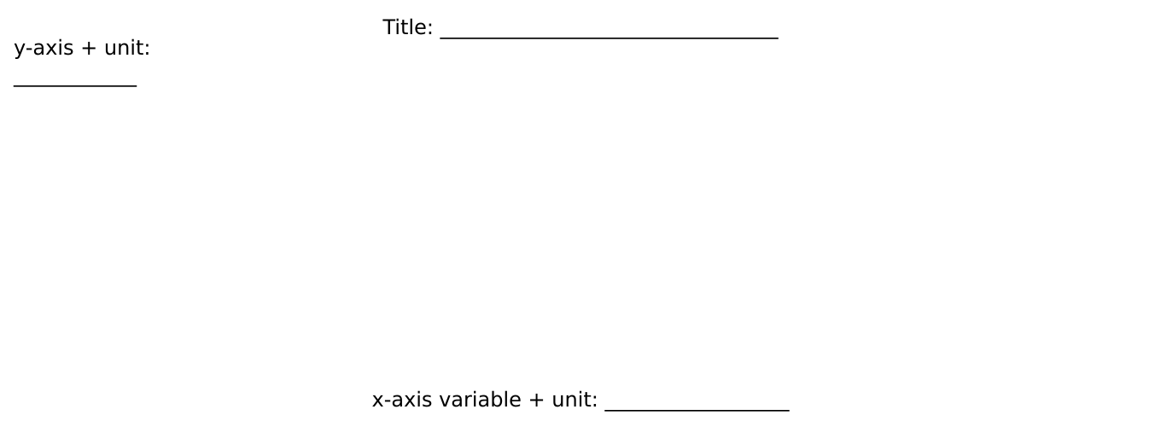
Blank graph frame with title and axis prompts
Preserve the raw table Check units and blanks Choose graph for the question Title, axes, units, equal scale Quote two values Retain anomaly and limitation
Graph-choice prompt: categories → bar; ordered change → line; relationship between two numerical variables → scatter. Association does not prove cause.
Evidence boundary: Teacher-approved/licensed sources retain title, author/producer, date, origin, scale and rights/use. No personal/family location or migration disclosure is required.

Independent evidence · Week 12

Supported
Use the raw repeat counts to check three means, complete graph title/axis/unit prompts, then state a pattern, anomaly and reliability limit.
Available support: Supported access: prepared table, formula cue and labelled axis frame; interpretation remains learner-owned.

Standard
Create a suitable graph and write two quantified pattern statements, one anomaly and one reliability or causation limit.
Available support: Standard scaffold: clean → calculate → choose → label → check → interpret.

Stretch
Compare two graph choices, evaluate reliability and explain why the evidence cannot establish cause.
Available support: Stretch scaffold: test alternative graph, anomaly and correlation/causation limit.

Response

Evidence → judgement → limitation
My decision / product:
Evidence I used:
Counter-evidence, anomaly or limitation:
Response route: written/typed verbal/recorded annotated/map scribed exact words
Exit: Give one quantified pattern, one anomaly and one reason the graph cannot prove cause.

Paper route · discuss the lesson choices
Use these choices with the matching teaching stage. Point to or number a choice, explain it, then revisit it after feedback. The original HTML keeps the live controls.
- bar chart
- pie chart
- line graph
- delete it
- keep it, flag it, explain or re-sample
- Footfall scatter
- EQS scatter
- Green scatter
- Noise scatter
Choice / card | My reason or evidence | My revision after feedback

Exit · one next step
After the adult has listened, what will you keep, improve or check next?

