Contrasting Places · Same Measure, Different Meaning
  - LAUNCH · Humanities · 40 minutes
I can compare two places using matched evidence and scale, explain similarities and differences, and qualify the comparison.
Name: __________________________ Date: ______________
You may write, type, say, sign, point or direct a partner. An adult can read the words and record your exact response. Keep the choice and explanation your own.

We do · make a choice and give a reason
Commit before reveal: Which is the strongest geographical comparison?
- Riverside East has 48 scheduled departures compared with Dalehaven’s 8, using the same constructed 2025 measure.
- Dalehaven looks nicer.
- One place has more buses and the other has more land-based jobs.
My choice and the evidence I used:

Resources and independent record
LAUNCH Humanities · Week 13 of 14 40 minutes · Aut2·W6 · Compare a contrasting place (online resources)

Enquiry: How far are two contrasting places different—and what evidence might challenge that claim?
Learning objective: I can compare two places using matched evidence and scale, explain similarities and differences, and qualify the comparison.
Vocabulary: indicator · similarity · contrast · density · accessibility · context · representative · stereotype
CONSTRUCTED CLASSROOM RESOURCE: This fictional composite is inspired by the broad Teesside setting. It is not official data, is not to scale and must not be used for navigation, safety or real-world planning.

Week 13 evidence pack · real-source core / constructed equal fallback
Core where approved and accessible: use a teacher-curated real contrasting-place pack or approved online resources. Record publisher, date, access date, definition, boundary/scale and rights/use. The fictional profiles below are the executable offline/equal-access fallback.
Riverside East context: fictional dense urban-industrial riverside district with a port/logistics legacy, compact housing and several route crossings. Dalehaven context: fictional rural market-centre area serving a dispersed hinterland with a larger land boundary and fewer scheduled services. Context may help form hypotheses; it does not prove cause or quality.
Matched methods: density = residents per km² inside each fictional administrative boundary; land share = same classroom land-cover classification; services = the same ten-service basket reachable from the mapped centre within 15 minutes at 4.8 km/h; bus departures = weekday scheduled departures 07:00–19:00 from stops within 400 m of the centre; employment = working residents by the same broad categories.
Matched 2025 indicator | Riverside East | Dalehaven
Population density | 3,200/km² | 180/km²
Built land | 72% | 18%
Green/open land | 19% | 71%
Services within a 15-minute walk of centre | 9/10 | 6/10
Scheduled bus departures, 07:00–19:00 | 48 | 8
Production/logistics employment | 29% | 11%
Land-based employment | 2% | 18%
Service employment | 60% | 58%

Same indicator Same unit Same date Same method/definition Same or stated scale Missing evidence named
Neutral comparison frame: Both… whereas… This may relate to… However, the evidence does not show…
Evidence boundary: Teacher-approved/licensed sources retain title, author/producer, date, origin, scale and rights/use. No personal/family location or migration disclosure is required.

Independent evidence · Week 13

Supported
Using the centre-approved real-place pack or the constructed equal fallback, match four indicators and complete Both… whereas… because… however… frames.
Available support: Supported access: paired values appear together; learner selects evidence and supplies comparison.

Standard
Using the approved real-place pack or fallback, write a sustained comparison with three paired statistics, context and one limitation.
Available support: Standard scaffold: similarity → difference → evidence → explanation → however.

Stretch
Using the approved real-place pack or fallback, judge whether accessibility is the most important contrast with counter-evidence and a scale/method caveat.
Available support: Stretch scaffold: weigh importance, counter-example, representation and missing data.

Response

Evidence → judgement → limitation
My decision / product:
Evidence I used:
Counter-evidence, anomaly or limitation:
Response route: written/typed verbal/recorded annotated/map scribed exact words
Exit: State the strongest matched contrast, one similarity and one missing indicator that could change the judgement.

Paper route · discuss the lesson choices
Use these choices with the matching teaching stage. Point to or number a choice, explain it, then revisit it after feedback. The original HTML keeps the live controls.
- A: 2021 census population · B: 2021 census population
- A: 2021 census population · B: a 1991 estimate
- A: bus routes per hour (timetable) · B: bus routes per hour (timetable)
- A: whole town area · B: one street survey
- A: “feels busy” · B: footfall count
- A: shops per 1,000 people · B: shops per 1,000 people
- matched
- mismatched
- Density
- Green land
- Bus access
- Services
- Service jobs
Choice / card | My reason or evidence | My revision after feedback

Visual evidence from the lesson
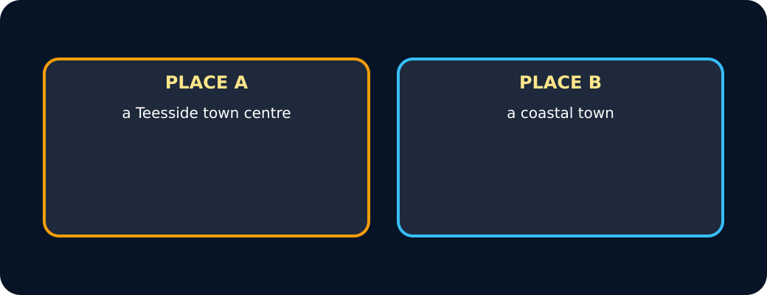
Two places
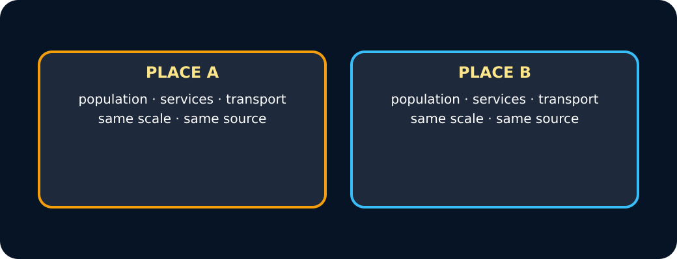
Matched evidence
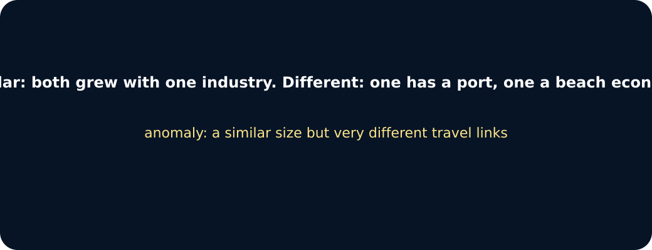
Pattern
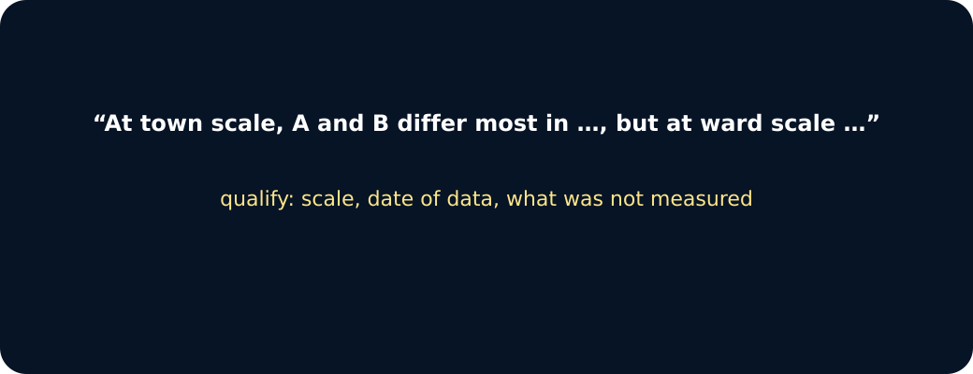
Judgement

Exit · one next step
After the adult has listened, what will you keep, improve or check next?

