Fieldwork Enquiry Verdict
  - LAUNCH · Humanities · 40 minutes
I can independently construct and evaluate a fieldwork enquiry using question, method, data, analysis, conclusion and limitations.
Name: __________________________ Date: ______________
You may write, type, say, sign, point or direct a partner. An adult can read the words and record your exact response. Keep the choice and explanation your own.

We do · make a choice and give a reason
Commit before reveal: A separate practice enquiry measured noise at only two sites, once. Which evaluation is strongest?
- The method is valid because both sites used the same score.
- It offers a snapshot, but few sites and one time weaken reliability and any wider claim.
- The result proves the same pattern exists across the whole region.
My choice and the evidence I used:

Resources and independent record
LAUNCH Humanities · Week 14 of 14 40 minutes · Aut2·W7 · Fieldwork enquiry write-up (December)

Enquiry: What does our evidence support about place—and what stops us claiming more?
Learning objective: I can independently construct and evaluate a fieldwork enquiry using question, method, data, analysis, conclusion and limitations.
Vocabulary: hypothesis · method · result · analysis · evidence · anomaly · correlation · conclusion · reliability · validity · evaluation · limitation · causation · improvement
CONSTRUCTED CLASSROOM RESOURCE: This fictional composite is inspired by the broad Teesside setting. It is not official data, is not to scale and must not be used for navigation, safety or real-world planning.

Week 14 frozen evidence pack · supplied classroom route
Enquiry: How do environmental quality and pedestrian activity vary with distance from the fictional Transit Gate?
Method record: Six sites at 120 m systematic intervals; three equal 3-minute pedestrian-count trials; litter, traffic pressure, vegetation cover and external upkeep each scored from −2 to +2; same recording fields at every site. Constructed observations represent one simulated period.
Indicator | −2 | −1 | 0 | +1
Litter | heavy / widespread | some in several places | mixed / unclear | little / isolated
Traffic pressure | continuous / very high | frequent / high | intermittent / mixed | occasional / low
Vegetation cover | none | sparse | limited / mixed | moderate
External upkeep | poor / widespread disrepair | several visible issues | mixed | maintained / good

Table continued · same row labels
Indicator | +2
Litter | none visible
Traffic pressure | none / very low
Vegetation cover | abundant
External upkeep | very high

Additional plotted indices: Green /5 runs from 1 = very little visible vegetation to 5 = abundant visible vegetation. Noise /5 runs from 1 = very quiet/low audible traffic to 5 = very loud/continuous audible traffic.
Definitions: reliability = consistency/repeatability of results; validity = how well the method and evidence answer the enquiry. A result can be repeatable without measuring the intended idea well.
Site | Distance | Count 1 | Count 2 | Count 3
Transit Gate | 0 m | 58 | 63 | 61
Market Link | 120 m | 49 | 46 | 50
Civic Crossing | 240 m | 38 | 42 | 40
Riverside Walk | 360 m | 26 | 29 | 27
Park Edge | 480 m | 18 | 17 | 19
Housing Green | 600 m | 13 | 12 | 11

Table continued · same row labels
Site | Mean | EQS (−8 to +8) | Green /5 | Noise /5
Transit Gate | 60.7 | -5 | 1 | 5
Market Link | 48.3 | -3 | 1 | 4
Civic Crossing | 40.0 | 0 | 2 | 3
Riverside Walk | 27.3 | 4 | 4 | 2
Park Edge | 18.0 | 6 | 5 | 1
Housing Green | 12.0 | 5 | 4 | 2

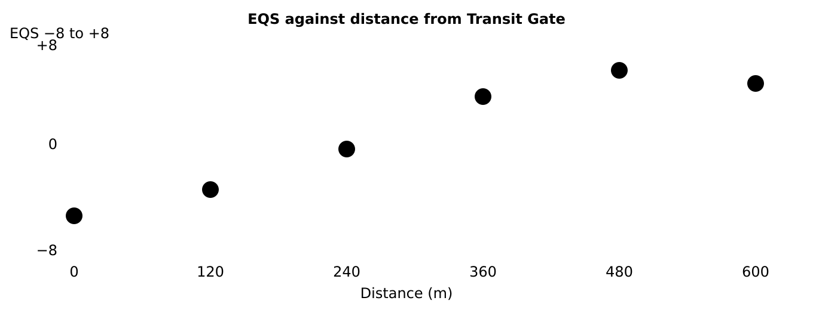
Constructed scatter graph of environmental quality score against distance; six points from minus five at zero metres to five at 600 metres

Selected W13 context · not direct transect evidence
Matched W13 methods: density = residents per km² inside each fictional administrative boundary; bus departures = weekday scheduled departures 07:00–19:00 from stops within 400 m of each centre; service employment = working residents using the same broad category.
Matched 2025 indicator | Riverside East | Dalehaven
Population density | 3,200/km² | 180/km²
Scheduled bus departures, 07:00–19:00 | 48 | 8
Service employment | 60% | 58%

Frozen boundary: use only this pack or the centre-approved equivalent agreed before start. During protected work, no new evidence, model answer or content prompt is introduced.
Evidence boundary: Teacher-approved/licensed sources retain title, author/producer, date, origin, scale and rights/use. No personal/family location or migration disclosure is required.

Independent evidence · Week 14

Supported
Use only the pre-agreed access route: approved section headings, reading support or exact-word transcription; the judgement stays learner-owned.
Available support: Supported access contract: headings/format/reader/scribe agreed before start; no sentence completion or evidence selection.

Standard
Produce the protected enquiry response using the frozen evidence pack and the approved response mode.
Available support: Standard access contract: independent written, typed or recorded response using frozen materials.

Stretch
Sustain a qualified judgement with counter-evidence, reliability/validity distinction and a justified next method.
Available support: Extended demand: synthesis across data, method and comparison; access remains but content prompting does not.

Response

Evidence → judgement → limitation
My decision / product:
Evidence I used:
Counter-evidence, anomaly or limitation:
Response route: written/typed verbal/recorded annotated/map scribed exact words
Protected-status check: no content prompt used access/process support only. If a content prompt occurs, stop: do not treat the outcome as protected and follow centre rules for a fresh opportunity.
Exit: After collection only: record the response route and whether any content prompt occurred. If it did, mark the outcome unprotected and follow centre rules for a fresh opportunity.

Paper route · discuss the lesson choices
Use these choices with the matching teaching stage. Point to or number a choice, explain it, then revisit it after feedback. The original HTML keeps the live controls.
- 1 · Question What exactly is being tested?
- 2 · Method Could another geographer repeat it?
- 3 · Results Which graph/data answer the question?
- 4 · Analysis Pattern, figures and anomaly?
- 5 · Conclusion How strongly is the claim supported?
- 6 · Evaluation Reliability, validity and improvement?
Choice / card | My reason or evidence | My revision after feedback

Exit · one next step
After the adult has listened, what will you keep, improve or check next?

