GIS Layers · Reading Place
  - LAUNCH · Humanities · 40 minutes
I can select and combine GIS layers at two scales to produce and qualify an evidence-based place description.
Name: __________________________ Date: ______________
You may write, type, say, sign, point or direct a partner. An adult can read the words and record your exact response. Keep the choice and explanation your own.

We do · make a choice and give a reason
Commit before reveal: Which sentence best describes the situation of a place?
- The site occupies mostly flat land.
- It lies east of the centre and is linked to it by a bridge and rail corridor.
- Retail is the dominant land use.
My choice and the evidence I used:

Resources and independent record
LAUNCH Humanities · Week 9 of 14 40 minutes · Aut2·W2 · Use digital mapping/GIS to describe a place

Enquiry: What can GIS reveal about a place—and what does it hide?
Learning objective: I can select and combine GIS layers at two scales to produce and qualify an evidence-based place description.
Vocabulary: GIS · layer · site · situation · scale · proximity · connectivity · distribution
CONSTRUCTED CLASSROOM RESOURCE: This fictional composite is inspired by the broad Teesside setting. It is not official data, is not to scale and must not be used for navigation, safety or real-world planning.

Week 9 evidence pack · Teesbridge Quarter
Scale 1 metadata: ↑ N · fictional 2025 classroom snapshot · coordinates A1–E5 · each cell is one comparative unit, not a real distance or navigational scale.
A1 River | B1 River | C1 River | D1 River + industry | E1 River + industry
A2 Base land | B2 Base land | C2 Base land | D2 Bridge + industry | E2 Industry
A3 Rail | B3 Rail | C3 Centre + station | D3 Rail | E3 Rail
A4 Housing | B4 Housing + clinic | C4 College + road | D4 Green | E4 Green
A5 Housing | B5 Housing | C5 Road | D5 Green | E5 Green

Layer | Mapped evidence in the fictional 5×5 model | Evidence limit
Base | River along the north edge; bridge at D2; centre/station at C3. | No real-world distance scale.
Transport | Rail corridor runs west–east through C3; a north–south road meets it. | Frequency, cost and journey time are absent.
Land use | Industry clusters north-east; housing south-west; green space south-east. | Dominant use hides mixed use and quality.
Services | Clinic at B4 and college at C4, close to housing and the centre. | Capacity, opening times and accessibility are absent.
Environment | Mapped green space clusters south-east. | Presence does not show public access or condition.

Scale 2 · wider fictional corridor overview
Teesbridge Quarter sits on the middle river corridor, 4 classroom-km east of Hillford Interchange and 6 classroom-km west of Port Reach. The regional rail/road route follows the valley; a broad green belt lies south of the corridor. These are comparative classroom distances, not real measurements.

Six statement cards · sort by site / situation
The settlement occupies riverside land.
Housing clusters in the south-west of the mapped area.
Green/open land clusters in the south-east.
The centre is linked west–east by a rail corridor.
The industrial zone lies close to the bridge and river.
The clinic and college lie near housing and the centre.
Two-scale prompt: Which claim survives when the view changes from the Quarter grid to the wider corridor?
Evidence boundary: Teacher-approved/licensed sources retain title, author/producer, date, origin, scale and rights/use. No personal/family location or migration disclosure is required.

Independent evidence · Week 9

Supported
Sort six prepared statements into site or situation, complete a four-sentence description using two layers, then add one sentence from the wider corridor view.
Available support: Supported access: layer key, site/situation sorter and Locate → Layer → Link → Limit headings.

Standard
Write a place evidence brief with location, two patterns, a layer relationship, one limitation and one claim that survives, changes or becomes less certain at the wider scale.
Available support: Standard scaffold: claim → mapped detail → comparison → limitation.

Stretch
Judge which two layers are most useful for locating a fictional clinic; reject one layer and explain uncertainty.
Available support: Stretch scaffold: weigh layer usefulness across two scales and reject a plausible alternative.

Response

Evidence → judgement → limitation
My decision / product:
Evidence I used:
Counter-evidence, anomaly or limitation:
Response route: written/typed verbal/recorded annotated/map scribed exact words
Exit: Name the strongest layer for the enquiry, one pattern it reveals and one thing it cannot prove.

Paper route · discuss the lesson choices
Use these choices with the matching teaching stage. Point to or number a choice, explain it, then revisit it after feedback. The original HTML keeps the live controls.
- river + sea
- housing
- roads + rail
- industry / port
- flood risk
- zoom to one neighbourhood
- Claim A: people live near transport because it is convenient
- Claim B: the housing layer shows a cluster near transport; the reason needs other evidence
- Base / reset
- Transport
- Land use
- Services
- Environment
Choice / card | My reason or evidence | My revision after feedback

Visual evidence from the lesson
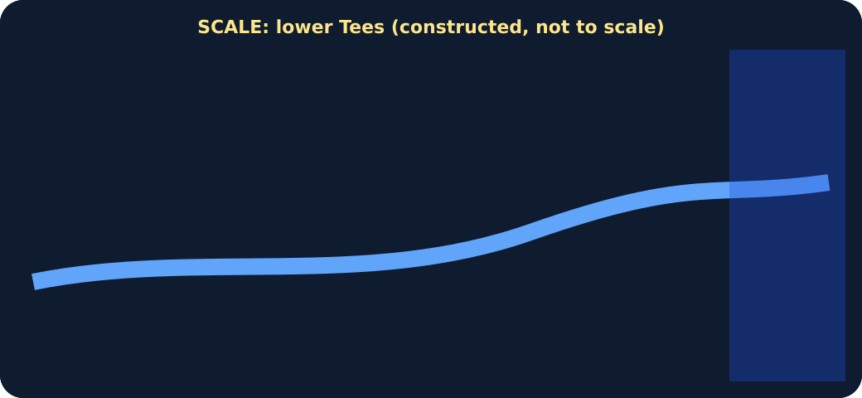
Base layer: river and sea only
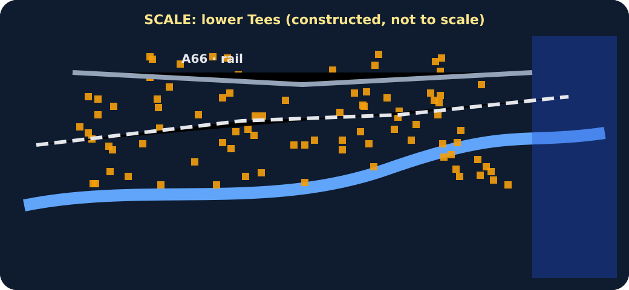
Housing and transport layers added
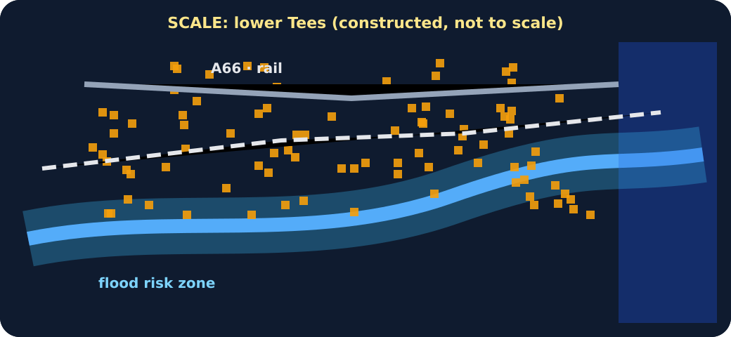
Flood-risk layer added
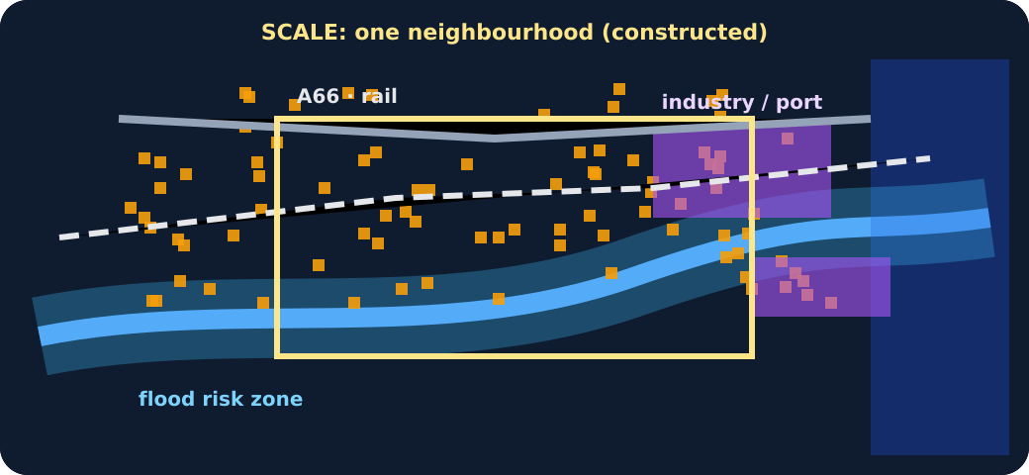
All layers with a zoom box

Layered schematic GIS map

Exit · one next step
After the adult has listened, what will you keep, improve or check next?

