Rock Hardness: Mark or Groove?
  - BUILD · Science · 40 minutes
I can explain relative hardness and identify a fair, safe scratch method for comparing rock samples.
Name: __________________________ Date: ______________
You may write, type, say, sign, point or direct a partner. An adult can read the words and record your exact response. Keep the choice and explanation your own.

Words for this lesson
Word | Meaning
hardness | resistance to a scratch
groove | a line cut into the surface
control | what we keep the same

First idea
A pale line appears after a secured blunt tool passes over a rock. What should happen before we call it a scratch groove?
A. Wipe the line and inspect whether an indentation remains.
B. Weigh the rock and call the heaviest one hardest.
C. Press harder until every rock shows a deep line.
My first idea and reason:

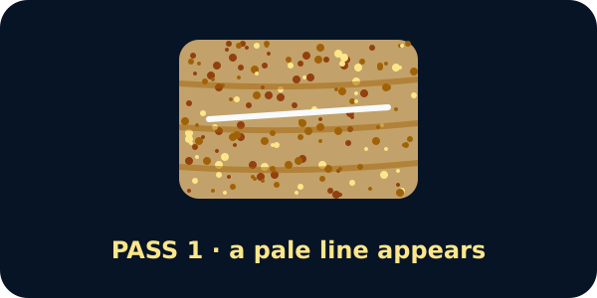
A rock with a pale line after one tool pass

We do · choose, explain, check
The pale line wipes away and no indentation remains. Which record is accurate?
A. No groove remained; this sample resisted the stated scratch method.
B. A deep groove formed, so the rock is soft.
C. The rock is unbreakable in every situation.
My choice: ______ Evidence or reason:

Mark, Wipe or Groove Evidence Gate
Place each method or observation under the role it performs in a valid hardness comparison.
Read or hear one card. Choose a group. Give the evidence. A partner checks your reason before you move on. Point or write card numbers; cutting is optional.
Group | Card numbers and evidence
VALID GROOVE EVIDENCE
VALID NO-GROOVE EVIDENCE
KEEP THIS THE SAME
DOES NOT MEASURE HARDNESS
STOP / USE PARITY ROUTE

Activity cards
1 · Deep indentation remains | 2 · Shallow indentation remains
After wiping, a clear groove remains in the dry surface. | The loose streak is gone, but a shallow groove can still be seen and felt by the teacher's inspection method.

3 · Line wipes away | 4 · Same tool, guide and passes
No indentation remains after the loose tool streak is removed. | Only the coded rock sample changes.

5 · The sample feels heavy | 6 · The edge flakes or dust appears
No scratch observation is made. | The sample becomes unstable during the attempted method.

Name what changed, three controls and the observation that decides groove or no groove.

Your lesson record
Plan and direct a safe two-sample relative hardness comparison, then record the method, groove observation and bounded conclusion.

Model helps us see
The mark–wipe–groove sequence makes the deciding observation visible and keeps loose tool streaks separate from damage to the sample.

Model does not show
This is a relative classroom comparison with one tool and method. It does not give a Mohs number, prove construction strength or represent every specimen of a named rock.

Supported
Choose groove/no-groove after-wipe cards for two samples and direct the adult through the same method.
Use pictures for tool, passes, wipe and groove. Complete: After wiping, __ remained.

Standard
Compare two coded samples with the same stated method and justify which resisted a groove more.
Use: We changed __. We kept __. Sample __ showed __, so under this method __.

Stretch
Evaluate the controls, distinguish hardness from strength and propose one safe repeat or method improvement.
Preserve the first result and explain why the improvement would make the comparison more dependable.

Evidence target
A Rock Hardness Method Card with prediction, changed sample, controls, after-wipe observation and a relative conclusion within the stated method.

Exit, Audience and evidence · W10A
Supported: Complete: hardness means resistance to __. After wiping I saw __.

Standard: Explain how the method distinguishes a tool streak from a groove and name two controls.
Stretch: Give a bounded relative-hardness conclusion and explain one thing the test cannot show.

What I said, and what it changed
________________________________________________

Next I will ______.

Adult witness note
What was observed, and with what level of independence?

My evidence and explanation

What does this evidence not show?

Visual reference cards
These are diagrams or model views from the uploaded lesson. Use their labels and the card descriptions; they are not photographs of your own results.
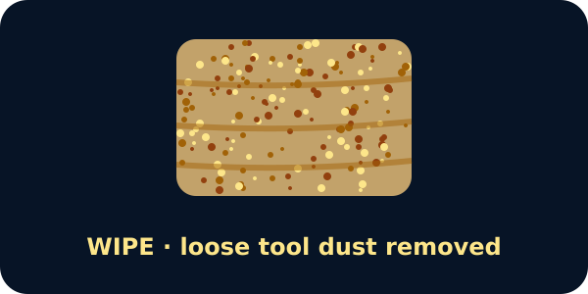
The same rock wiped clean
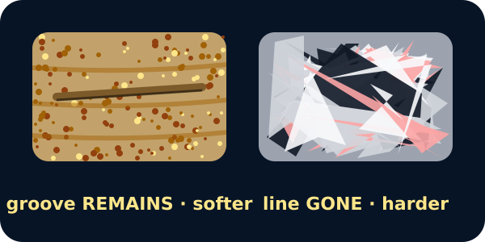
Two rocks after wiping: one keeps a groove, one does not
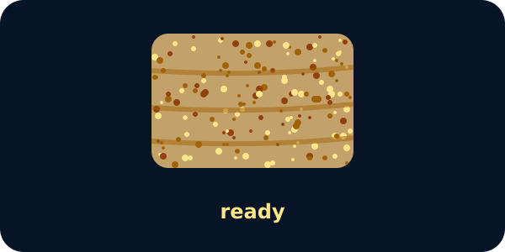
Scratch test on the chosen rock

Exit · one next step
After the adult has listened, what will you keep, improve or check next?

