Hardness Evidence Lab
  - BUILD · Science · 40 minutes
I can use the same stated scratch method to compare four coded rock samples and give a cautious evidence-based conclusion.
Name: __________________________ Date: ______________
You may write, type, say, sign, point or direct a partner. An adult can read the words and record your exact response. Keep the choice and explanation your own.

Words for this lesson
Word | Meaning
relative | compared with the others
repeat | same method again
conclusion | what the results support

First idea
Codes A–D give four different after-wipe results. Which recording rule protects the evidence?
A. Keep every valid result and note any safety stop or repeat.
B. Keep only the result that matches the prediction.
C. Press harder until all four grooves are equally deep.
My first idea and reason:

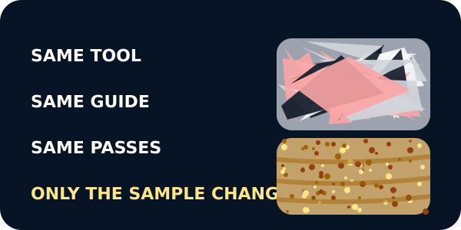
The locked method: same tool, guide and passes

We do · choose, explain, check
Code C gives a faint groove when you predicted no groove. The method was followed safely. What should you do?
A. Keep the faint-groove result and, if useful, repeat the same method.
B. Delete it because it does not match the prediction.
C. Press harder until the groove looks like the expected result.
My choice: ______ Evidence or reason:

Four-Code Hardness Evidence Matrix
Place each after-wipe result, method card and limitation in its correct evidence role.
Read or hear one card. Choose a group. Give the evidence. A partner checks your reason before you move on. Point or write card numbers; cutting is optional.
Group | Card numbers and evidence
DEEP GROOVE
SHALLOW GROOVE
FAINT GROOVE
NO GROOVE AFTER WIPE
METHOD / REPEAT RULE
LIMIT OF THE CONCLUSION

Activity cards
1 · Code A | 2 · Code B
A deep clear indentation remains after the loose streak is wiped. | A shallow groove remains; a few loose grains require the practical route to stop and be checked.

3 · Code C | 4 · Code D
A faint groove remains after wiping under the same representative method. | The light streak wipes away and no indentation remains.

5 · Keep first result, then repeat | 6 · These samples, this tool, this method
A valid unexpected result stays in the table before the same stated method is repeated. | Another specimen or tool could produce a different relative pattern.

State the relative pattern, quote two codes and name one result-handling rule and one limitation.

Your lesson record
Run or direct the same safe scratch method on four coded samples, record every after-wipe result, repeat one check where appropriate and write a cautious conclusion.

Model helps us see
The four-code table keeps raw observations, repeats and the conclusion together so an awkward result cannot disappear.

Model does not show
The fixed data represent particular teaching samples and one scratch method. They do not assign Mohs values, measure toughness or approve a rock for construction.

Supported
Match four after-wipe picture cards to Codes A–D and complete one two-code comparison.
Use deep, shallow, faint and none symbols. Adult handling and exact scribing are valid.

Standard
Complete all four rows, keep one repeat/check note and write a conclusion comparing at least two codes.
Use: Code __ showed __ while Code __ showed __, so under this method __.

Stretch
Evaluate the relative pattern, explain an unexpected result and propose one safe improvement without claiming a universal hardness value.
Separate sample variation, method variation and properties the test did not measure.

Evidence target
A complete four-code raw-results table, one preserved repeat/check note, a relative comparison using at least two codes and one method or sample limitation.

Exit, Audience and evidence · W10B
Supported: Point and complete: Code __ had the deepest groove; Code __ had no groove after wiping.

Standard: Use two code results to give a relative-hardness conclusion and state one limit.
Stretch: Explain why every valid result must remain and how a repeat could improve confidence without proving a universal value.

What I said, and what it changed
________________________________________________

Next I will ______.

Adult witness note
What was observed, and with what level of independence?

My evidence and explanation

What does this evidence not show?

Visual reference cards
These are diagrams or model views from the uploaded lesson. Use their labels and the card descriptions; they are not photographs of your own results.
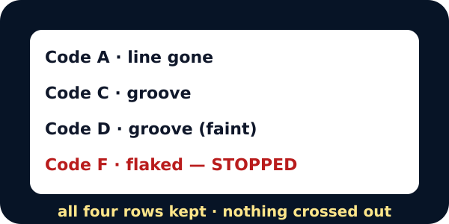
A results table with all four codes recorded
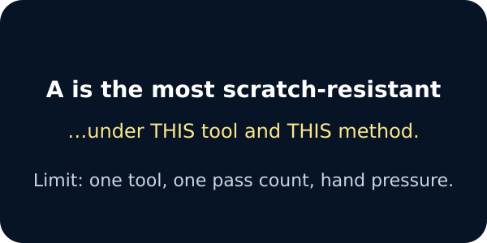
A cautious conclusion with its limit

Exit · one next step
After the adult has listened, what will you keep, improve or check next?

