Water Through Rock Lab
  - BUILD · Science · 40 minutes
I can follow or direct a fixed water-passage method, record what reaches the collector and make a careful comparison of supplied samples.
Name: __________________________ Date: ______________
You may write, type, say, sign, point or direct a partner. An adult can read the words and record your exact response. Keep the choice and explanation your own.

Words for this lesson
Word | Meaning
permeability | how water passes through
volume | amount of liquid
valid | the method worked as stated

First idea
Water appears in the tray, but the collar leaked around the sample edge. What should the lab team record?
A. Count all tray water as passed through the rock.
B. Mark the run invalid because water bypassed the sample; stop and use the repaired or fixed-data route.
C. Guess how much probably went through and keep the result.
My first idea and reason:

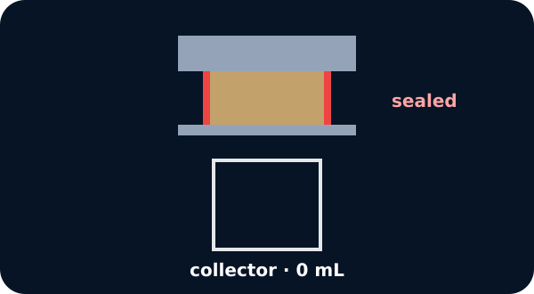
A sealed sample above a collector

We do · choose, explain, check
Sample A collects 0.5 mL and Sample B collects 3.0 mL after the same 5 mL and 120-second method. Which comparison is supported?
A. More water passed through supplied Sample B under this method.
B. Sample A is waterproof forever.
C. Every rock like B always passes exactly 3.0 mL.
My choice: ______ Evidence or reason:

Water-passage lab console
Route each lab record to VALID A, VALID B, METHOD FAULT or CAREFUL COMPARISON.
Read or hear one card. Choose a group. Give the evidence. A partner checks your reason before you move on. Point or write card numbers; cutting is optional.
Group | Card numbers and evidence
VALID · SAMPLE A
VALID · SAMPLE B
METHOD FAULT · DO NOT COMPARE
CAREFUL COMPARISON

Activity cards
1 · A · sealed run | 2 · A · surface note
5 mL added; 120 seconds; seal held; 0.5 mL collected below. | A small bead remained on top and the collector held 0.5 mL; no edge leak was seen.

3 · B · sealed run | 4 · B · underside note
5 mL added; 120 seconds; seal held; 3.0 mL collected below. | Drops formed under the prepared sample inside the sealed area and entered the collector.

5 · Loose collar | 6 · Timer missed
Water ran down the outside edge into the tray; the collector reading cannot be separated from the leak. | The team cannot say whether the run lasted 60, 120 or 180 seconds.

7 · Bounded result | 8 · Time caution
Under the fixed method, more water passed through supplied Sample B than supplied Sample A. | Little water in 120 seconds does not prove that a sample is waterproof for every time and use.

Use the frozen records to say what passed through, which run was valid and what the result does not prove.

Your lesson record
Follow or direct the fixed water-passage lab for supplied Samples A and B, or analyse the fixed equivalent records, then give a bounded comparison.

Model helps us see
Check in order: seal held → 5 mL added → 120 s timed → collector read in mL → claim names supplied samples and method.

Model does not show
The lab uses a short classroom test on prepared samples. Natural variation, tiny cracks, sample thickness and sealing can affect results; the test is not a full building-performance check.

Supported
Sequence the fixed method, place A and B result cards and complete an oral, pointed or scribed comparison.
Use: A collected __ mL. B collected __ mL. More water passed through __ in this test.

Standard
Record both valid results, reject one fault record and explain the sample comparison with a time limit.
Check seal, volume, time, collector and claim boundary in order.

Stretch
Evaluate how thickness, seal or natural variation could affect the comparison and propose one control to investigate in W13.
Do not rewrite the observed values; improve the future method.

Evidence target
Method checklist, surface/underside observation, collector values with mL, valid/fault decision, bounded comparison and one method-control question for W13.

Exit, Audience and evidence · W11B
Supported: Which supplied sample had more water reach the collector — A or B?

Standard: Give the comparison and explain why it does not mean waterproof forever.
Stretch: Name one method control that needs closer planning before a larger fair test.

What I said, and what it changed
________________________________________________

Next I will ______.

Adult witness note
What was observed, and with what level of independence?

My evidence and explanation

What does this evidence not show?

Visual reference cards
These are diagrams or model views from the uploaded lesson. Use their labels and the card descriptions; they are not photographs of your own results.
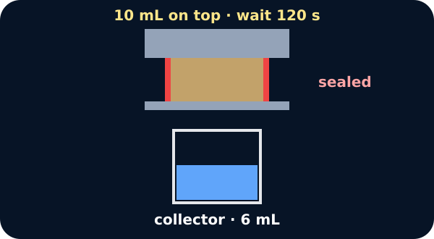
Water collecting below the sample
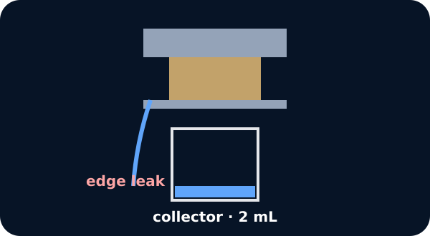
An edge leak spoiling a result
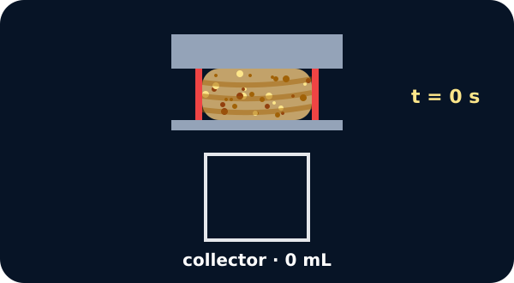
Sealed water bench with collector

Exit · one next step
After the adult has listened, what will you keep, improve or check next?

