Rock Jobs: Which Property Matters?
  - BUILD · Science · 40 minutes
I can identify which tested or observed rock property matters for a stated everyday job.
Name: __________________________ Date: ______________
You may write, type, say, sign, point or direct a partner. An adult can read the words and record your exact response. Keep the choice and explanation your own.

Words for this lesson
Word | Meaning
property | what the material is like
purpose | the job it must do
suitable | works for this job

First idea
A pupil says, ‘The least permeable sample must be best for every rock job.’ Which first idea would you test?
A. Agree. Every use needs the least water passage.
B. Ask what the job is; a rain barrier and a drainage layer need different water behaviour.
C. Ignore water and choose the brightest colour for every job.
My first idea and reason:

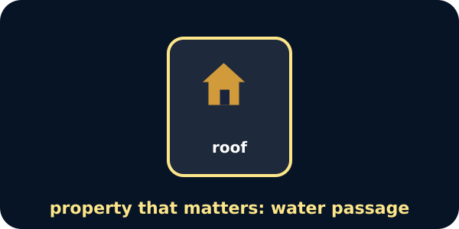
A roof job card

We do · choose, explain, check
Which property question is most relevant to a rain-facing roof-cover model?
A. Which sample is the darkest?
B. Which prepared sample lets less water through and can form overlapping flat pieces?
C. Which sample has the longest name?
My choice: ______ Evidence or reason:

Job-to-property question lab
Route each brief clue to WATER CONTROL, WEAR / SURFACE, SHAPE / APPEARANCE or NEEDS ANOTHER CHECK.
Read or hear one card. Choose a group. Give the evidence. A partner checks your reason before you move on. Point or write card numbers; cutting is optional.
Group | Card numbers and evidence
WATER CONTROL
WEAR / SURFACE
SHAPE / APPEARANCE
NEEDS ANOTHER CHECK

Activity cards
1 · Rain-cover clue | 2 · Drainage clue
The material must help limit water reaching the model space below. | Water should move away through spaces in a bed of suitable rock pieces instead of pooling at the top.

3 · Busy-path clue | 4 · Walking-surface clue
The surface faces repeated shoes and wheels in the fictional yard. | The brief needs a stable, even surface; a separate local safety check would assess grip and installation.

5 · Overlap clue | 6 · Display clue
The roof model needs thin pieces that can lie flat and overlap. | The brief is for a stable indoor display where pattern and finish are part of the stated purpose.

7 · Dark-colour claim | 8 · Hardest-is-best claim
The darkest rock must be strongest, hardest and least permeable. | The sample with the faintest scratch mark should be used for every job, even without water or shape evidence.

Say: The job needs __. The property question is __ because __. We still need to check __.

Your lesson record
Create property-question cards for four everyday rock jobs before any candidate sample is chosen.

Model helps us see
Use the chain JOB → PROPERTY QUESTION → EVIDENCE NEEDED. Do not choose a sample until all three boxes are clear.

Model does not show
The briefs simplify real design. Cost, thickness, treatment, strength, installation, safety and local standards also matter; classroom evidence cannot approve real construction.

Supported
Match one key property picture to three clear jobs and complete one because sentence.
Use: For a __, we need to know __ because __.

Standard
Complete all four briefs, naming the relevant property evidence and one missing check for each.
Keep separate columns for job, property question and evidence needed.

Stretch
Explain a two-property trade-off and why opposite permeability behaviour can suit different water jobs.
Include one real-design factor the classroom brief does not model.

Evidence target
Four job-property questions, two because explanations, one needs-another-check decision and one model limit.

Exit, Audience and evidence · W12A
Supported: Complete or point: For a __, the property that matters is __.

Standard: Explain which property matters for one job and why another property does not answer it.
Stretch: Compare a rain-barrier and drainage purpose, explaining why useful permeability can point in opposite directions.

What I said, and what it changed
________________________________________________

Next I will ______.

Adult witness note
What was observed, and with what level of independence?

My evidence and explanation

What does this evidence not show?

Visual reference cards
These are diagrams or model views from the uploaded lesson. Use their labels and the card descriptions; they are not photographs of your own results.
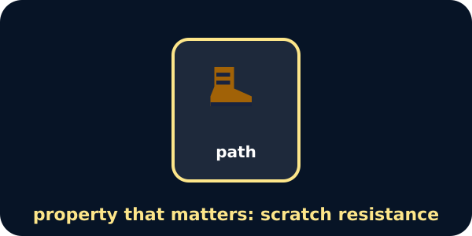
A path job card
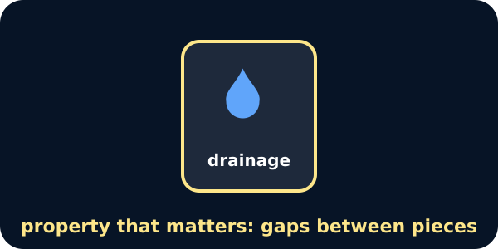
A drainage job card

Exit · one next step
After the adult has listened, what will you keep, improve or check next?

