Choose Rock for the Job
  - BUILD · Science · 40 minutes
I can choose a supplied rock sample for a stated model job and justify the decision with relevant property evidence and a limit.
Name: __________________________ Date: ______________
You may write, type, say, sign, point or direct a partner. An adult can read the words and record your exact response. Keep the choice and explanation your own.

Words for this lesson
Word | Meaning
criteria | the job rules
candidate | one possible choice
justify | give evidence for why

First idea
For a rain-cover model, Sample R lets 0.5 mL through and forms flat pieces. Sample P lets 1.0 mL through but has the faintest scratch mark. Which is the stronger first choice for this brief?
A. Sample R, because its lower water passage and flat overlapping shape answer this brief.
B. Sample P, because scratch resistance must decide every job.
C. Choose whichever colour the group likes most.
My first idea and reason:

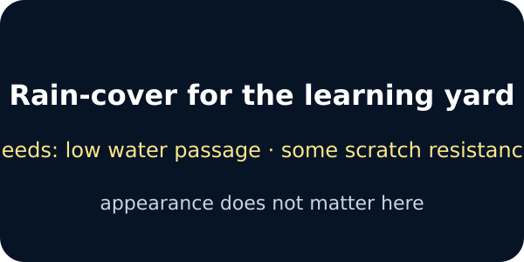
The job brief

We do · choose, explain, check
For a hard-wearing path model, which decision uses the most relevant supplied evidence?
A. Choose P because it had a faint scratch mark and the surface card shows a stable, even path piece; keep grip as a separate safety check.
B. Choose D because its pattern is the most colourful.
C. Choose R because it let the least water through, even though the brief is about wear and walking surface.
My choice: ______ Evidence or reason:

Rock-choice evidence matrix
Route each candidate evidence card to RAIN COVER, PATH, INDOOR DISPLAY or NEEDS ANOTHER CHECK.
Read or hear one card. Choose a group. Give the evidence. A partner checks your reason before you move on. Point or write card numbers; cutting is optional.
Group | Card numbers and evidence
RAIN-COVER MODEL
HARD-WEARING PATH MODEL
INDOOR DISPLAY
NEEDS ANOTHER CHECK

Activity cards
1 · Candidate R | 2 · R caution
0.5 mL through in the fixed water test; source card says it can form flat overlapping pieces; moderate scratch mark. | The 120-second result does not prove permanent waterproofing or real roof approval.

3 · Candidate P | 4 · P safety gap
Faintest mark in the fixed scratch comparison; supplied surface card shows an even rough path piece; 1.0 mL through. | No classroom result approves grip, loading or installation; those remain separate checks.

5 · Candidate D | 6 · Colour-only vote
Supplied piece has a clear pattern and smooth finish; it is stable indoors but shows a deeper scratch mark and 3.5 mL water passage. | Choose D for the outdoor path because most pupils like its colour.

7 · Candidate U | 8 · Display stability
U looks smooth in a photograph, but no scratch, water, shape or source evidence is supplied. | D may fit the visual brief only if the supplied base remains stable and is used indoors as stated.

Say: I chose __ for the model __ because __. Candidate __ was weaker because __. The matrix cannot tell us __.

Your lesson record
Choose a supplied candidate for one model job, compare at least two options and revise or confirm the decision after a genuine audience question.

Model helps us see
Use: The brief needs __. I compared __ and __. I chose __ because __. We still need to check __.

Model does not show
The fixed matrix is fictional and simplified. It supports classroom reasoning only; it cannot approve real materials, structures, costs, installation or safety.

Supported
Choose between two candidates for one brief and complete an oral, pointed or scribed because sentence plus one question-mark limit.
Use: The job needs __. I choose __ because __. We still need to check __.

Standard
Compare three candidates on relevant criteria, justify one choice and revise or confirm it after an audience question.
Cross out irrelevant columns before comparing.

Stretch
Evaluate a trade-off, defend why one tempting candidate is unsuitable and explain how the decision would change for a different purpose.
Keep classroom evidence separate from real construction approval.

Evidence target
Brief criteria, two-candidate comparison, chosen candidate, relevant because evidence, one limit, one audience question and visible response.

Exit, Audience and evidence · W12B
Supported: Complete or point: For the model __, I chose __ because __.

Standard: State your choice, strongest evidence and one limit after the audience response.
Stretch: Explain whether the audience question changed, confirmed or transferred your decision and why.

What I said, and what it changed
________________________________________________

Next I will ______.

Adult witness note
What was observed, and with what level of independence?

My evidence and explanation

What does this evidence not show?

Visual reference cards
These are diagrams or model views from the uploaded lesson. Use their labels and the card descriptions; they are not photographs of your own results.
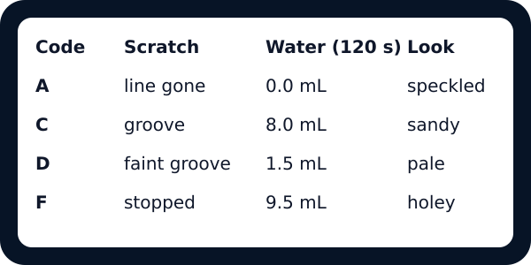
The evidence matrix for four codes
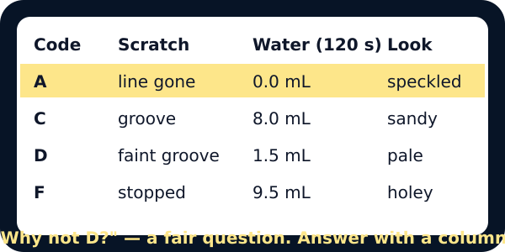
Code A highlighted with an audience question

Evidence matrix

Exit · one next step
After the adult has listened, what will you keep, improve or check next?

