Fair Test Planner: Change One Thing
  - BUILD · Science · 40 minutes
I can plan a safe fair comparison by naming one changed variable, one measured result, the controls and the repeats.
Name: __________________________ Date: ______________
You may write, type, say, sign, point or direct a partner. An adult can read the words and record your exact response. Keep the choice and explanation your own.

Words for this lesson
Word | Meaning
variable | a factor that can change
control | keep this the same
repeat | do the same method again

First idea
Team A gives Sample A 5 mL for 120 seconds. Team B gives Sample B 10 mL for 60 seconds. Could a final comparison show which sample let more water through?
A. Yes. Any two collected-water numbers make a fair comparison.
B. Not yet. Sample, starting volume and time all changed, so the cause is unclear.
C. Yes, because using more water always makes a better test.
My first idea and reason:

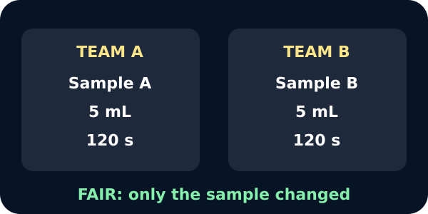
Two teams differing only in sample

We do · choose, explain, check
Which plan changes one factor and measures one result?
A. Change sample code; measure water collected in mL; keep volume, time, area and thickness the same.
B. Change sample, water volume and time; measure whichever result appears.
C. Scratch A, wet B and compare the two different observations as permeability.
My choice: ______ Evidence or reason:

W14 fair-test control board
Route each plan card to CHANGE, MEASURE, KEEP THE SAME or REPEAT / PILOT / SAFETY.
Read or hear one card. Choose a group. Give the evidence. A partner checks your reason before you move on. Point or write card numbers; cutting is optional.
Group | Card numbers and evidence
CHANGE
MEASURE
KEEP THE SAME
REPEAT / PILOT / SAFETY

Activity cards
1 · Sample code | 2 · Collected water
Use final supplied Sample A for one condition and final supplied Sample B for the other in W14. | Record water reaching the collector after 120 seconds, in mL.

3 · Starting volume | 4 · Test time
Use exactly 5 mL for every pilot and final valid trial. | Use exactly 120 seconds for each valid trial.

5 · Exposed area | 6 · Prepared thickness
Use the same sealed collar opening for every prepared piece. | Staff supply matched pieces with the same planned thickness.

7 · Final repeats | 8 · Practice pilot
Plan up to three W14 trials per sample using dry matched pieces or the approved fixed-data equivalent. | Before W14, use one clearly labelled practice sample or fixed pilot record to test the instructions, seal, timer and table.

9 · Safety stop
Stop for leaks, unstable equipment, sample damage, flaking, dust or unclear measurement; switch to the fixed route.

Rehearse: Change __. Measure __. Keep __, __ and __ the same. Pilot __. Repeat __ in W14. Stop if __.

Your lesson record
Produce a W14-ready fair-test plan and a separate W13B pilot checklist, leaving all final sample result cells blank.

Model helps us see
Use the planner: QUESTION → CHANGE → MEASURE → KEEP THE SAME → REPEAT → PILOT CHECK → SAFETY STOP.

Model does not show
A fair plan reduces alternative explanations but cannot remove natural sample variation. The pilot can improve procedure, yet only W14's approved repeated comparison may address the investigation question.

Supported
Build the method from fixed picture cards and choose one pilot check and one safety stop.
Use one card at a time: Change __. Measure __. Keep __ the same. Pilot __.

Standard
Write the full plan, justify three controls and prepare separate pilot and final-data sheets.
Check that no final A/B result or conclusion appears before W14.

Stretch
Evaluate a flawed alternative, justify thickness and exposed-area controls, and explain what the pilot can and cannot establish.
Separate procedural validity from the final scientific comparison.

Evidence target
W14 question, prediction, changed variable, measure with unit, at least three controls, repeat plan, blank results table, W13B pilot checks and safety stop.

Exit, Audience and evidence · W13A
Supported: Complete or point: Change __. Measure __. Pilot __.

Standard: Explain why W13B tests the method but does not answer the final A/B question.
Stretch: Justify one control and one pilot readiness check, then state why final results remain blank.

What I said, and what it changed
________________________________________________

Next I will ______.

Adult witness note
What was observed, and with what level of independence?

My evidence and explanation

What does this evidence not show?

Visual reference cards
These are diagrams or model views from the uploaded lesson. Use their labels and the card descriptions; they are not photographs of your own results.
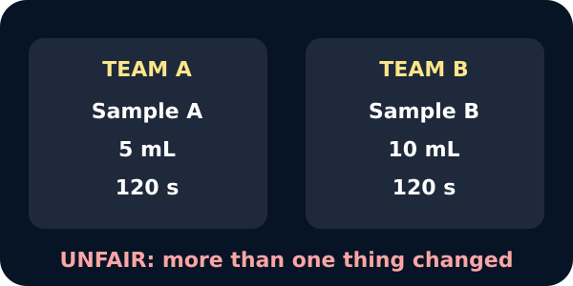
Team B used more water
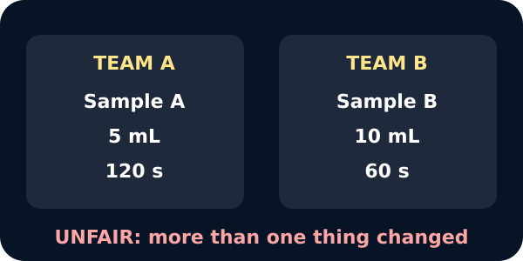
Team B also used less time

Exit · one next step
After the adult has listened, what will you keep, improve or check next?

