Method Pilot: Test the Test
  - BUILD · Science · 40 minutes
I can carry out or direct a small method pilot, identify a procedural problem and revise the plan ready for W14.
Name: __________________________ Date: ______________
You may write, type, say, sign, point or direct a partner. An adult can read the words and record your exact response. Keep the choice and explanation your own.

Words for this lesson
Word | Meaning
pilot | small practice run
fault | a problem in the method
revise | change the plan clearly

First idea
Pilot P1 uses one practice sample. One millilitre leaks around the collar edge. What should happen next?
A. Use the tray water to decide the practice rock is highly permeable.
B. Record the edge leak as a method fault, revise the seal check and pilot the repaired method again or use the fixed route.
C. Hide the leak and copy the expected value so the method looks ready.
My first idea and reason:

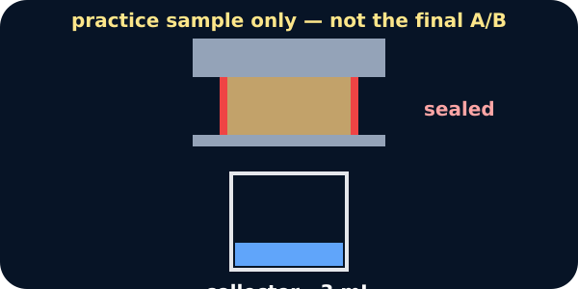
A practice run on the bench

We do · choose, explain, check
Which pilot response improves the future investigation without creating a false conclusion?
A. A leak occurs, so record ‘practice rock is permeable’ and start W14.
B. A leak occurs, so add ‘press and inspect the seal before adding 5 mL’; rerun the practice route and keep final A/B results blank.
C. A leak occurs, so change the sample, water volume and time together until a neat value appears.
My choice: ______ Evidence or reason:

Pilot fault-and-revision desk
Route each pilot note to KEEP, REPAIR or W14 READINESS. Do not route any card to a final rock conclusion.
Read or hear one card. Choose a group. Give the evidence. A partner checks your reason before you move on. Point or write card numbers; cutting is optional.
Group | Card numbers and evidence
KEEP IN METHOD V2
REPAIR THE METHOD
W14 READINESS DECISION

Activity cards
1 · Practice label | 2 · Volume step
The pilot piece is clearly marked PRACTICE P and stored separately from final Samples A and B. | The method states add exactly 5 mL using the marked needle-free tool.

3 · Stop rule | 4 · Pilot fault P1
Stop for a leak, unstable rig, sample damage, flaking, dust or unclear measurement and switch route. | One millilitre runs around the collar edge into the tray before the timer ends.

5 · Table fault | 6 · Timing fault
The collector column is headed Amount but gives no unit. | The instruction says wait a while and two pupils choose different end points.

7 · Ready decision | 8 · Repair then review
Practice P2 holds its seal, follows 5 mL and 120 seconds, records mL clearly and triggers no safety stop. | The second practice still leaks or gives an unreadable collector value.

9 · Fixed-route decision
A stable, measurable physical setup is unavailable, so the approved W14 route uses the supplied repeated data and the same reasoning table.

State: The pilot found __. We revised __. The W14 route is ready / needs review because __. The pilot cannot tell us __.

Your lesson record
Carry out or analyse one practice pilot, record a method fault or successful check, revise the method and issue a W14 readiness decision without a final rock conclusion.

Model helps us see
Use: The pilot showed __. This affects the method because __. We revised __ to __. For W14, the route is __.

Model does not show
A successful pilot only shows that the procedure can be followed and recorded under practice conditions. It does not prove the final samples will produce a pattern or answer the investigation question.

Supported
Sequence the practice steps, choose one fault card and one matching repair, then select ready, review or fixed route for W14.
Use: The pilot showed __. We changed __. For W14 we will __.

Standard
Complete the pilot log, justify one precise revision and issue an evidence-based readiness decision.
Keep method observation, revision and readiness in separate boxes; leave final conclusion blank.

Stretch
Evaluate whether the revision fixes the identified fault without creating a new variable, then specify the W14 approval conditions.
Explain why a successful pilot increases procedural confidence but not confidence in a final sample pattern.

Evidence target
Pilot checklist, one procedure observation or fault, method V1 and visibly revised V2, safety/access decision, W14 readiness card and a statement of what the pilot cannot conclude.

Exit, Audience and evidence · W13B
Supported: Complete or point: The pilot found __. We changed __. W14 route __.

Standard: Describe the method fault, revision and readiness decision without giving a rock conclusion.
Stretch: Explain why the pilot can approve a procedure but cannot support the final A/B permeability claim.

What I said, and what it changed
________________________________________________

Next I will ______.

Adult witness note
What was observed, and with what level of independence?

My evidence and explanation

What does this evidence not show?

Visual reference cards
These are diagrams or model views from the uploaded lesson. Use their labels and the card descriptions; they are not photographs of your own results.
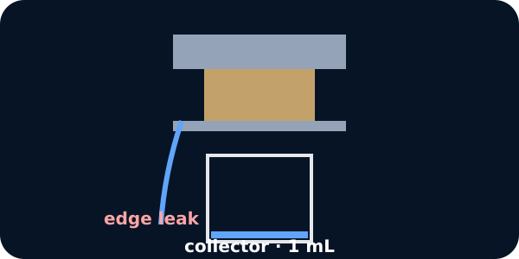
An edge leak during the pilot
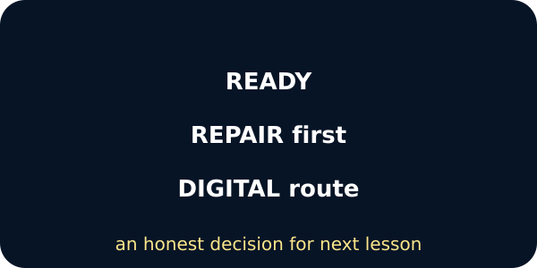
Three readiness decisions

Exit · one next step
After the adult has listened, what will you keep, improve or check next?

