Autumn Science Review Map
  - BUILD · Science · 40 minutes
Organise previously learned observations about skeletons, nutrition and rocks into an evidence map, then identify what each observation can and cannot support.
Name: __________________________ Date: ______________
You may write, type, say, sign, point or direct a partner. An adult can read the words and record your exact response. Keep the choice and explanation your own.

We do · make a choice and give a reason
Everyone commits through pointing, selecting, saying, signing, typing or directing an adult. Compare the bounded and over-strong responses, then answer a fresh example.
My choice and the evidence I used:

Resources and independent record
BUILD Science · Week 14A · Autumn Science Review Map
Objective: Organise previously learned observations about skeletons, nutrition and rocks into an evidence map, then identify what each observation can and cannot support.

Working record
Record the supplied source, chosen action or observation, then add the explanation and an honest limit. Leave unavailable evidence as MISSING or AWAITING AUTHORISED CHECK.
Focus | Record or action | Explanation, response or limit
Topic 1
Topic 2
Topic 3

BUILD Science · route, audit and learner confirmation

Choose a route

Supported
Sort nine supplied record cards into the three topic headings. Choose one sentence frame per topic: ‘The record shows __. It can support __. It cannot show __.’ An adult may read each card exactly and place it only as directed.

Standard
Select two records per topic, write a cautious claim for each topic and add a specific evidence limit. Explain one fair-comparison link between nutrition labels and a rock test without mixing their conclusions.

Stretch
Evaluate the strength of one record from each topic by considering method, comparison basis and uncertainty. Defend one cross-topic connection and reject one tempting connection that the evidence does not support.

Evidence audit
- One genuine record or completed action and why it matters:
- One support or method detail that must stay separate:
- One honest question or missing item:
- One next action the learner chose:

Paper route · discuss the lesson choices
Use these choices with the matching teaching stage. Point to or number a choice, explain it, then revisit it after feedback. The original HTML keeps the live controls.
- a sorted mat of vertebrates and invertebrates
- a table of after-wipe scratch results
- a plan with CHANGE / MEASURE / SAME boards
- a labelled arm model showing biceps and triceps
- a sketch of the sealed water bench with mL collected
- four sugar labels ordered per 100 g
- body science
- rocks
- fair tests
Choice / card | My reason or evidence | My revision after feedback

Visual evidence from the lesson
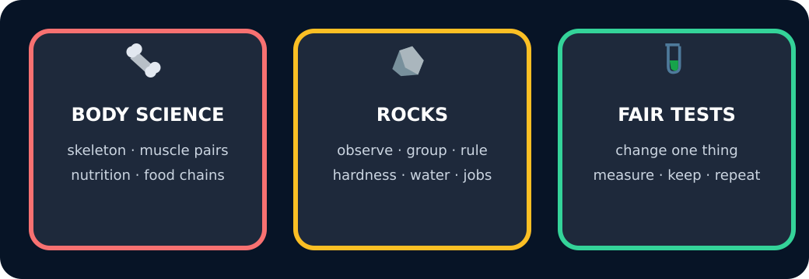
Three autumn topics as a map

Exit · one next step
After the adult has listened, what will you keep, improve or check next?

