Autumn Science Evidence
  - BUILD · Science · 40 minutes
Select genuine class records about skeletons, nutrition and rocks, organise them by topic, and add a cautious explanation and evidence limit to each.
Name: __________________________ Date: ______________
You may write, type, say, sign, point or direct a partner. An adult can read the words and record your exact response. Keep the choice and explanation your own.

We do · make a choice and give a reason
A rock record distinguishes appearance from a controlled property test. Existing evidence is used honestly; a missing practical is not restaged for a photograph.
My choice and the evidence I used:

Resources and independent record
BUILD Science · Week 14B · Autumn Science Evidence
Objective: Select genuine class records about skeletons, nutrition and rocks, organise them by topic, and add a cautious explanation and evidence limit to each.

An honest autumn science evidence set working record
Use each row to show the supplied evidence or genuine action, the response about an honest Autumn science evidence set, and one explanation, boundary or authorised next check.
Focus | Record or action | Explanation, response or limit
Supplied evidence
Reasoning or action
Boundary and next check

BUILD Science · route, audit and learner confirmation

Choose a route

Supported
Match six supplied records to topic headings and complete one caption frame and limit frame per topic.

Standard
Select and justify two records per topic, then write cautious captions and a method-specific limit.

Stretch
Evaluate the strength of the selected records, reject one weak item and defend the final evidence set.

Evidence audit
- Source, material or action locator visible:
- Reasoning can be checked:
- Safety and missing status honest:
- Learner's next action received exactly:

Paper route · discuss the lesson choices
Use these choices with the matching teaching stage. Point to or number a choice, explain it, then revisit it after feedback. The original HTML keeps the live controls.
- a photo of the sorted vertebrate mat
- a scratch table with one row marked “stopped”
- the arm model with the contracting muscle labelled
- a water bench sketch with no volume written
- a photo of the packet fronts (no labels)
- fully supports the outcome
- supports part of it — name the gap
- does not show the science
Choice / card | My reason or evidence | My revision after feedback

Visual evidence from the lesson
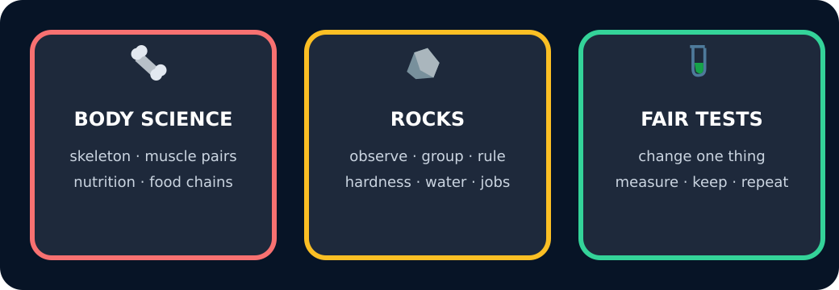
Three autumn topics as a map

Exit · one next step
After the adult has listened, what will you keep, improve or check next?

