Fossil Formation Story
  - BUILD · Science · 40 minutes
Sequence the main stages by which remains or traces can become fossils over a very long time and distinguish evidence from a compressed story.
Name: __________________________ Date: ______________
You may write, type, say, sign, point or direct a partner. An adult can read the words and record your exact response. Keep the choice and explanation your own.

We do · make a choice and give a reason
More layers can build and compact over a very long time as minerals and rock processes preserve evidence. Later movement or erosion may expose a fossil; Mary Anning used careful observation of real fossils as evidence about life long ago.
My choice and the evidence I used:

Resources and independent record
BUILD Science · Week 15A · Fossil Formation Story
Objective: Sequence the main stages by which remains or traces can become fossils over a very long time and distinguish evidence from a compressed story.

A fossil-formation sequence working record
Use each row to show the supplied evidence or genuine action, the response about a fossil-formation sequence, and one explanation, boundary or authorised next check.
Focus | Record or action | Explanation, response or limit
Supplied evidence
Reasoning or action
Boundary and next check

BUILD Science · route, audit and learner confirmation

Choose a route

Supported
Order five picture cards and match one prepared explanation to each stage.

Standard
Order and explain the stages using burial, sediment, change, preservation and exposure.

Stretch
Explain why fossil formation is uncommon and evaluate where the simple sequence has limits.

Evidence audit
- Source, material or action locator visible:
- Reasoning can be checked:
- Safety and missing status honest:
- Learner's next action received exactly:

Paper route · discuss the lesson choices
Use these choices with the matching teaching stage. Point to or number a choice, explain it, then revisit it after feedback. The original HTML keeps the live controls.
- more layers choose down and harden into rock
- a living thing dies and sinks to the bottom
- uplift or erosion brings the fossil to the surface
- soft parts decay; hard parts are covered by sediment
- minerals replace or fill the remains
- Every fossil forms exactly this way
- This is one common route; footprints, amber and moulds form differently
Choice / card | My reason or evidence | My revision after feedback

Visual evidence from the lesson
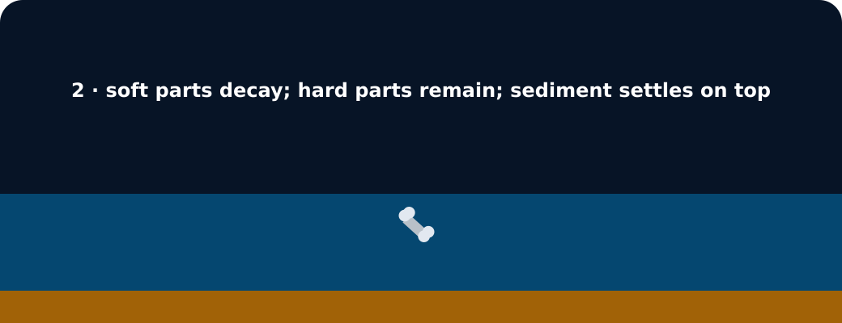
Fossil formation stage 2: hard parts covered by sediment

Exit · one next step
After the adult has listened, what will you keep, improve or check next?

