Fossil Formation Evidence
  - BUILD · Science · 40 minutes
Use supplied fossil and layer evidence to produce a labelled fossil-formation account with an explicit uncertainty statement.
Name: __________________________ Date: ______________
You may write, type, say, sign, point or direct a partner. An adult can read the words and record your exact response. Keep the choice and explanation your own.

We do · make a choice and give a reason
A labelled diagram must keep observed features separate from inferred stages. Missing provenance or preparation details remain AWAITING AUTHORISED CHECK.
My choice and the evidence I used:

Resources and independent record
BUILD Science · Week 15B · Fossil Formation Evidence
Objective: Use supplied fossil and layer evidence to produce a labelled fossil-formation account with an explicit uncertainty statement.

Fossil formation evidence working record
Use each row to show the supplied evidence or genuine action, the response about fossil formation evidence, and one explanation, boundary or authorised next check.
Focus | Record or action | Explanation, response or limit
Supplied evidence
Reasoning or action
Boundary and next check

BUILD Science · route, audit and learner confirmation

Choose a route

Supported
Match observation cards to three labelled stages and choose one uncertainty frame.

Standard
Annotate four observable details and connect them to a sequenced formation account.

Stretch
Evaluate which inferences are strongest, reject one unsupported label and explain the model's limitations.

Evidence audit
- Source, material or action locator visible:
- Reasoning can be checked:
- Safety and missing status honest:
- Learner's next action received exactly:

Paper route · discuss the lesson choices
Use these choices with the matching teaching stage. Point to or number a choice, explain it, then revisit it after feedback. The original HTML keeps the live controls.
- the shape of a shell pressed into the rock
- flat bands running through the rock
- a bone-shaped piece that is now stone
- the fossil lies flat between two bands
- the rock is hard and took a very long time to form
- a footprint with no bone or shell
- hard parts / impressions remain
- buried under sediment layers
- pressed and hardened over a long time
- a trace, not a body
Choice / card | My reason or evidence | My revision after feedback

Visual evidence from the lesson
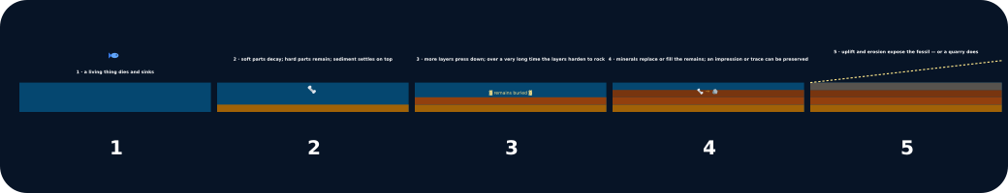
Five fossil stages in a strip

Exit · one next step
After the adult has listened, what will you keep, improve or check next?

