Sugar Evidence: Read the Label
  - BUILD · Science · 40 minutes
I can compare sugar values using the same label basis and order four supplied food labels from least to most sugar.
Name: __________________________ Date: ______________
You may write, type, say, sign, point or direct a partner. An adult can read the words and record your exact response. Keep the choice and explanation your own.

Words for this lesson
Word | Meaning
nutrition label | food information panel
per 100 g | in the same 100 g amount
evidence | the number we read

First idea
Label A says 6 g sugar per 100 g. Label B says 9 g sugar per 100 g. Which first claim can the evidence support?
A. Label A has less sugar per 100 g than Label B.
B. Label A is the healthiest food in every way.
C. The values cannot be compared because every number on a label means something different.
My first idea and reason:

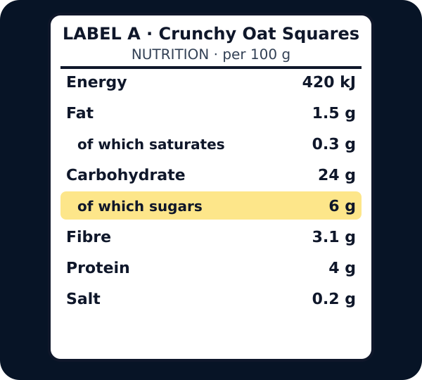
Nutrition label A with the of-which-sugars line highlighted: 6 g per 100 g

We do · choose, explain, check
Which comparison is fair using the supplied cards?
A. Compare 4 g per 100 g with 11 g per 100 g.
B. Compare 4 g per 100 g with 3 g per serving without converting.
C. Choose the packet with the picture we like best.
My choice: ______ Evidence or reason:

Same-Basis Sugar Label Lab
Read each supplied card, place the four values in order, then place the method and limitation cards.
Read or hear one card. Choose a group. Give the evidence. A partner checks your reason before you move on. Point or write card numbers; cutting is optional.
Group | Card numbers and evidence
1 · LEAST SUGAR PER 100 g
2 · NEXT VALUE
3 · NEXT VALUE
4 · MOST SUGAR PER 100 g
FAIR-COMPARISON RULE
LIMIT OF THE CLAIM

Activity cards
1 · Label A · 4 g per 100 g | 2 · Label B · 9 g per 100 g
The supplied sugar line reads 4 g for each 100 g. | The supplied sugar line reads 9 g for each 100 g.

3 · Label C · 14 g per 100 g | 4 · Label D · 23 g per 100 g
The supplied sugar line reads 14 g for each 100 g. | The supplied sugar line reads 23 g for each 100 g.

5 · Same nutrient, unit and basis | 6 · Sugar is one part of nutrition
Every value is sugar in g per 100 g. | The cards do not show every nutrient, portion, medical need or the whole diet.

Read the ordered values with units and basis. What claim is supported, and what broader claim is not supported?

Your lesson record
Read and order four supplied label cards from least to most sugar per 100 g, then write or communicate one supported claim and one limitation.

Model helps us see
The matched label cards remove serving-size differences so pupils can see a fair numerical comparison.

Model does not show
The simplified cards show sugar values only. They do not show portion eaten, frequency, other nutrients, allergies, medical needs or a whole dietary pattern.

Supported
Match four large number cards to a number line, then complete: __ g is least; __ g is most.
Keep g and per 100 g printed beside every number. Offer two placements at a time and exact scribing.

Standard
Read the four sugar lines, build the table independently and explain one comparison using less/more and per 100 g.
Use: Label __ has __ g per 100 g. This is less/more than __ because __.

Stretch
Audit a mixed-basis comparison, explain why it is invalid and state what extra information would be needed before a wider nutrition claim.
Distinguish per serving from per 100 g and keep the conclusion within the available evidence.

Evidence target
Four sugar values in correct order with g per 100 g, one evidence sentence and one statement of what the comparison cannot show.

Exit, Audience and evidence · W8A
Supported: Point and complete: __ g per 100 g is least; __ g per 100 g is most.

Standard: Give one fair same-basis sugar comparison and state why sugar alone cannot describe the whole food.
Stretch: Explain why mixed per-serving and per-100 g values cannot be ordered directly, then limit the conclusion.

What I said, and what it changed
________________________________________________

Next I will ______.

Adult witness note
What was observed, and with what level of independence?

My evidence and explanation

What does this evidence not show?

Visual reference cards
These are diagrams or model views from the uploaded lesson. Use their labels and the card descriptions; they are not photographs of your own results.
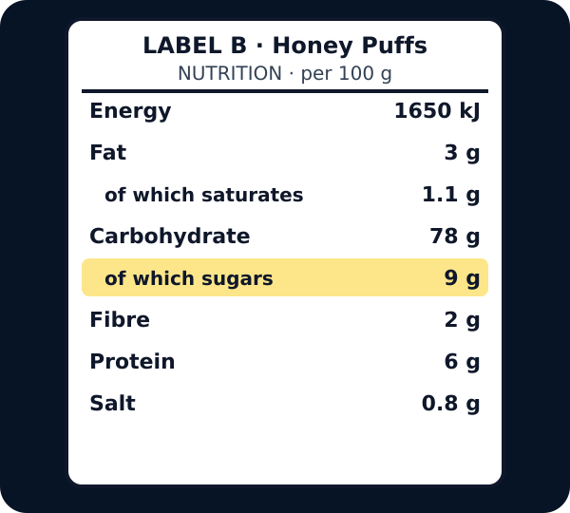
Nutrition label B with the of-which-sugars line highlighted: 9 g per 100 g
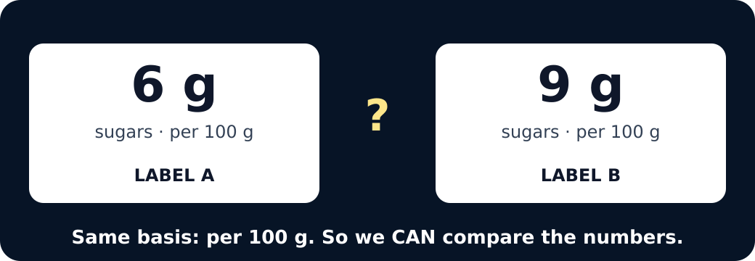
Six grams beside nine grams, both per 100 g, with a question mark
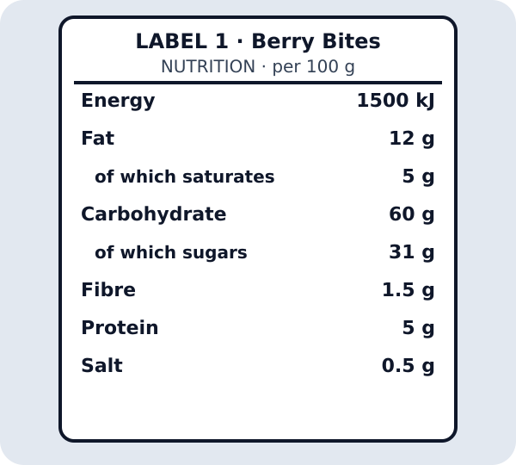
Tappable nutrition label 1
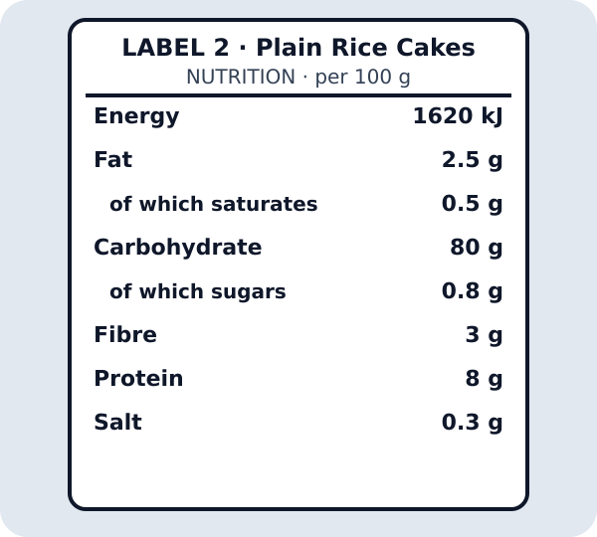
Tappable nutrition label 2

Exit · one next step
After the adult has listened, what will you keep, improve or check next?

