Body Science Checkpoint
  - BUILD · Science · 40 minutes
I can use models and evidence to show what I know about skeletons, muscle pairs, nutrition, balance and food sources.
Name: __________________________ Date: ______________
You may write, type, say, sign, point or direct a partner. An adult can read the words and record your exact response. Keep the choice and explanation your own.

Words for this lesson
Word | Meaning
support | hold up and give shape
contract | shorten and pull
nutrition | getting what the body needs from food

First idea
A pupil says, ‘The bone pushes the muscle, so the arm bends.’ Which idea should the checkpoint test?
A. Keep it: bones push muscles to make them shorter.
B. Test the pair: one muscle contracts and pulls while the other relaxes.
C. Ignore the arm model and compare sugar labels instead.
My first idea and reason:

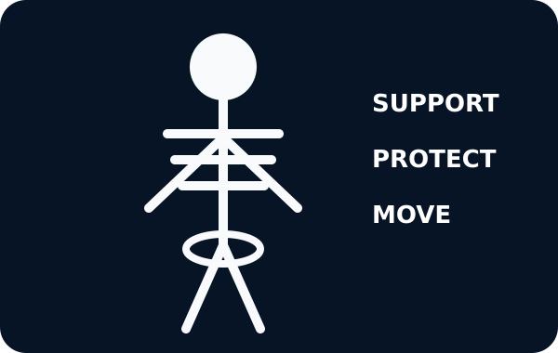
A simple skeleton with the words support, protect, move

We do · choose, explain, check
When the biceps contracts to bend the elbow, what should the triceps do in the simple model?
A. Relax while the biceps pulls the forearm bone.
B. Push the bone from behind.
C. Contract fully in the same direction as the biceps.
My choice: ______ Evidence or reason:

Four-Strand Body Science Checkpoint
Route each evidence card to the strand it checks. Then choose one strand to explain and one to revisit.
Read or hear one card. Choose a group. Give the evidence. A partner checks your reason before you move on. Point or write card numbers; cutting is optional.
Group | Card numbers and evidence
SKELETON / BACKBONE
MUSCLE PAIR
NUTRITION / BALANCE
FOOD SOURCE / CHAIN

Activity cards
1 · Skull around the brain | 2 · Snake X-ray shows an internal spine
A hard bone surrounds and guards the brain. | The animal has a backbone even though it has no legs.

3 · Biceps becomes shorter | 4 · Partner relaxes during the bend
The muscle contracts and pulls the forearm bone to bend the elbow. | In the simple model, the triceps relaxes while the biceps contracts.

5 · Energy, growth and repair | 6 · A varied pattern across food groups
Different nutrients support different body jobs. | No single food or sugar value describes a balanced dietary pattern.

7 · Plant → caterpillar | 8 · Caterpillar → bird
The plant is the producer at the start of this simple chain. | The bird is a consumer that obtains food by eating another animal.

Name one secure strand, one connection between strands and the exact next strand to revisit.

Your lesson record
Complete or direct four short checkpoint stations, preserve a piece of evidence from each and explain one connection between two strands.

Model helps us see
The four checkpoint strands make the half-term knowledge visible without turning one response mode into the only way to show understanding.

Model does not show
Models simplify bodies, joints, diets and food chains. This checkpoint samples key ideas; it is not a medical, dietary or full attainment diagnosis.

Supported
Complete one two-choice item at each station, then choose a secure strand and a next strand.
Use symbols, model handling or pointing. Read each option exactly and scribe the pupil's own explanation.

Standard
Complete all four stations, justify one response from each and connect two strands using because.
Use: __ works with __ because __. My evidence is __. Next I need to practise __.

Stretch
Explain two cross-strand links, repair one misconception and evaluate one model limitation.
Keep the claim within the model and distinguish evidence from a wider health judgement.

Evidence target
One observable response from each strand, one because connection, the pupil's chosen next strand and an adult witness note naming independence and prompts.

Exit, Audience and evidence · W8B
Supported: Point to one secure strand and one strand to practise next.

Standard: Explain one connection between skeletons, muscles, nutrition or food sources using evidence.
Stretch: Repair one checkpoint misconception, state a model limit and choose the next teaching step.

What I said, and what it changed
________________________________________________

Next I will ______.

Adult witness note
What was observed, and with what level of independence?

My evidence and explanation

What does this evidence not show?

Visual reference cards
These are diagrams or model views from the uploaded lesson. Use their labels and the card descriptions; they are not photographs of your own results.
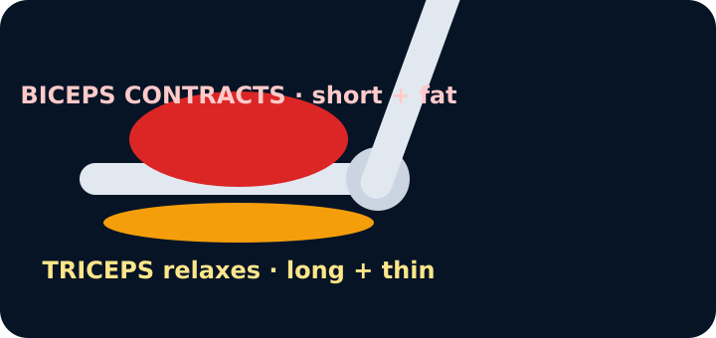
An arm model bent at the elbow: the biceps is short and fat, the triceps long and thin
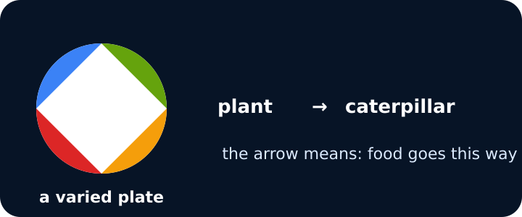
A plate of four food groups and a food-chain arrow from plant to caterpillar

Arm model showing biceps and triceps

Exit · one next step
After the adult has listened, what will you keep, improve or check next?

