Rock Evidence Lab: Look Before You Label
  - BUILD · Science · 40 minutes
I can compare rock specimens using observed properties and create a group using a stated rule.
Name: __________________________ Date: ______________
You may write, type, say, sign, point or direct a partner. An adult can read the words and record your exact response. Keep the choice and explanation your own.

Words for this lesson
Word | Meaning
property | a feature we can notice or test
observe | look closely and record
classify | put into groups with a rule

First idea
Two rocks are both grey. Is that enough evidence to place them in the same useful group?
A. Yes. One shared colour is all we need for every purpose.
B. Not yet. Observe the same extra features on both rocks, then state a grouping rule.
C. Guess both names first and make the evidence fit later.
My first idea and reason:


Coded rock A: speckled with crystals

We do · choose, explain, check
Which line is an observation that can be checked on the supplied specimen?
A. Several large crystals are visible in the speckled surface.
B. It must be granite because that is my first guess.
C. It will make the best roof because it looks strong.
My choice: ______ Evidence or reason:

Coded Rock Feature Lab
Place each coded observation under its strongest named visible feature. The name is not the target.
Read or hear one card. Choose a group. Give the evidence. A partner checks your reason before you move on. Point or write card numbers; cutting is optional.
Group | Card numbers and evidence
VISIBLE CRYSTALS
VISIBLE GRAINS
BANDS / FLAT PLANES
LARGE HOLES
FINE · NO LARGE FEATURE

Activity cards
1 · Code A | 2 · Code B
Speckled surface with several visible interlocking crystals. | Dark, fine-looking surface with no large visible grains, bands or holes.

3 · Code C | 4 · Code D
Rough tan surface with many visible sand-sized grains and faint bands. | Pale, mostly fine-looking surface with no large crystals, bands or holes in this view.

5 · Code E | 6 · Code F
Blue-grey fine-looking specimen with clear flat, sheet-like planes. | Pale rough-looking surface with many clearly visible large holes.

7 · Mystery image T
Brown-grey surface with visible bands, no large crystals and no large holes.

Choose one visible feature as a rule. Which codes belong in the yes group, and which evidence supports each placement?

Your lesson record
Inspect or direct the inspection of coded rock specimens, compare two using the same features and create two groups with a stated rule.

Model helps us see
Coded macro views slow down naming and make the observation-to-rule sequence visible.

Model does not show
Appearance alone cannot prove an unknown rock's identity or hidden properties. Lighting, scale, weathering and natural variation can change how a specimen looks.

Supported
Compare two coded macro cards with a four-word feature bank, then place them using one shown rule.
Use: I can see __. Both have __ / only __ has __. Adult exact scribing is valid.

Standard
Observe four to six coded specimens, compare a pair and create two groups using one stated property rule.
Record the rule before moving specimens. Use only evidence that another person can check.

Stretch
Create two different valid groupings, explain why both work and state why neither proves every specimen's identity.
Separate classification under a rule from identification of an unknown rock.

Evidence target
A Rock Comparison Ticket with two codes, two observed properties, one similarity, one difference and one explicit grouping rule.

Exit, Audience and evidence · W9A
Supported: Point and complete: I observed __. My rule was __.

Standard: Compare two coded specimens and defend one group using observed properties.
Stretch: Explain how a new valid rule could regroup the same specimens and why appearance cannot prove every name.

What I said, and what it changed
________________________________________________

Next I will ______.

Adult witness note
What was observed, and with what level of independence?

My evidence and explanation

What does this evidence not show?

Visual reference cards
These are diagrams or model views from the uploaded lesson. Use their labels and the card descriptions; they are not photographs of your own results.
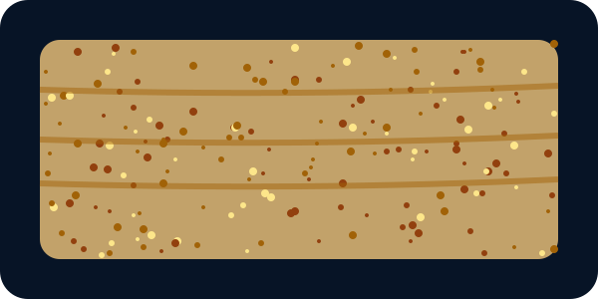
Coded rock C: sandy grains with faint bands
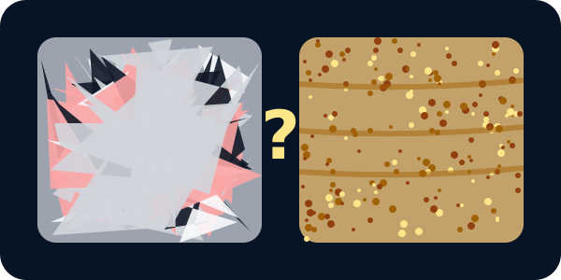
Rock A beside rock C with a question mark
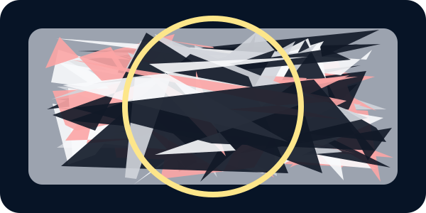
Magnified view of the chosen coded rock

Exit · one next step
After the adult has listened, what will you keep, improve or check next?

