Build a Rock Sorting Key
  - BUILD · Science · 40 minutes
I can apply a clear rock-grouping rule, check a mystery specimen and defend the placement with evidence.
Name: __________________________ Date: ______________
You may write, type, say, sign, point or direct a partner. An adult can read the words and record your exact response. Keep the choice and explanation your own.

Words for this lesson
Word | Meaning
criterion | the feature that decides
consistent | same meaning every time
key | questions that sort

First idea
A mystery specimen does not fit the group you expected. What should happen first?
A. Change the rule only for the mystery so the guess works.
B. Apply the same stated question to the mystery and accept the evidence-led group.
C. Hide the mystery because it makes the display harder.
My first idea and reason:

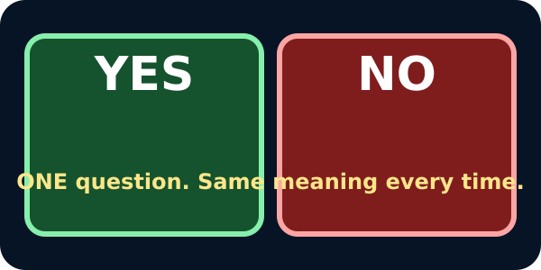
Two mats, YES and NO

We do · choose, explain, check
Code C has faint visible bands. Your rule asks, ‘Are visible bands present?’ Where should it go?
A. YES, because faint visible bands still meet the stated rule.
B. NO, because only very dark bands count today.
C. Move the boundary after seeing Code C so either answer works.
My choice: ______ Evidence or reason:

Bands-or-Planes Sorting Key
Apply this fixed question to every card: Are visible bands or clear flat sheet-like planes present?
Read or hear one card. Choose a group. Give the evidence. A partner checks your reason before you move on. Point or write card numbers; cutting is optional.
Group | Card numbers and evidence
YES · BANDS / FLAT PLANES PRESENT
NO · NOT VISIBLE IN THIS VIEW

Activity cards
1 · Code A | 2 · Code B
Speckled crystals; no visible bands or flat sheet-like planes. | Fine dark surface; no visible bands or flat sheet-like planes.

3 · Code C | 4 · Code D
Many sand-sized grains and faint but visible bands. | Mostly fine-looking surface; no visible bands or flat planes.

5 · Code E | 6 · Code F
Clear flat, sheet-like planes are visible. | Many large holes; no visible bands or flat planes.

7 · Mystery T
Brown-grey surface with visible bands and no large holes.

Defend Mystery T's placement. Then name another observable rule that would regroup every specimen.

Your lesson record
Create and operate one yes/no sorting key for the coded rock set, place Mystery T and then show how a second rule changes the groups.

Model helps us see
The yes/no mats and visible criterion make consistency easy to check and make any moved boundary obvious.

Model does not show
One two-way appearance key only classifies specimens under its chosen rule. It cannot identify an unknown rock from one image or reveal hidden properties.

Supported
Use one prepared yes/no question, place four reference cards and Mystery T, then say one evidence word for each.
Keep the criterion and matching feature symbol visible. Offer one card at a time and exact adult scribing.

Standard
Write or choose one yes/no criterion, classify all references, place Mystery T and regroup with a second rule.
Use: My criterion is __. Code __ goes in YES/NO because __.

Stretch
Evaluate two different keys for the same set and explain which is more useful for a stated display purpose.
Judge clarity, consistency and what each criterion reveals or hides.

Evidence target
A Sorting Key Case Card with one exact question, all reference placements, defended Mystery T placement and one complete regrouping rule.

Exit, Audience and evidence · W9B
Supported: Complete: My question was __. Mystery T went in YES/NO because __.

Standard: Defend Mystery T's placement and explain what changed when the criterion changed.
Stretch: Compare two valid keys and explain why neither key proves Mystery T's rock name.

What I said, and what it changed
________________________________________________

Next I will ______.

Adult witness note
What was observed, and with what level of independence?

My evidence and explanation

What does this evidence not show?

Visual reference cards
These are diagrams or model views from the uploaded lesson. Use their labels and the card descriptions; they are not photographs of your own results.
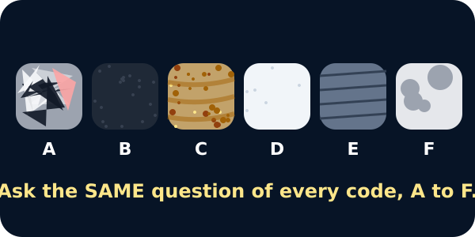
Six coded rocks in a row
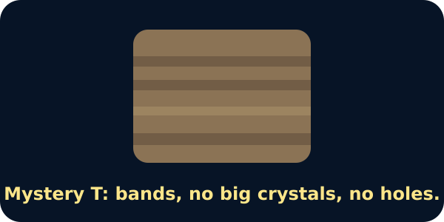
The mystery rock T with bands

Exit · one next step
After the adult has listened, what will you keep, improve or check next?

