Autumn Science: Explain, Check, Improve
  - GROW · Science · 40 minutes
I can use real autumn science evidence to explain one linked idea, note a limit, and improve my work after feedback.
Name: __________________________ Date: ______________
You may write, type, say, sign, point or direct a partner. An adult can read the words and record your exact response. Keep the choice and explanation your own.

We do · make a choice and give a reason
Choose the move that makes the science more true, not just longer.
Clear Add the missing locator, label or science word so another reader can find the record and follow the link.
Fair Narrow the claim, restore an uncertainty or state what the record cannot show.
Wider Connect the same reasoning to a second authentic record without inventing a result or changing the first one.
Checked change Keep the first version. Write the new version beside it and name the response you used.
My choice and the evidence I used:

Resources and independent record

GROW Science · Autumn 2 · Week 7 · Do
SoW: GROW Weekly - Autumn!C45 — “Review and evidence autumn science (Entry Level Science / UAS).”
Learning objective: I can use real autumn science evidence to explain one linked idea, note a limit, and improve my work after feedback.

Success checks for today's activity — not assessment criteria
- Choose one linked autumn science idea. Name the real evidence you used.
- Explain how the evidence supports the idea. Do not claim more than it shows.
- Use one response to make the work clear, fair or wider. Record what changed.

Supported
Use a claim/evidence/reason frame and one evidence item. Respond in private to one feedback choice.

Standard
Explain a linked idea with two evidence links, one limit and a saved change.

Stretch
Judge two accounts or two pieces of evidence. Then use the same thinking for a new linked question.

Independent task · 16 minutes
Make one evidence-led account from real autumn work. Include a claim, the place to find the evidence, the link, one limit and one clear change after a response. You may write, draw and label, use the school's approved audio route, or explain in private to an adult.

Autumn Science: Explain, Check, Improve · evidence record
Claim / decision | Source / date / locator | Learner contribution and meaning | Shared work / adult support | Limit / status

Reasoning or review

Honest gap / uncertainty

Next action, responsible role and report-back
This lesson may help make evidence for Pearson ELC Science 8939 or a local UAS review. Only the centre can assess it or claim an award. The lesson adds no new rule.

Learner review before confirmation
Read, point to or ask an adult to read each prompt exactly. Keep missing evidence and uncertainty visible.
Evidence link I am confirming
My claim, real record and reason:
Limit or uncertainty I have kept visible
What this evidence does not show, or what is not found yet:
Checked change and next action
What I changed after a response, what should be checked next, who is responsible and when I will hear back.

Paper route · discuss the lesson choices
Use these choices with the matching teaching stage. Point to or number a choice, explain it, then revisit it after feedback. The original HTML keeps the live controls.
- the globe-and-lamp model explains day and night
- the rover test compared two surfaces
- the classroom ball stood for Earth
- the climate figures we used were simplified
- a model is not to scale and simplifies the axis
- three repeats on two surfaces — a pattern, not a law
- a smooth ball hides mountains and slight flattening
- real climate data is noisier than a diagram
Choice / card | My reason or evidence | My revision after feedback

Visual evidence from the lesson
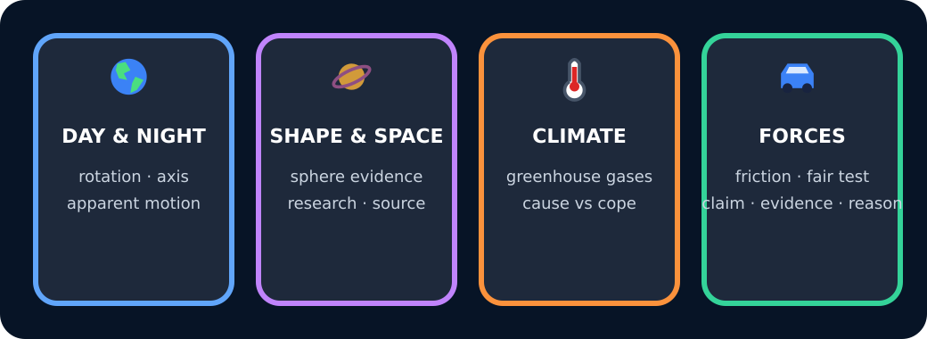
Four autumn topics

Exit · one next step
After the adult has listened, what will you keep, improve or check next?

