Solar System Research: Evidence Desk
  - GROW · Science · 40 minutes
I can research one Solar System focus using suitable sources, accurate notes and a clear source record.
Name: __________________________ Date: ______________
You may write, type, say, sign, point or direct a partner. An adult can read the words and record your exact response. Keep the choice and explanation your own.

Words for this lesson
Word | Meaning
source | where information came from
credible | reasonable to trust
paraphrase | same meaning, your words

First idea
You find three different statements about Jupiter. Which would you use first? Commit before the source check.
A. The shortest statement, because it is quickest to copy.
B. A relevant statement from a named, suitable source that can be checked.
C. The statement on the brightest page.
My first idea and reason:

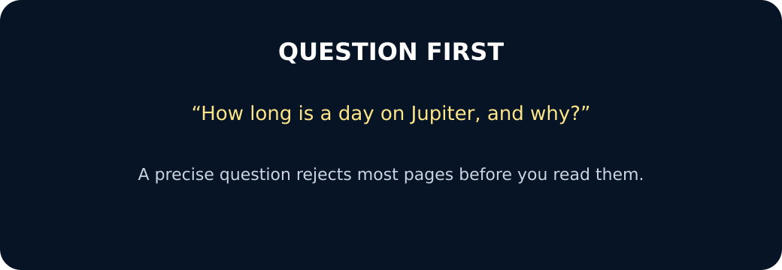
Question first

We do · choose, explain, check
Which note is ready to use in a Solar System research record?
A. ‘Mars is cool!!!’ copied from an unnamed post.
B. ‘Mars takes about 687 Earth days to orbit the Sun’ paraphrased, with the checked source recorded.
C. A full paragraph pasted from the first search result with no source name.
My choice: ______ Evidence or reason:

Solar System evidence desk
Route each research item to keep, check or reject, then freeze the decisions you can justify.
Read or hear one card. Choose a group. Give the evidence. A partner checks your reason before you move on. Point or write card numbers; cutting is optional.
Group | Card numbers and evidence
Keep for the record
Check before use
Reject for this question

Activity cards
1 · Named science source | 2 · Old page, changing claim
The note answers the question, keeps the value and unit, uses the pupil's own words and records the source code. | A named source answers the question, but the claim concerns a current spacecraft and the page date is missing.

3 · Unnamed dramatic post | 4 · Accurate but copied
It says Saturn is made of solid gold, gives no evidence and names no responsible author or organisation. | A useful paragraph from a named source is pasted word for word and the source is not recorded in the notes.

5 · Reliable but off-topic | 6 · Cross-checked fact
A trusted weather source explains today's rain but the research question is about Neptune's orbit. | Two suitable sources agree on the fact; the note preserves the value and unit and lists both source labels.

State one decision rule and show how a frozen card meets or fails it.

Your lesson record
Choose one local Solar System question and prepare a three-fact research record for the next lesson.

Model helps us see
Use the note frame: My question is __. The source states __. In my own words __. Source __. Check status __.

Model does not show
Checking a source helps, but it does not guarantee that every statement is right. Facts may be shortened, updated or given with limits.

Supported
Choose one question and use its three local cards to complete three short source-note rows.
Use highlighted key words and: The card says __. This means __. Source code __.

Standard
Choose one question, compare its three local cards and prepare three facts in your own words.
Record source code, key meaning, own-word note and use/check/leave-out choice in separate boxes.

Stretch
Research a question with a comparison or explanation, cross-check claims and note any uncertainty or disagreement.
Evaluate why each source is suitable and preserve exact values, units and qualifications.

Evidence target
One chosen question, three accurate own-word facts, at least two source codes, one agreement check and one card to check or leave out.

Exit, Audience and evidence · W10A
Supported: Share one fact in your own words and point to the source label.

Standard: Explain why one chosen note is ready for a presentation and one other item is not.
Stretch: Evaluate your strongest source decision and name one further check that would improve confidence.

What I said, and what it changed
________________________________________________

Next I will ______.

Adult witness note
What was observed, and with what level of independence?

My evidence and explanation

What does this evidence not show?

Visual reference cards
These are diagrams or model views from the uploaded lesson. Use their labels and the card descriptions; they are not photographs of your own results.
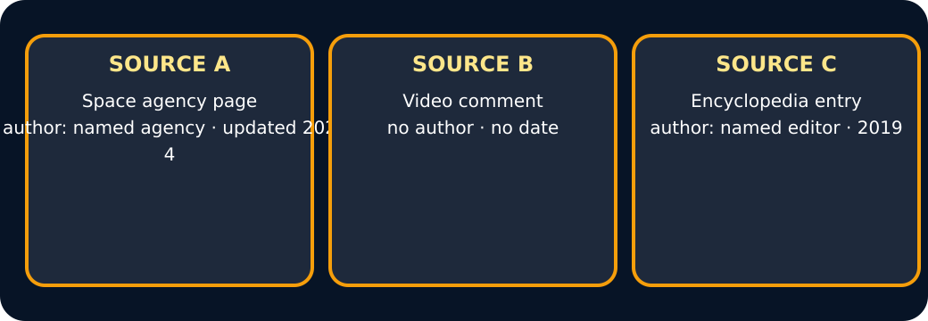
Three source cards
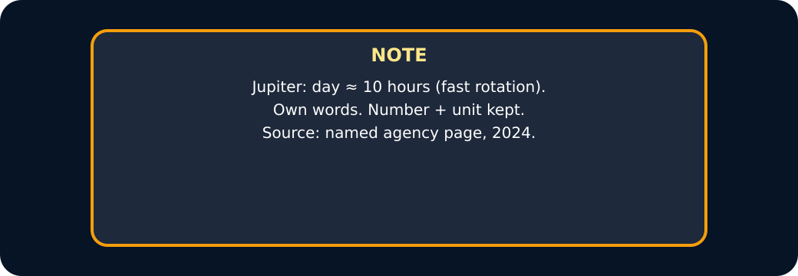
A note in own words with its source

Exit · one next step
After the adult has listened, what will you keep, improve or check next?

