Solar System Presentation: Mission Briefing
  - GROW · Science · 40 minutes
I can present researched Solar System findings clearly, credit sources and respond to an audience question with a change or a clear reason plus one transfer step.
Name: __________________________ Date: ______________
You may write, type, say, sign, point or direct a partner. An adult can read the words and record your exact response. Keep the choice and explanation your own.

Words for this lesson
Word | Meaning
claim | answer statement
evidence | facts that support
audience | real receiver

First idea
Which opening would help an audience understand a Solar System briefing? Commit before the model.
A. ‘I found lots of things. Here is every note.’
B. ‘Our question was __. The evidence shows __.’
C. ‘Watch this animation first; I will explain the topic later.’
My first idea and reason:

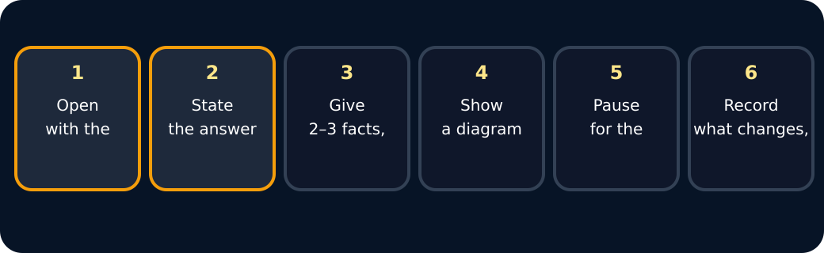
Briefing steps

We do · choose, explain, check
Which presentation panel gives the audience the strongest scientific case?
A. A large title, five animations and no source labels.
B. A focused claim, two facts that answer the question, a labelled diagram and source codes.
C. A copied paragraph read quickly without explaining the question.
My choice: ______ Evidence or reason:

Mission briefing studio
Route each presentation component to its scientific job before the live briefing.
Read or hear one card. Choose a group. Give the evidence. A partner checks your reason before you move on. Point or write card numbers; cutting is optional.
Group | Card numbers and evidence
Focused claim
Evidence and source
Audience response and next step

Activity cards
1 · Opening line | 2 · Supporting fact
‘Our question was why Mars looks red. Our claim is that iron minerals at the surface have reacted with oxygen.’ | A useful fact in the pupil's own words is shown beside the science organisation and source code.

3 · Labelled diagram | 4 · Received question
A simple diagram points to the surface feature discussed and includes its source label. | The presenter repeats the audience question to check that it was understood accurately.

5 · Visible revision | 6 · Confirmed, then transfer
After a question about scale, the presenter adds ‘not to scale’ to the Solar System diagram. | The audience checks the source and meaning, confirms both are accurate and clear, and the presenter records: ‘No content change; next I will explain it to a new audience without the sentence frame.’

7 · One-sentence answer
The presenter gives the main answer before adding selected detail.

Rehearse the claim-evidence-audience chain. State the change, or justify no content change and name one transfer step.

Your lesson record
Deliver a short Solar System briefing to a real audience, receive one question and record either a useful change or a clear no-content-change reason plus one transfer step.

Model helps us see
Use: Our question was __. Our claim is __. Evidence from __ shows __. Your question made me change __ / confirmed __, so next I will __.

Model does not show
A short briefing cannot contain every fact. Attractive slides do not prove accuracy, and an audience question does not replace source checking.

Supported
Present one claim and two facts with a three-panel frame; receive one choice-based question and change one panel, or mark it confirmed and choose one next audience.
Use symbols, pointing, switches, signing, speech or an adult scribing exact words. Rehearse with the sentence frame.

Standard
Give a one-to-two-minute briefing with claim, evidence and sources, then respond with a visible change or a clear reason plus one transfer step.
Use cue cards: question, claim, evidence 1, evidence 2, source, audience response, next step.

Stretch
Present a justified finding, acknowledge one uncertainty or limit and respond to a probing question with a revision or a defended no-change decision plus transfer.
Explain why the response makes the Science clearer, more accurate or ready to transfer.

Evidence target
A saved slide, paper panel or witness record; source labels; one audience question; and either a before-and-after change or a clear confirmation plus one transfer step.

Exit, Audience and evidence · W10B
Supported: Complete or point: I said __. My audience asked __. I changed __ / kept __ because __. Next __.

Standard: What did you say, who received it, and what changed? If no content changed, why was that right and what transfers next?
Stretch: Judge whether the response improved, confirmed or transferred the Science, then justify exactly one further step.

What I said, and what it changed
________________________________________________

Next I will ______.

Adult witness note
What was observed, and with what level of independence?

My evidence and explanation

What does this evidence not show?

Visual reference cards
These are diagrams or model views from the uploaded lesson. Use their labels and the card descriptions; they are not photographs of your own results.
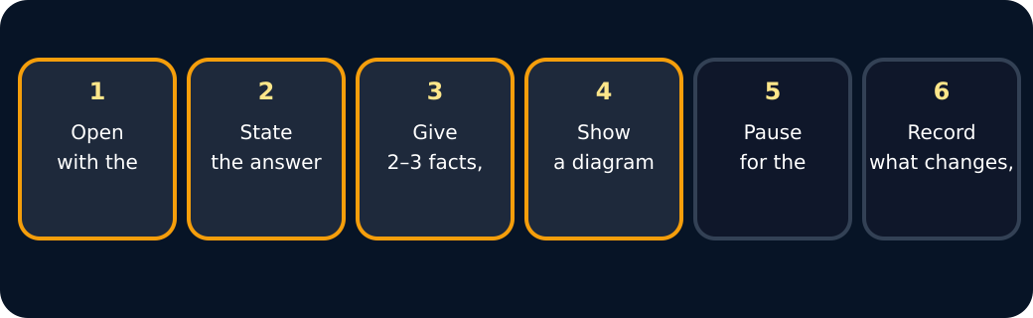
Briefing steps
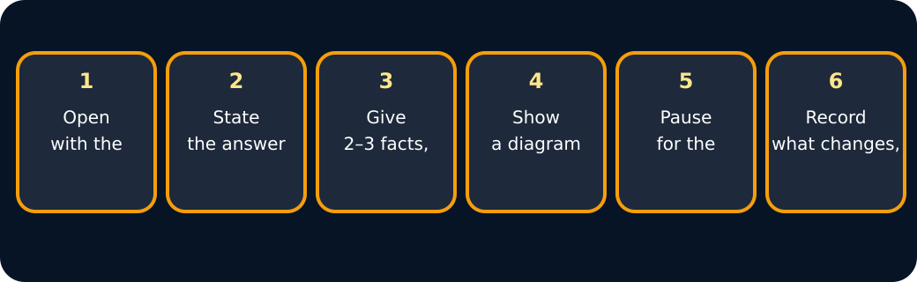
Briefing steps

Exit · one next step
After the adult has listened, what will you keep, improve or check next?

