Climate Chain: From Gas to Warming
  - GROW · Science · 40 minutes
I can explain how extra greenhouse gases raise Earth's average temperature and connect warming to wider climate effects.
Name: __________________________ Date: ______________
You may write, type, say, sign, point or direct a partner. An adult can read the words and record your exact response. Keep the choice and explanation your own.

Words for this lesson
Word | Meaning
climate | weather pattern over time
greenhouse gas | gas that affects heat flow
average | one value for a set

First idea
It is cold today. Which evidence could tell us about climate?
A. Today's temperature at one place
B. A long record of averages from many places
C. One photograph of snow
My first idea and reason:

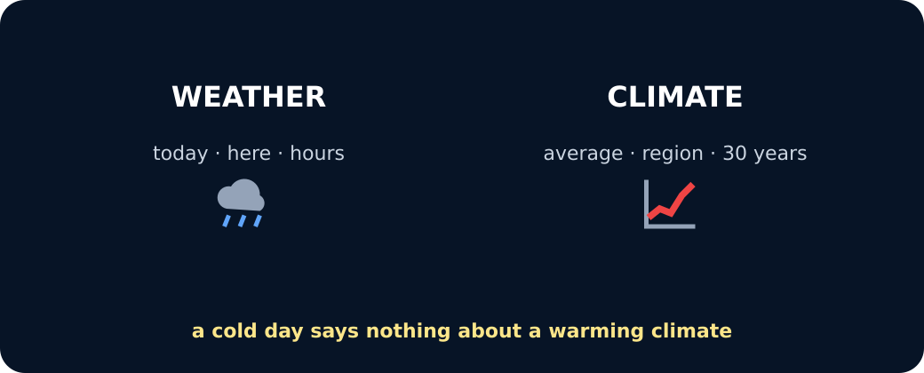
Weather versus climate

We do · choose, explain, check
Which statement is scientific?
A. Climate is the usual pattern over many years; one cold day is weather.
B. Global warming means every place becomes hotter every day.
C. The ozone hole is the main cause of global warming.
My choice: ______ Evidence or reason:

Climate Chain Lab
Order one genuine five-link chain from a human activity to one likely effect. Say why each link follows the one before it.
Read or hear one card. Choose a group. Give the evidence. A partner checks your reason before you move on. Point or write card numbers; cutting is optional.
Group | Card numbers and evidence
1 · HUMAN ACTIVITY
2 · MORE GREENHOUSE GAS
3 · ENERGY CHANGE
4 · GLOBAL WARMING
5 · LIKELY EFFECT

Activity cards
1 · Burning fossil fuels | 2 · More greenhouse gas in the atmosphere
Coal, oil and gas release extra carbon dioxide when burned. | The amount of carbon dioxide in the atmosphere increases.

3 · Net energy loss slows | 4 · Global average temperature rises
More outgoing infrared is absorbed; some is re-emitted towards the surface, so energy leaves Earth more slowly. | Earth warms until incoming and outgoing energy balance again at a higher average temperature.

5 · Land ice melts
Warming increases melting of glaciers and ice sheets, contributing to sea-level rise.

Read all five links with because and can lead to. Keep the effect likely, not guaranteed everywhere.

Your lesson record
Create the five-link chain activity → more greenhouse gas → slower net energy loss → higher global average → one likely effect, then explain it aloud, by pointing or in writing.

Model helps us see
The step-by-step energy route makes invisible transfers visible and separates the useful natural greenhouse effect from the enhanced effect caused by extra gases.

Model does not show
The arrows show direction, not real amounts, times or the full climate system. Greenhouse gases are not a solid lid and do not create energy.

Supported
Order the five icon-backed links and complete: More greenhouse gas slows ___. The higher global average can lead to ___.
Two cards are pre-positioned; use pointing, speech, symbol choice or exact adult scribing.

Standard
Draw or order the full chain and explain one effect using because.
Use the three headings Cause, Energy mechanism and Effect, then remove the sentence frame.

Stretch
Contrast the natural and enhanced greenhouse effects, then explain why one weather event is weak evidence.
Add one model limitation and use changed risk rather than guaranteed outcome.

Evidence target
One ordered causal chain, one explained effect and one honest model limitation.

Exit, Audience and evidence · W11A
Supported: Weather or climate: an average measured over many years?

Standard: What changes in the energy route when extra greenhouse gas is added?
Stretch: Why can a cold day occur while the global average temperature is rising?

What I said, and what it changed
________________________________________________

Next I will ______.

Adult witness note
What was observed, and with what level of independence?

My evidence and explanation

What does this evidence not show?

Visual reference cards
These are diagrams or model views from the uploaded lesson. Use their labels and the card descriptions; they are not photographs of your own results.
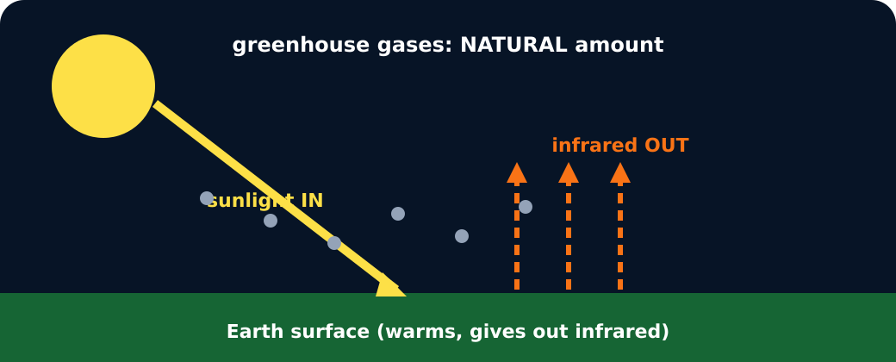
Natural greenhouse effect
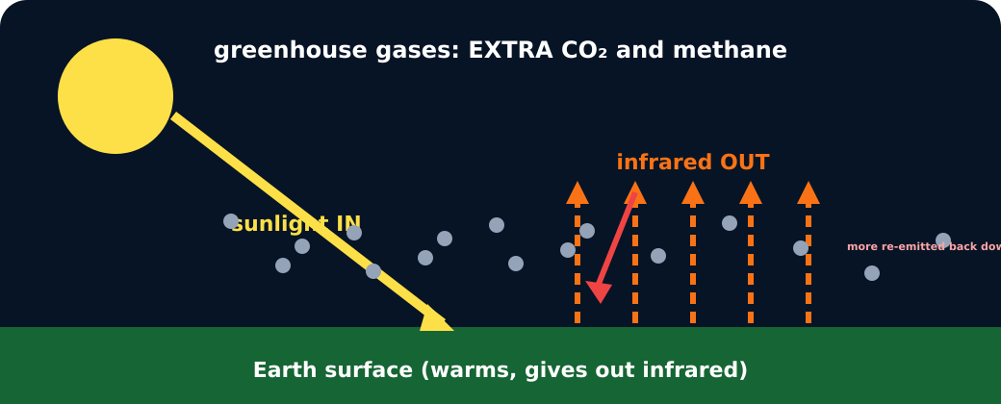
Enhanced greenhouse effect

Greenhouse effect model

Exit · one next step
After the adult has listened, what will you keep, improve or check next?

