Climate Action: Plan, Measure, Improve
  - GROW · Science · 40 minutes
I can explain how an action reduces climate impact, distinguish reducing causes from coping with effects, and plan evidence to check whether it worked.
Name: __________________________ Date: ______________
You may write, type, say, sign, point or direct a partner. An adult can read the words and record your exact response. Keep the choice and explanation your own.

Words for this lesson
Word | Meaning
mitigation | reduce a cause
adaptation | cope with an effect
baseline | what happens before

First idea
Which plan reduces a cause, and which plan helps people cope with an effect?
A. Switch off lights in empty rooms
B. Provide safe shade during high heat
C. Put up a poster and take no measurements
My first idea and reason:

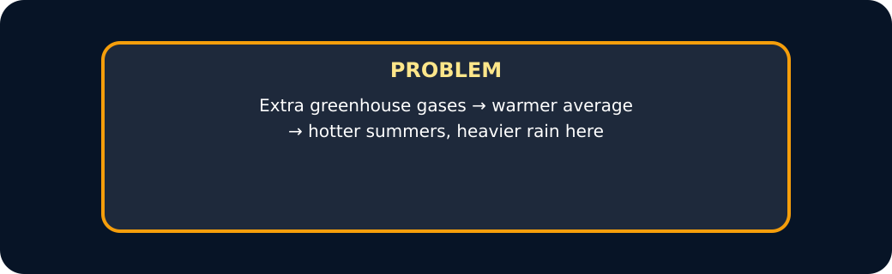
Problem card

We do · choose, explain, check
Which plan can check whether the lighting action worked?
A. Record unused light-on minutes for five days before and five days after, in the same way.
B. Put up a poster, then state that the problem is solved.
C. Ask one person whether the climate feels better.
My choice: ______ Evidence or reason:

Before/After Evidence Lab
Sort each card as Mitigation, Adaptation or Evidence check. Use the fictional data only to practise reasoning.
Read or hear one card. Choose a group. Give the evidence. A partner checks your reason before you move on. Point or write card numbers; cutting is optional.
Group | Card numbers and evidence
MITIGATION
ADAPTATION
EVIDENCE CHECK

Activity cards
1 · Unused lights off | 2 · Safe shade in high heat
A staff-approved routine reduces unnecessary electricity demand. | A shaded area lowers people's exposure to heat.

3 · Before: 300 minutes | 4 · After: 90 minutes
Five fictional daily records total 300 empty-room light-on minutes. | Five fictional daily records total 90 empty-room light-on minutes.

5 · A poster proves success
The poster was displayed, but no behaviour or energy measure was collected.

State only what the sample supports, then name one thing it cannot show.

Your lesson record
Choose one approved school scenario and create an action, mechanism and measurement plan before making any success claim.

Model helps us see
The before-and-after route keeps the claim connected to something observable rather than a promise or poster.

Model does not show
Light-on minutes suggest possible electricity savings only when the same lamps and conditions are compared; they do not measure a global climate result.

Supported
Select labelled cards for Action, How it helps and What we measure.
Choose between two approved scenarios and use a before/after picture strip.

Standard
Complete the full plan with a baseline, prediction, repeated measure and one controlled condition.
Use the prompt: If we ___, then ___ because ___. We will measure ___.

Stretch
Compare mitigation with adaptation and identify one confounding factor or evidence limit.
Explain why the result must stay local and provisional until the evidence is collected.

Evidence target
A safe action-to-mechanism chain, baseline, repeated measure, comparable condition and one limitation.

Exit, Audience and evidence · W11B
Supported: Mitigation or adaptation: switching off an unused light?

Standard: Explain one action-to-mechanism chain.
Stretch: Name the measure, one limitation and why success cannot be claimed before evidence.

First question card for W12
The safe question I choose for W12 is ______. ________________________________________
We will measure ______. ________________________________________

What I said, and what it changed
________________________________________________

Next I will ______.

Adult witness note
What was observed, and with what level of independence?

My evidence and explanation

What does this evidence not show?

Visual reference cards
These are diagrams or model views from the uploaded lesson. Use their labels and the card descriptions; they are not photographs of your own results.
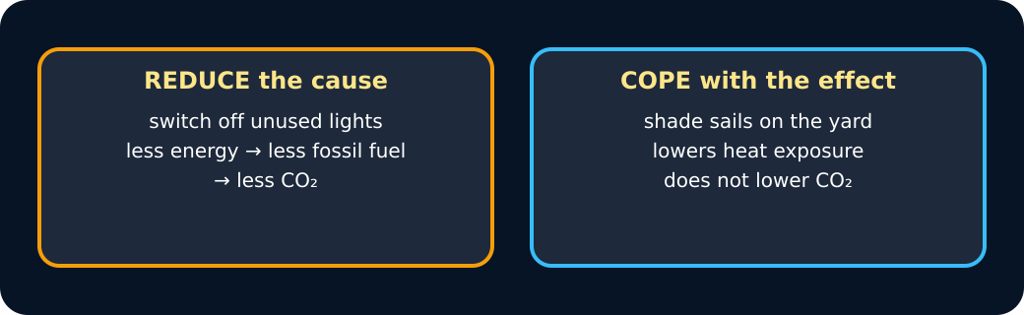
Two kinds of action

Measure card

Exit · one next step
After the adult has listened, what will you keep, improve or check next?

