Science Connections: Evidence Control
  - GROW · Science · 40 minutes
I can connect a scientific question to the right idea and use evidence to explain my answer.
Name: __________________________ Date: ______________
You may write, type, say, sign, point or direct a partner. An adult can read the words and record your exact response. Keep the choice and explanation your own.

Words for this lesson
Word | Meaning
evidence | what we observed
connection | how ideas link
cause | what makes a change happen

First idea
A rover travels less far on fabric than on a smooth surface. Which idea should control the answer?
A. Friction between surfaces
B. Earth's rotation
C. The enhanced greenhouse effect
My first idea and reason:


The question

We do · choose, explain, check
Which answer best connects the rover question, evidence and reason?
A. The rover travelled less on fabric: 18–20 cm compared with 44–46 cm, because greater friction opposed its motion.
B. Earth rotates once in about 24 hours.
C. The fabric result looks best to me.
My choice: ______ Evidence or reason:

Evidence Control Board
Place each evidence card under Forces, Space or Climate. Say the scientific link, not just the topic name.
Read or hear one card. Choose a group. Give the evidence. A partner checks your reason before you move on. Point or write card numbers; cutting is optional.
Group | Card numbers and evidence
FORCES
SPACE
CLIMATE

Activity cards
1 · 46, 44, 45 versus 18, 20, 19 cm | 2 · Same load: effort farther from the pivot needs less force
Repeated rover distances on smooth and fabric surfaces. | An observation made with the same load and setup while the effort point moved farther from the pivot.

3 · The observer turns into and out of light | 4 · A sphere stays round from several views
A day-and-night model observation while the Sun stays fixed. | A comparison between a sphere and a flat disc.

5 · More outgoing infrared is re-emitted | 6 · 300 minutes before; 90 minutes after
An energy-route observation when greenhouse-gas level increases. | A fictional local measure following an approved lighting action.

Choose one frozen card and give a complete answer: claim, evidence, scientific reason and one limit.

Your lesson record
Answer the embedded questions: Forces — why did the rover travel less far on fabric? Space — why do day and night happen? Climate — why can extra greenhouse gas raise Earth's average temperature?

Model helps us see
The common answer route reduces memory load while keeping the scientific idea specific to each topic.

Model does not show
One short answer cannot show every force, space or climate detail; select only what directly answers the question.

Supported
Choose one embedded question: rover and friction, day and night, or extra greenhouse gas and warming. Match one claim, evidence card and reason.
Use icon-backed choices and the stem: I think ___ because the evidence shows ___.

Standard
Answer two of the three embedded questions from different topics and underline the evidence used.
Use Question, Evidence and Reason headings, then check relevance.

Stretch
Answer all three embedded topic questions, compare evidence quality and name one model or data limitation.
Explain why an alternative piece of evidence is less relevant or less secure.

Evidence target
At least one complete answer with relevant evidence, scientific reasoning and one honest limit.

Exit, Audience and evidence · W12A
Supported: Which topic explains why a rover travels less far on fabric?

Standard: Use one result to answer a forces, space or climate question.
Stretch: Explain how relevance and a limitation affect the strength of an answer.

What I said, and what it changed
________________________________________________

Next I will ______.

Adult witness note
What was observed, and with what level of independence?

My evidence and explanation

What does this evidence not show?

Visual reference cards
These are diagrams or model views from the uploaded lesson. Use their labels and the card descriptions; they are not photographs of your own results.
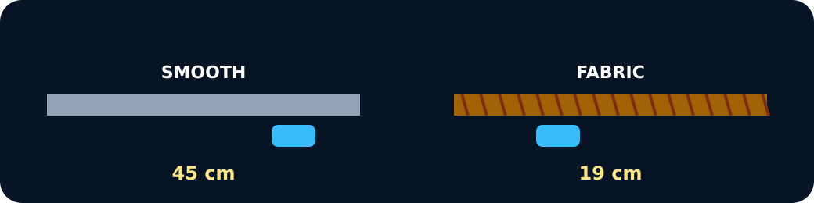
Rover distances on smooth and fabric
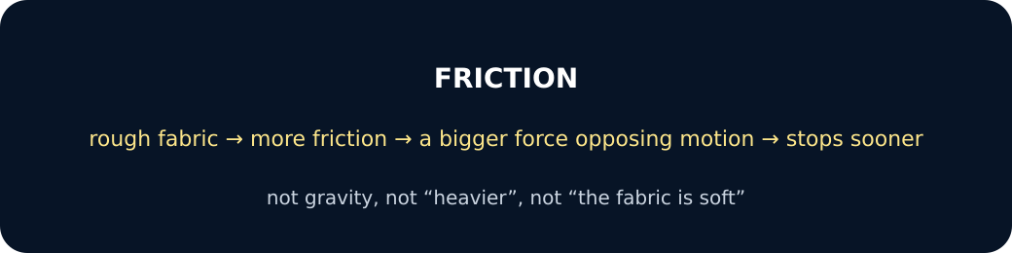
Friction reason

Exit · one next step
After the adult has listened, what will you keep, improve or check next?

