Rover Rescue: Plan a Fair Test
  - GROW · Science · 40 minutes
I can plan a fair investigation of how surface type affects a rover's travel distance.
Name: __________________________ Date: ______________
You may write, type, say, sign, point or direct a partner. An adult can read the words and record your exact response. Keep the choice and explanation your own.

Words for this lesson
Word | Meaning
independent variable | what I change
dependent variable | what I measure
control variable | what I keep the same

First idea
Which plan lets us find out whether surface type affects rover travel distance?
A. Change surface only; keep ramp and release the same
B. Change surface and ramp height together
C. Push the rover differently each time
My first idea and reason:

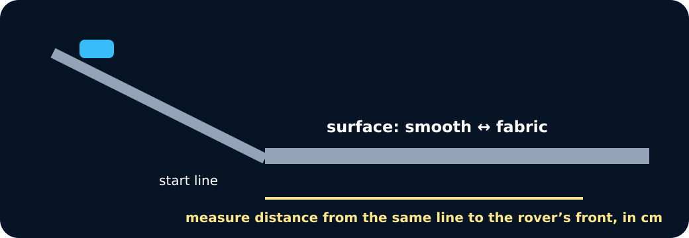
Ramp and surface

We do · choose, explain, check
Which is the fairest rover test question?
A. How does surface type affect travel distance when ramp height and release stay the same?
B. What happens when surface and ramp height both change?
C. Which rover looks fastest after a different push each time?
My choice: ______ Evidence or reason:

Fair-Test Control Board
Place each method card under Change, Measure or Keep the same. Reject any plan that changes two variables.
Read or hear one card. Choose a group. Give the evidence. A partner checks your reason before you move on. Point or write card numbers; cutting is optional.
Group | Card numbers and evidence
CHANGE
MEASURE
KEEP THE SAME
REPEAT / RECORD

Activity cards
1 · Surface type | 2 · Travel distance in cm
Use smooth and fabric as the two conditions. | Measure from the same line to the rover's front.

3 · Low ramp height | 4 · Same rover
Use the same safe height for every surface run. | Use the same trolley or rover for all six runs.

5 · Same no-push release | 6 · Three results per condition
Release from one marked start point without adding a push. | Record every run, including an unexpected result.

Read the frozen plan as a method: We change surface. We measure ___. We keep ___ the same. We repeat ___.

Your lesson record
Produce a safe fair-test plan comparing smooth and fabric surfaces, with three repeats per condition.

Model helps us see
The change–measure–keep board makes variable roles visible before equipment is touched.

Model does not show
The classroom rover, surfaces and short ramp simplify a real planetary rover. The model can compare friction here, not copy every real condition.

Supported
Use the prepared surface question and complete Change, Measure, Keep and Repeat with icon-backed cards.
Adult places equipment only as directed; a six-row table and unit are supplied.

Standard
Write a fair question, prediction, variable table and numbered method for two conditions with three repeats.
Use the check: one change, one measured outcome, same release and safe low ramp.

Stretch
Justify the controls, predict random variation and explain one limitation of transfer to a real rover.
Optionally suggest a sensible condition order without changing the safety rule.

Evidence target
Question, prediction, variable table, safe numbered method, two conditions, six result spaces and one model limitation.

Exit, Audience and evidence · W13A
Supported: What one thing will you change in your rover test?

Standard: Name the dependent variable and two controls.
Stretch: Explain why three repeats and one-at-a-time change make the conclusion stronger.

What I said, and what it changed
________________________________________________

Next I will ______.

Adult witness note
What was observed, and with what level of independence?

My evidence and explanation

What does this evidence not show?

Visual reference cards
These are diagrams or model views from the uploaded lesson. Use their labels and the card descriptions; they are not photographs of your own results.
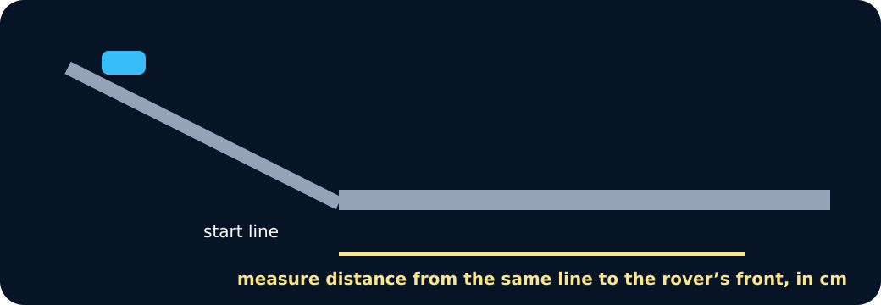
Measuring distance
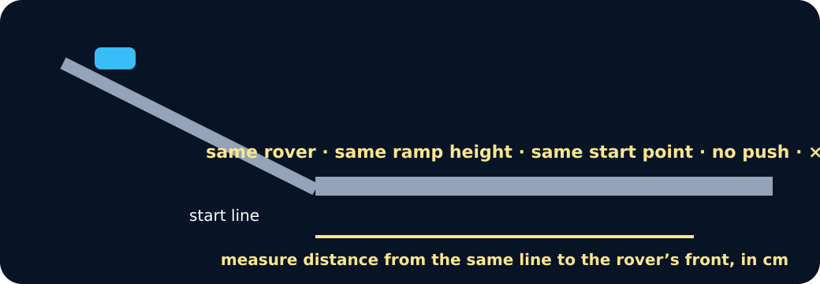
Controls

Exit · one next step
After the adult has listened, what will you keep, improve or check next?

