Rover Evidence Lab
  - GROW · Science · 40 minutes
I can carry out a comparative fair test, use repeated distance results for a conclusion and improve the method.
Name: __________________________ Date: ______________
You may write, type, say, sign, point or direct a partner. An adult can read the words and record your exact response. Keep the choice and explanation your own.

Words for this lesson
Word | Meaning
repeat | same method again
conclusion | what the results support
limitation | what the test cannot show

First idea
Smooth-surface results are 48, 51 and 49 cm. What should happen to the 51 cm result?
A. Keep it with the other valid repeats
B. Delete it because it is not identical
C. Keep only 51 because it is the furthest
My first idea and reason:

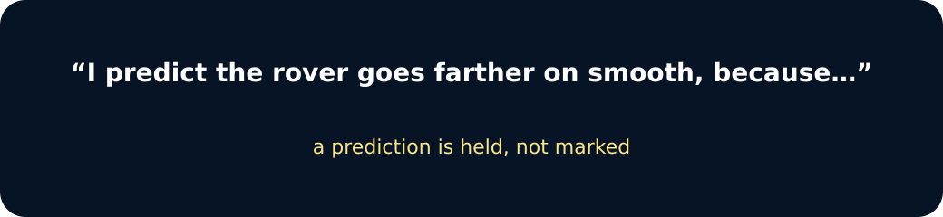
Prediction

We do · choose, explain, check
Which recording choice gives the strongest evidence?
A. Record all three valid results for each condition using the same measuring rule.
B. Keep only the furthest result from each condition.
C. Change a result when it does not match the prediction.
My choice: ______ Evidence or reason:

Rover Results Lab
Place each evidence card under Smooth, Fabric or Conclusion. Freeze the pattern before choosing an improvement.
Read or hear one card. Choose a group. Give the evidence. A partner checks your reason before you move on. Point or write card numbers; cutting is optional.
Group | Card numbers and evidence
SMOOTH
FABRIC
CONCLUSION / LIMIT

Activity cards
1 · 48, 51, 49 cm | 2 · Range: 3 cm (48–51 cm interval)
Three digital-twin runs on the smooth surface. | Maximum minus minimum for the smooth results: 51 − 48 = 3 cm.

3 · 27, 29, 28 cm | 4 · Range: 2 cm (27–29 cm interval)
Three digital-twin runs on the fabric surface. | Maximum minus minimum for the fabric results: 29 − 27 = 2 cm.

5 · Smooth produced greater travel distance | 6 · One classroom rover is a simplified model
Lower friction opposed the rover's motion less in this model. | Real rovers face different gravity, terrain and designs.

State the pattern, one evidence-linked conclusion, one method improvement and one model limitation.

Your lesson record
Carry out or direct the fair rover test, record two conditions with three repeats, then give a conclusion, improvement and limitation.

Model helps us see
The fixed six-result set provides a complete parity route and models how raw data become a cautious conclusion.

Model does not show
A short classroom ramp tests one rover, two surfaces and one set of conditions; it cannot represent gravity, terrain or every real rover design.

Supported
Direct each run, match the six values to conditions and complete an oral or symbol-supported conclusion.
Adult handles equipment; use pre-labelled rows and the frame: On ___ it went ___ because ___.

Standard
Complete three safe repeats per condition, record all results and write a conclusion plus one improvement.
Check the method against change, measure, keep and repeat before concluding.

Stretch
Compare typical values, calculate numerical ranges, explain variation and evaluate transfer to a real rover.
Suggest one justified method improvement without changing the original raw data.

Evidence target
Prediction, all six raw results, pattern statement, evidence-linked conclusion, one improvement and one model limitation.

Exit, Audience and evidence · W13B
Supported: Which condition gave the greater travel distance?

Standard: Use one repeated result pattern to explain the effect of surface on the rover.
Stretch: Give one method improvement and one model limitation, explaining why each matters.

What I said, and what it changed
________________________________________________

Next I will ______.

Adult witness note
What was observed, and with what level of independence?

My evidence and explanation

What does this evidence not show?

Visual reference cards
These are diagrams or model views from the uploaded lesson. Use their labels and the card descriptions; they are not photographs of your own results.
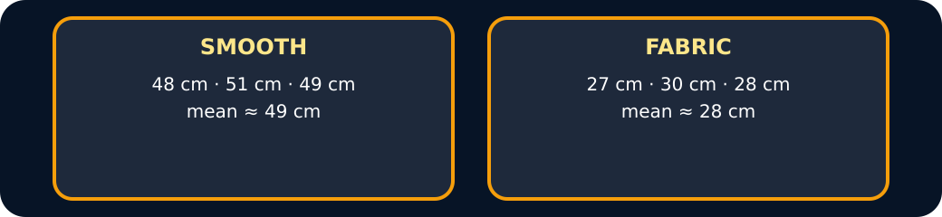
Results

Conclusion

Exit · one next step
After the adult has listened, what will you keep, improve or check next?

