Day and Night: Sky Shift
  - GROW · Science · 40 minutes
I can explain that Earth's rotation causes day and night and makes the Sun appear to move across our sky.
Name: __________________________ Date: ______________
You may write, type, say, sign, point or direct a partner. An adult can read the words and record your exact response. Keep the choice and explanation your own.

Words for this lesson
Word | Meaning
rotate | turn
axis | turning line
apparent | seems to

First idea
At sunset, what do you predict is really moving? Commit to a first idea; it is not marked.
A. The Sun travels around Earth once each day.
B. Earth turns while the Sun stays in the model's fixed position.
C. Clouds carry daylight away.
My first idea and reason:

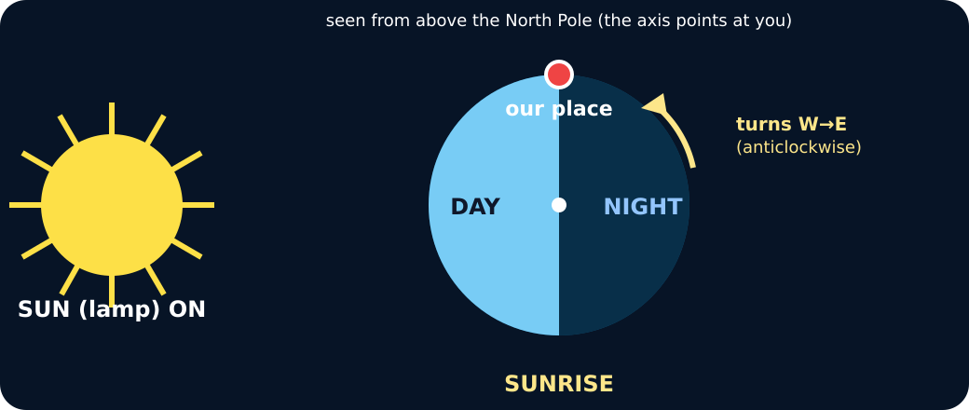
Earth beside a lamp; the marked place is at the edge of the lit half

We do · choose, explain, check
The marked place is on the dark side and rotates towards the lamp. What comes next there?
A. Morning, because the place is entering the lit half.
B. Night, because the lamp has switched off.
C. A season, because one turn takes a year.
My choice: ______ Evidence or reason:

Four-position sky lab
Match each observation at the marked place to its position in one rotation.
Read or hear one card. Choose a group. Give the evidence. A partner checks your reason before you move on. Point or write card numbers; cutting is optional.
Group | Card numbers and evidence
Sunrise
Middle of the day
Sunset
Night

Activity cards
1 · Entering light | 2 · Facing the lamp
The marked place crosses from the unlit half into the lit half. | The marked place is near the centre of the lit half and faces the lamp.

3 · Leaving light | 4 · Facing away
The marked place crosses from the lit half into the unlit half. | The marked place is near the centre of the unlit half and faces away from the lamp.

Use the frozen evidence to say what moved, what stayed fixed and why the Sun appeared to move.

Your lesson record
Create a four-position explanation of day, night and the Sun's apparent movement for one marked place.

Model helps us see
Trace the marker with one finger. Say: facing the Sun means day; facing away means night.

Model does not show
The lamp and globe are not to scale, the axis angle is simplified, and a quick turn represents about 24 hours.

Supported
Order four picture cards and complete: When our place faces the Sun it is __. When it faces away it is __.
Use the word bank: rotates, Sun, day, night, appears. An adult may scribe your exact words.

Standard
Draw and label four positions in one rotation, then explain day, night, sunrise and sunset.
Use: Earth rotates, therefore our place…, so the Sun appears to….

Stretch
Explain the same four positions to someone who thinks the Sun orbits Earth each day.
Include observer viewpoint, apparent movement and one honest model limitation.

Evidence target
One saved or paper sequence with four positions, rotation arrows and a because sentence using apparent.

Exit, Audience and evidence · W8A
Supported: Complete or point: Earth turns. Facing the Sun gives __; facing away gives __.

Standard: Explain why day and night happen and why the Sun appears to move across our sky.
Stretch: Correct the daily-Sun-orbit idea and state one limitation of today's model.

What I said, and what it changed
________________________________________________

Next I will ______.

Adult witness note
What was observed, and with what level of independence?

My evidence and explanation

What does this evidence not show?

Visual reference cards
These are diagrams or model views from the uploaded lesson. Use their labels and the card descriptions; they are not photographs of your own results.
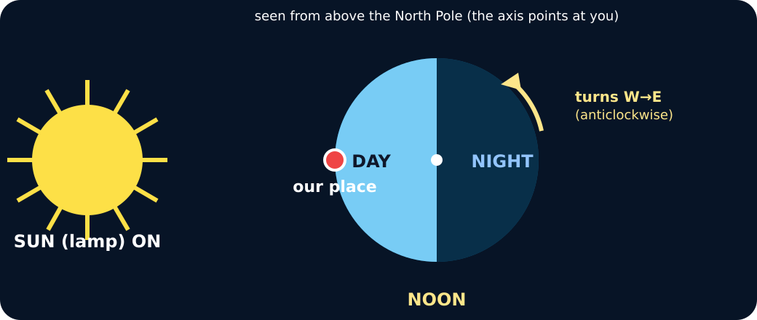
The marked place is facing the lamp
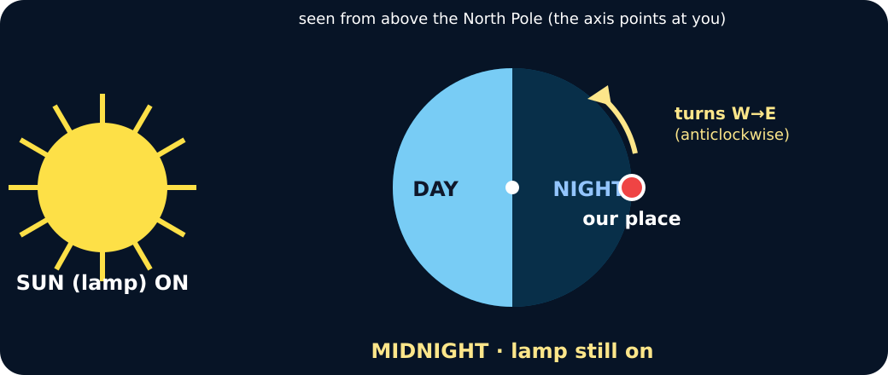
The marked place is on the dark half; the lamp is still on
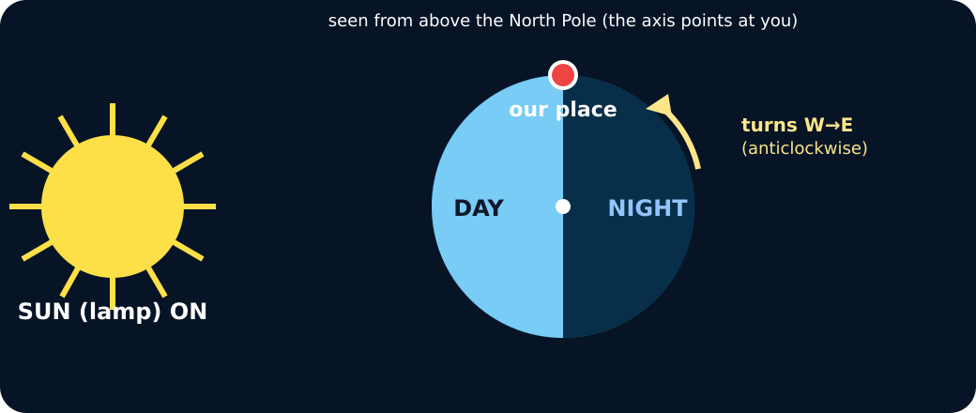
Rotating Earth model with a lamp as the Sun

Exit · one next step
After the adult has listened, what will you keep, improve or check next?

