Day and Night: 24-Hour Control Room
  - GROW · Science · 40 minutes
I can use a rotating-Earth model to collect and explain evidence across one complete day-night cycle.
Name: __________________________ Date: ______________
You may write, type, say, sign, point or direct a partner. An adult can read the words and record your exact response. Keep the choice and explanation your own.

Words for this lesson
Word | Meaning
cycle | repeating sequence
rotation | one full turn
evidence | what we observed

First idea
A pupil says, ‘Clouds make night because they hide the Sun.’ Which first response would you test?
A. Agree: thick clouds create night.
B. Track a marked place as Earth turns, with the lamp kept on.
C. Use a brighter lamp so night disappears.
My first idea and reason:

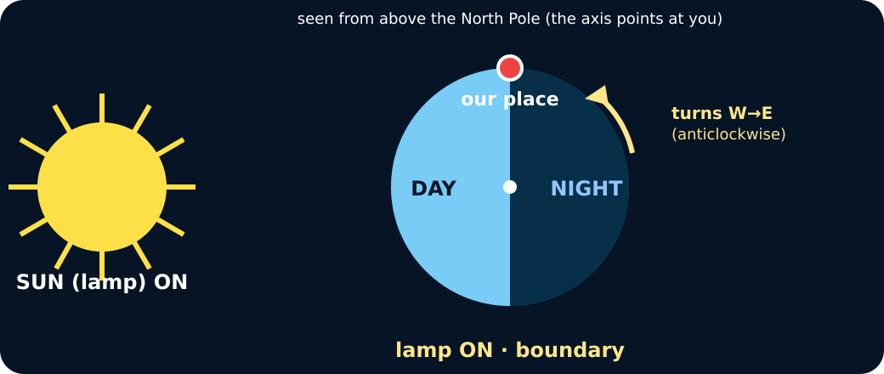
Marker at the boundary, lamp on

We do · choose, explain, check
The lamp stayed on throughout, but the marker became dark. Which evidence explains this?
A. The marker rotated onto the side facing away from the lamp.
B. The lamp stopped producing light for half the turn.
C. Clouds formed on the globe during the turn.
My choice: ______ Evidence or reason:

24-hour evidence console
Commit each control-room observation to the correct point in the cycle.
Read or hear one card. Choose a group. Give the evidence. A partner checks your reason before you move on. Point or write card numbers; cutting is optional.
Group | Card numbers and evidence
Sunrise
Middle of the day
Sunset
Middle of the night

Activity cards
1 · Control row 1 | 2 · Control row 2
Marker crosses the boundary from unlit to lit; the model Sun seems low in the east. | Marker faces the lamp and is well inside the lit half; the model Sun seems high.

3 · Control row 3 | 4 · Control row 4
Marker crosses from lit to unlit; the model Sun seems low in the west. | Marker faces directly away from the lamp and is well inside the unlit half.

Use two frozen rows to show how rotation explains night while the lamp remains on and no cloud is present.

Your lesson record
Run or represent one complete four-position rotation and produce a control-room evidence record.

Model helps us see
Keep one finger on the marker. At each pause say lit or unlit first, then name the time position.

Model does not show
Quarter turns compress continuous rotation and do not show exact local times, seasons, weather or Earth's scale.

Supported
Complete four rows using picture choices for sunrise, day, sunset and night.
Use: The place is __ because it faces __. The Sun appears __.

Standard
Record four quarter turns and explain the complete cycle using rotation and apparent movement.
Include what stayed fixed, what moved and two linked observations.

Stretch
Use the four rows to show how west-to-east rotation explains the pattern. Compare this explanation with the cloud and daily-Sun-orbit ideas without claiming the model alone decides between every possible sky model.
Cite exact observations, state the apparent east-to-west direction and include one model limitation.

Evidence target
Four ordered rows recording marker position, light state, apparent Sun position and one final because conclusion.

Exit, Audience and evidence · W8B
Supported: Choose and explain one row: it is day or night because the marked place faces __.

Standard: Use two evidence rows to explain one full day-night cycle.
Stretch: Explain why the cloud claim fails, then name one question this model cannot answer.

What I said, and what it changed
________________________________________________

Next I will ______.

Adult witness note
What was observed, and with what level of independence?

My evidence and explanation

What does this evidence not show?

Visual reference cards
These are diagrams or model views from the uploaded lesson. Use their labels and the card descriptions; they are not photographs of your own results.
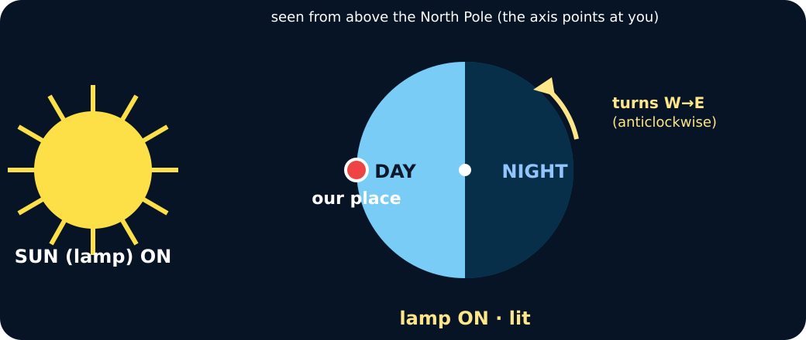
Marker fully lit, lamp on
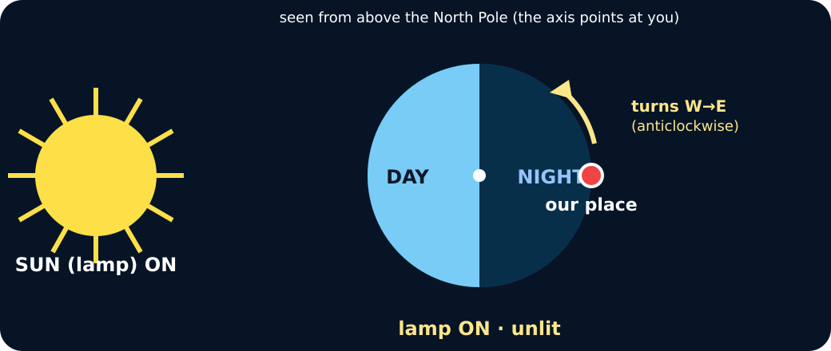
Marker unlit, lamp still on
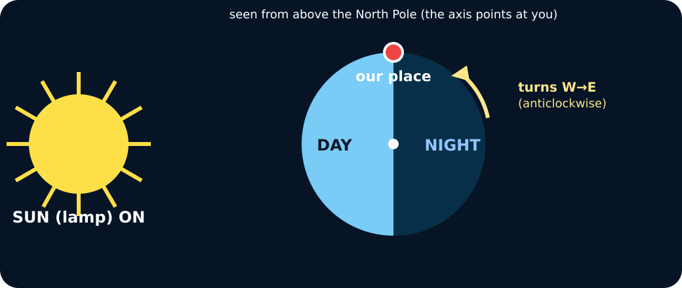
Rotating Earth model with lamp, cloud test and lamp test

Exit · one next step
After the adult has listened, what will you keep, improve or check next?

